20 March 2003

A Simple Sub-Optimal Combining System for Multiple Antenna Arrays
The HVAC channel has some degree of frequency selectivity. The peak-to-peak variation in the channel response can be as high as 35 dB in realistic environments (like NREC HVAC network). Multiple antenna arrays are being used to flatten the channel response and provide a reliable channel. In this report, we discuss a simple circuit that allows to combine the channel responses from different antennas and to provide a relatively flat channel (i.e. reduce peak-to-peak variation across the channel response). We can use simple transmission lines (i.e. microstrip lines) to introduce phase shift. Fig. 1 shows the schematic diagram of the concept. Each antenna is passed through different transmission lines (L1, L2, L3, L4) that correspond to different phase shifts (0, 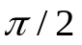,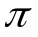,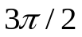). The optimum path is found in Matlab. The channel responses passing through different transmission lines are added to form the final flat channel.

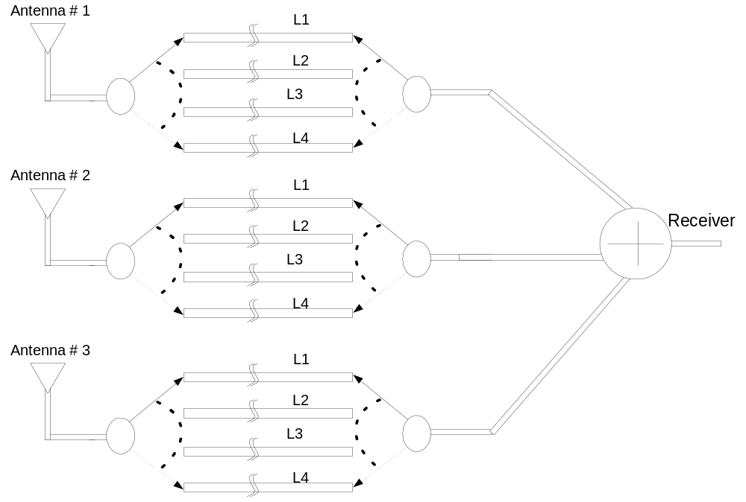

Fig.1: Schematic circuit diagram of sub-optimal combining system

Theory

The transmission line causes a phase shift given by:
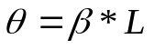
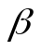is the propagation constant in the medium, and L is the path length of the transmission line (e.g. a microstrip line).

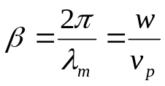
where v_{p} is the speed of the wave in the material. V_{p} depends on the dielectric constant of the medium.
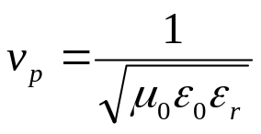
where 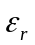 is the relative dielectric constant of the medium (typical value is 2.2).

The phase values (0, ,,) are computed for fc=2.45 GHz, and the corresponding transmission line lengths are 0, 2, 4, 6 cm. The phase values are not constant across 100 MHz band. They have some variations. Fig. 2 shows the variation of phase values across the channel. The phase shift is adjusted to be at 2.45 GHz. The phase change across 100 MHz band is less than 3.6 degrees.

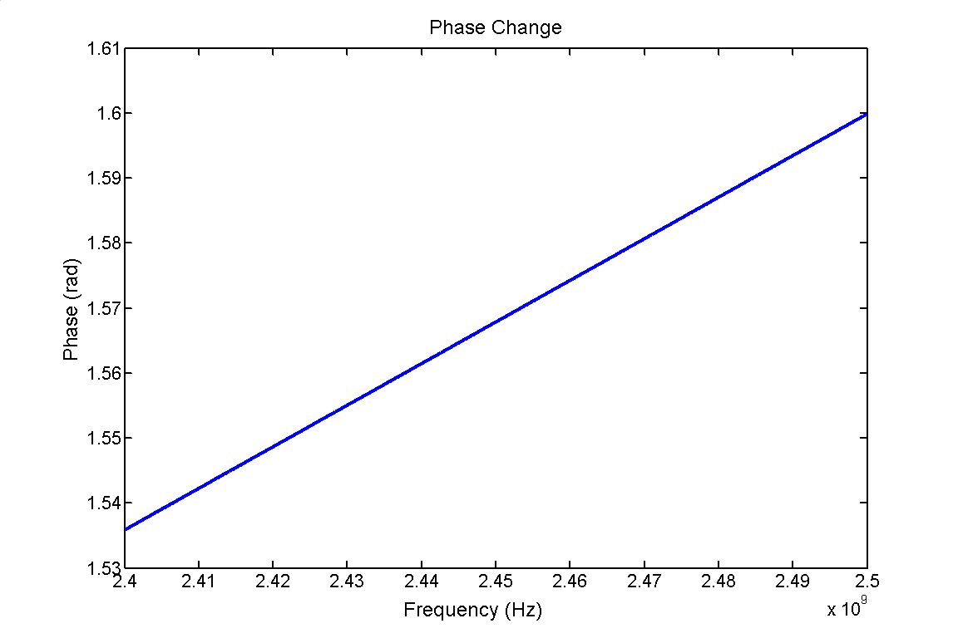
Fig 2. Phase change as a function of frequency
Results:
Fig. 3 shows one example of the above method. There are three receive antennas, and we have three separate sub-channels. Each one of these passes through different transmission lines (4 options) and they’re added. The black curve shows the optimum channel.
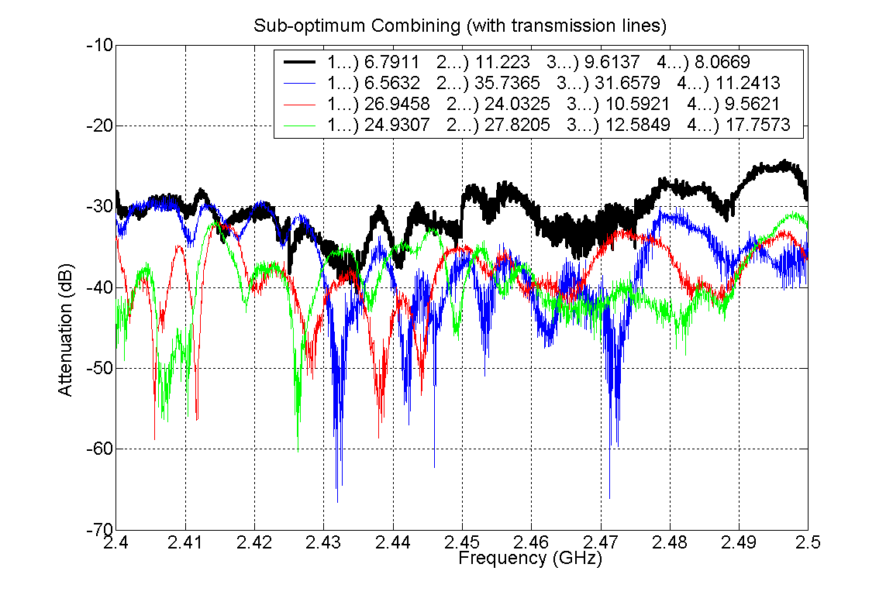

Figure 3: Multiple antennas && sub-optimum combining with system shown in Fig. 1

The system is tried with different channel combinations (3 receive antennas are used in all cases.). Fig. 4,5,6,7 show some statistical information about the results. Table I gives the summary of the results.

 | 2.4-2.425 GHz | 2.425-2.45 GHz | 2.450-2.475 GHz | 2.475-2.5 GHz
Single receive antenna | 19 dB | 31.7 dB | 22.87 dB | 16.3 dB
3 receive antennas summed uniformly | 26 dB | 30.6 dB | 22 dB | 17.9 dB
3 receive antennas summed with Complex Coeff. | 11.5 dB | 15.7 dB | 9.9 dB | 8.5 dB
Table I. Peak-to-peak variations (dB) for different scenarios.
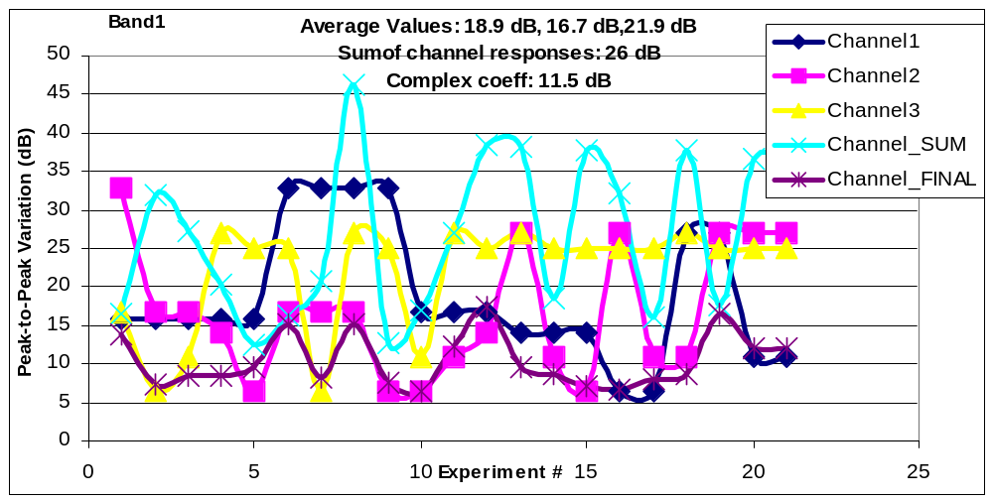

Figure 4: Peak-to-peak variation (dB) for different trials for the first band ( 2.4-2.425 GHz)

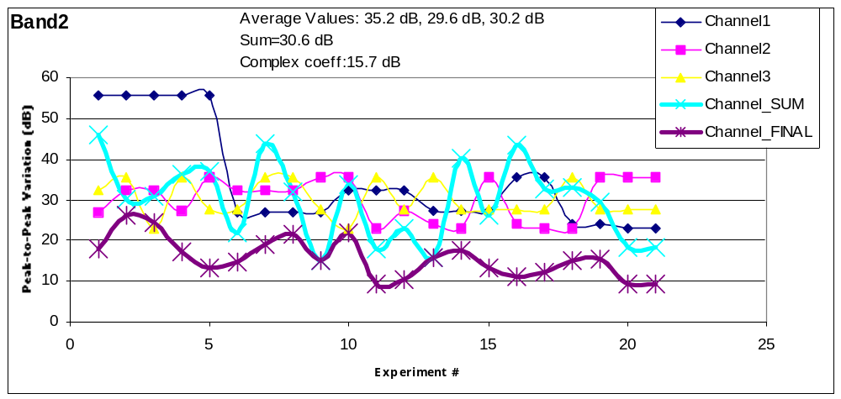

Figure 5: Peak-to-peak variation (dB) for different trials for the second band ( 2.425-2.450 GHz)

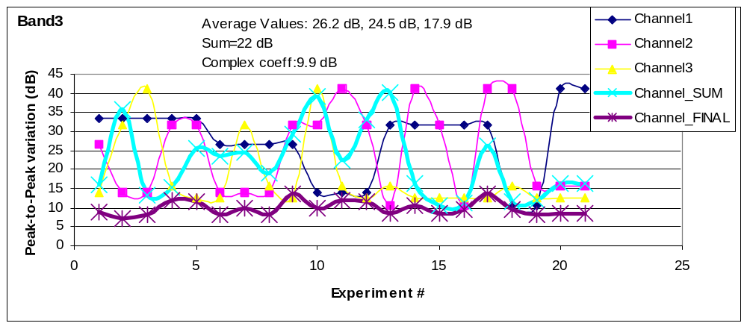

Figure 6: Peak-to-peak variation (dB) for different trials for the third band ( 2.450-2.475 GHz)

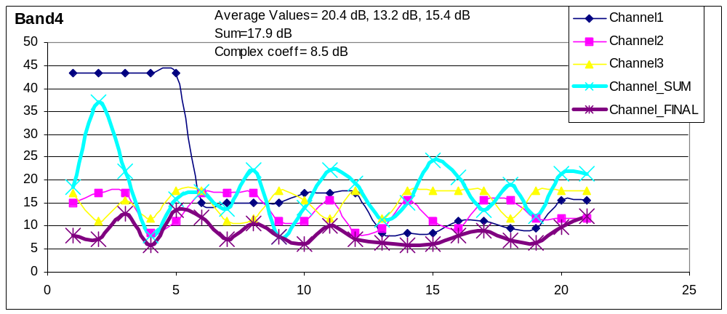

Figure 6: Peak-to-peak variation (dB) for different trials for the fourth band ( 2.475-2.500 GHz)

Comparison with Optimum Combining techniques
The following figures compares optimum combining method (with the help of I/Q modulators or DSP board) with the sub-optimal combining technique (with microstrip lines).
Optimal combining uses much more points to evaluate the best coefficients while suboptimal one uses only 4 values to find the correct coefficient for each channel.

Figure 7: Optimal & Sub-optimal combining: possible complex coefficients
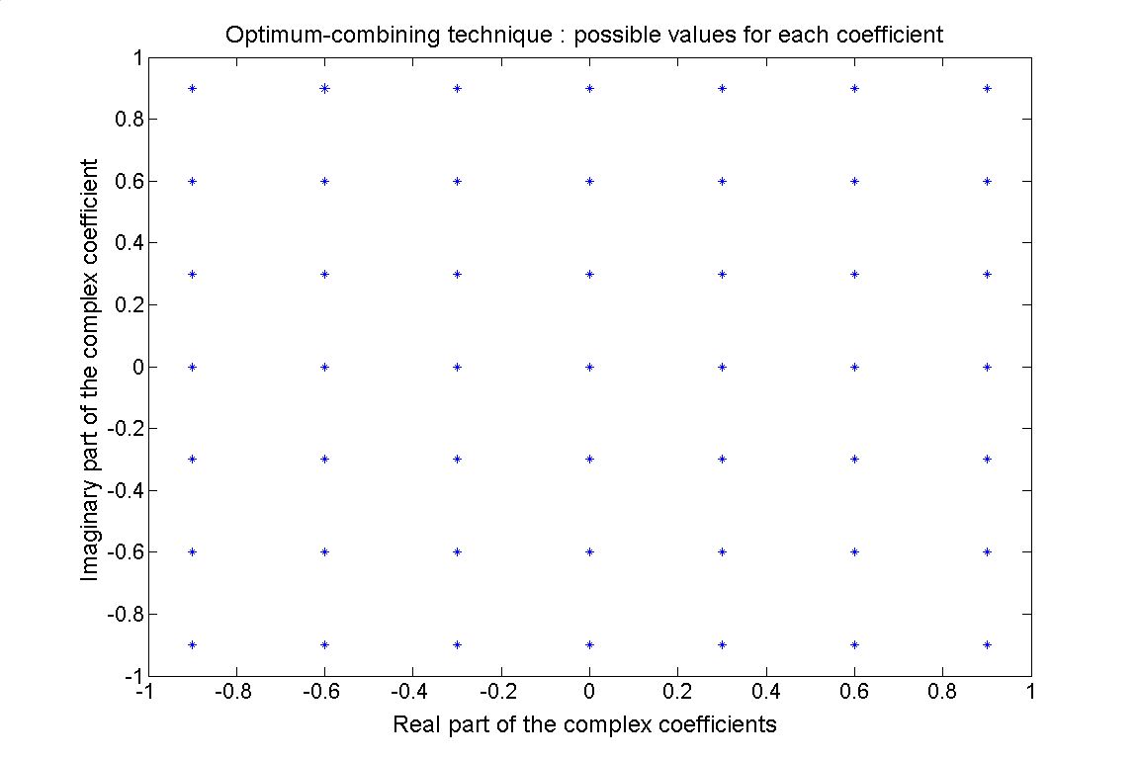 | 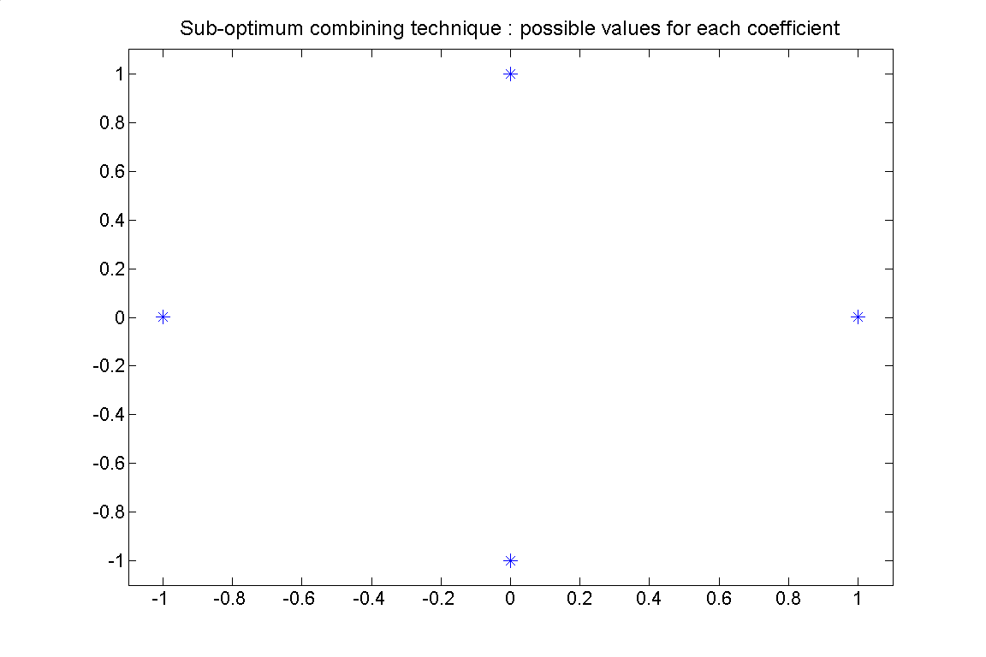

H_final= c1*H1+c2*H2+c3*H3
In the optimal combining technique, one has 49 possible points for c1, c2, and c3. The algorithm finds the coefficients that give the minimum peak-to-peak variation.
In the sub-optimal combining technique, there are 4 possible values for c1, c2 and c3. We find the minimum peak-to-peak variation.

Figure 8,9,10,11 show some comparisons between these two techniques.

Figure 8 and 9 show the results for the same set of channels with two techniques (one with optimal, one with sub-optimal technique)
The average peak-to-peak variations are 8.9 dB for the sub-optimal combining technique and 7.4 dB for the optimal combining technique. This corresponds to 17% decrease in the peak-to-peak variation.

As for the other example (Fig. 10, 11), the optimal combining technique provides 10% improvement over sub-optimal method. (12.6 dB for optimal one, 13.9 dB for sub-optimal case).

Bottomline: With optimal combining technique, one can play with the precision of the complex-coefficients and adjust the flatness of the channel response. This is a complicated system (in terms of finding correct coefficients and applying them with I/Q modulators or dsp chips). On the other hand, sub-optimal combining technique is relatively easy to implement (just microstrip lines and a switch) and provide good flatness across the channel.
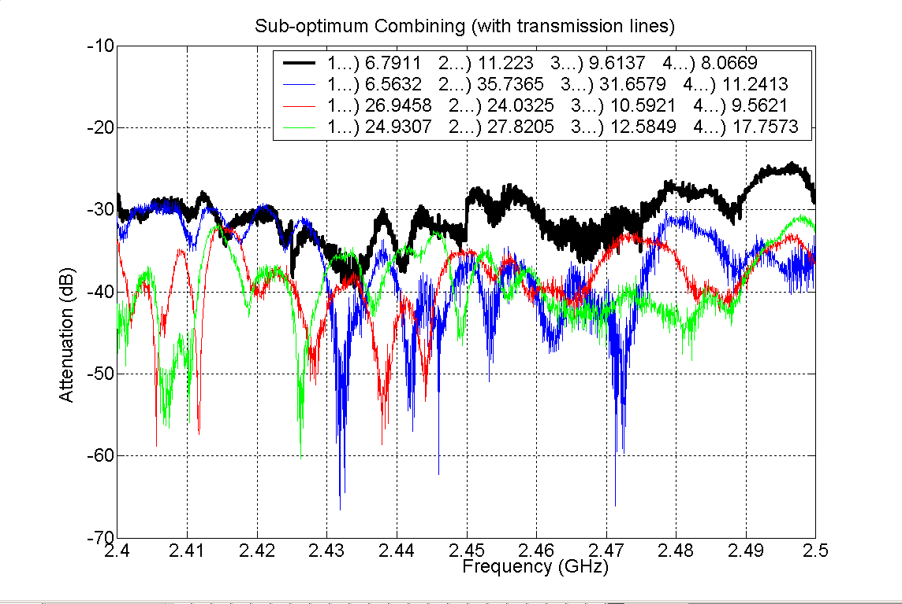
Figure 8:
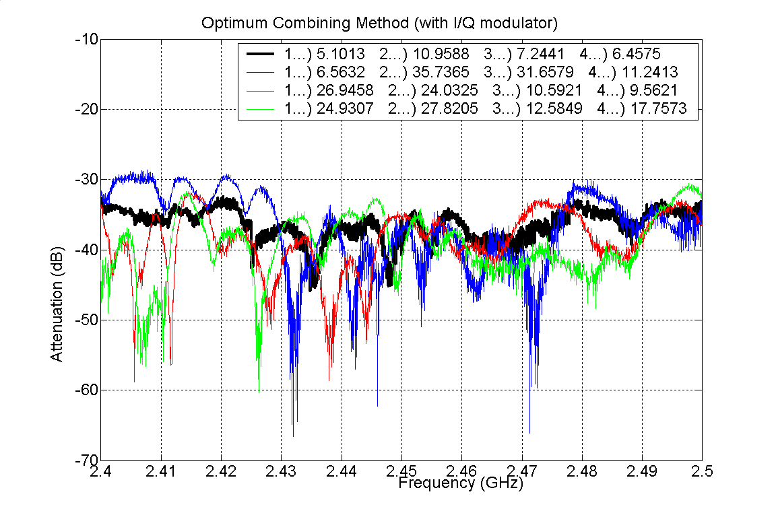
Figure 9:

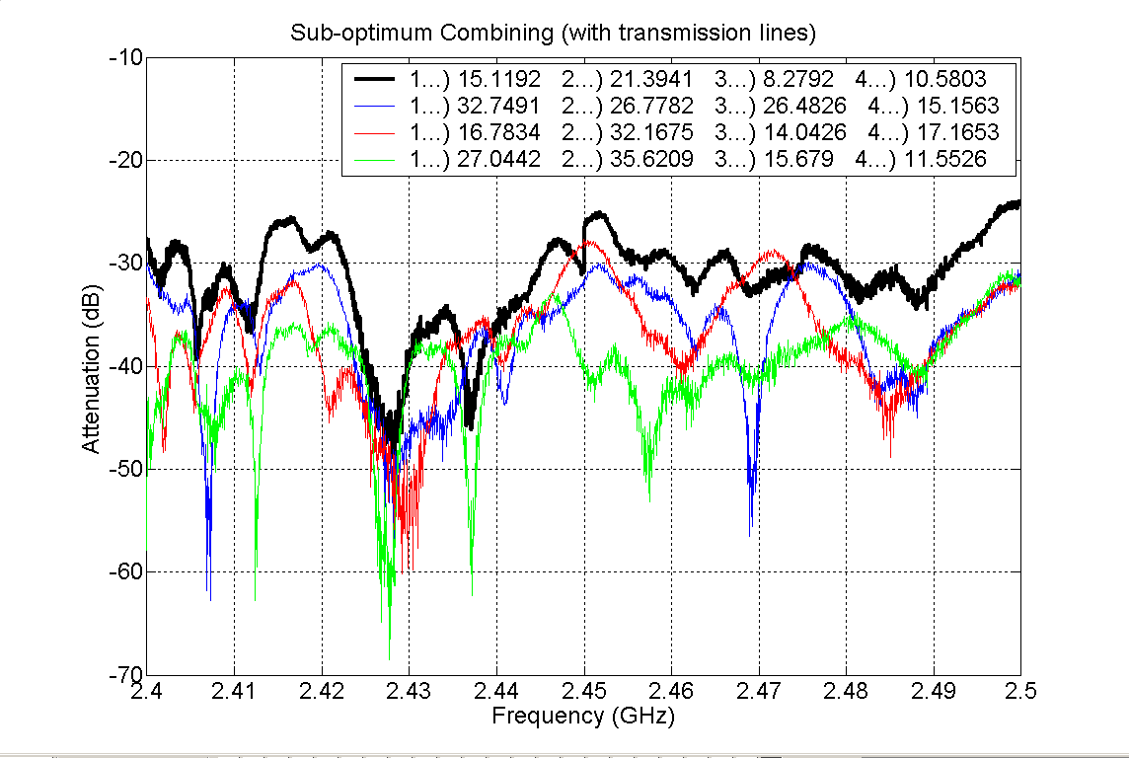
Figure 10
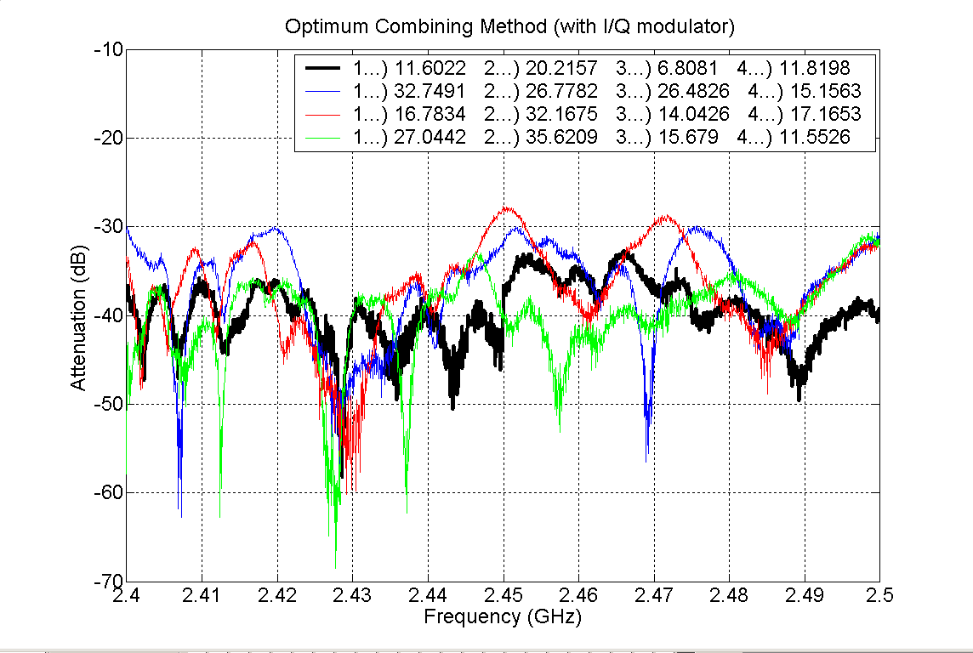
Figure 11

