System Topology based Identification of High Risk N-k Contingencies

A Report Developed for
PSerc Project S26: Risk of Cascading Outages

By
Siddhartha Khaitan, Ph.D. Candidate
James D. McCalley, Professor
Electrical and Computer Engineering Department
Iowa State University

May 30, 2006

Table of contents

1. Introduction 3
2. System Topology and Primary Multiple Contingencies 4
3. Topological Identification of Primary High-order Contingencies 7
4. Estimating the Reliability of Typical Substations 16
5. High-order Contingencies due to inadvertent tripping 23
Assuming that the probability of failure/fault to be same for each line. Let 23
6. Conclusion 36
APPENDIX A 38
APPENDIX B 40
REFERENCE 41

- Introduction
There is increasing need to provide operators with enhanced on-line information regarding system security levels, what influences these levels, and what actions should be taken, or not taken, in order to most economically achieve an improved level. This report aims to address one aspect of this issue by providing a method to identify multiple component contingencies that represent high risk. The causes of cascading events in power systems are various [1]. One major contribution to cascading is high order initiating contingencies—removal of several power system components in a very short time, typically within seconds. Contingency set identification is an essential step in monitoring the power system security level [1]. Most literature [2][3] on contingency selection emphasizes screening methods to select contingencies from a presumed N−1 contingency set plus a limited number of high order contingencies, ranking them using an appropriate severity index. Some exceptions include [4][5][6] which studied the effect of multiple component contingencies caused by substation and protection failures. However, the literature on systematic selection of high order contingencies, called N−k contingencies (where k ≥ 2 is implicit), is limited. [7] and [8] proposed the on-line detection of hidden failure in protection device to prevent cascading failure. The proposed method needs exhaustive information on the logic of protection device installed in power system, which make it very difficult to be implemented. The difficulty of N−k contingency selection lies in its combinatorial nature: the total number of distinct non-ordered (simultaneous) N−k contingencies is N!/[k!(N−k)]. For a very modest size power system model with N=1000, there are 499,500 N−2 contingencies, 166,167,000 N−3 contingencies, over 41 billion N−4 contingencies, and so on. One might argue that most of these contingencies are so low in probability that they do not warrant attention. However, N−k contingencies do occur, and when they do, consequences can be very severe, and these very practical facts motivate the objective of this research, to identify high risk N-k contingencies for on-line security assessment. Such contingencies can then be added to the standard contingency list used by the energy management system (EMS) for transmission security assessment.
The purpose of this report is to illustrate the probability calculation for high-probability N-k contingencies. A systematic method to calculate the probabilities of N-k contingencies for online security assessment is presented. The developed methodology is illustrated through five substation configurations including single breaker-single bus, ring bus, double breaker-double bus, single-bus connected with bus tie, and breaker and a half. The difference between these five configurations lies in their robustness to N-k contingencies as illustrated in the probability calculation. Some of the material in this report is drawn from [9].
Section 2 identifies that changes in system topology, protection failure and misoperation can lead to high risk N-k contingencies. Section 3 describes through an example our graph-search algorithm and probability estimation algorithm of N-k contingencies caused by topology variation and protection failure or stuck breaker following a primary contingency. Section 4 evaluates the reliability of five basic substations in terms of the functional group and the probability estimation model developed in Section 3. In Section 5 a systematic method to calculate the probability of inadvertent tripping following an initial event is presented and illustrated through the five basic substation topological configurations. Section 6 concludes. Appendix A provides the pseudo code for the graph search algorithm developed and in Appendix B rare event approximation and probability order precision is discussed.
- System Topology and Primary Multiple Contingencies
Transmission substations are normally designed to ensure that a single fault results in at most the loss of a single circuit. However, the actual substation topology, at any given moment, may differ from the designed configuration, as the topological configuration of a substation, in terms of the connectivity of the elements through the switching devices (switches and breakers), may change. Variations in substation topology can occur as a result of operator action for purposes of facility maintenance and for purposes of mitigating undesirable operating conditions such as high circuit loading or out-of-limit voltages. To a lesser extent, topological variation may also occur as a result of forced outages.
Substation topological variation may, in some instances, result in situations where the operation of the protective systems, in response to the occurrence of a fault in the network, removes two or more elements when clearing the fault. Such topologies significantly increase the risk-level of the network, as it exposes the system to a multi-outage contingency as a result of a single fault, whose probability is equivalent to that of an N-1 contingency. As N-k contingencies are inherently more severe than N-1 contingencies, an N-k contingency having a probability of the same order of magnitude as an N-1 contingency may cause a very high amount of risk, since risk associated with a specific contingency is the expected value of the contingency consequence [10]. We will classify event probabilities by their probability order [11][12][13] which is best described by an example. If the probability of an event, say a fault at a particular location, occurring in the next hour, is 10⁻⁵, then the probability of two independent faults occurring in the next time hour is 10⁻¹⁰, and three independent faults 10⁻¹⁵, and so on. We say, then, that any event (or event combination, independent or not) with probability having order of magnitude -5 is an order 1 event, any event with probability having order of magnitude -10 is an order 2 event, any event with probability having order of magnitude -15 is an order 3 event, and so on. A detailed discussion on probability precision based on rare event approximation and probability orders is given in Appendix A.
An operator may not be aware of increased N-k likelihood that results from switching actions. In this case, automated detection is critical. Even if the operator is aware of the increased likelihood, the question remains as to its severity and therefore its risk.
A search algorithm and the associated code have been developed to detect these situations and the pseudo code is given in Appendix B. The inputs required for the algorithm include the breaker-switch status data obtained from the SCADA system. As this data is also used for EMS topology processing, it is available in most control centers.
Another cause of N-k events is the failure of a breaker to open or protection failure to trip under a faulted condition. Such an event is of lower probability than that of an N-1 outage, as it is comprised of a fault and a protection system failure. Because these are two independent events, it is of order- 2. Yet, the severity, in terms of number of outaged elements, may be extreme, and therefore the risk may not be negligible. The graph-search algorithm given in Appendix B also detects this situation.
A systematic methodology for the probability calculation of inadvertent tripping or protection system misoperation leading to N-k events is also developed and illustrated through five substation topologies [14]. This is an order-2 or higher order contingency.
The NERC Disturbance Analysis Working Group (DAWG) provides a database on large disturbances that have occurred in the bulk transmission systems in North America since 1984 [15]. The analysis of this information has resulted in a classification of three types among those related to protection failures: (1) inadvertent tripping, (2) protection relay fail to trip, and (3) breaker failure. A summary of the DAWG database in terms of this classification is given in Table 1.
Table 1: Summary on disturbances caused by protection system failures
Year | Inadvertent Tripping | Protection  fails to trip | Breaker  Failure | Total No. protection malfunction
1984 | 4 | 0 | 1 | 5
1985 | 2 | 0 | 5 | 7
1986 | 1 | 1 | 2 | 4
1987 | 2 | 0 | 0 | 2
1988 | 6 | 0 | 0 | 6
1989 | 6 | 0 | 0 | 6
1990 | 0 | 2 | 1 | 3
1991 | 3 | 1 | 1 | 5
1992 | 1 | 1 | 2 | 4
1993 | 1 | 0 | 3 | 4
1994 | 2 | 0 | 3 | 5
1995 | 5 | 1 | 1? | 7
1996 | 2 | 0 | 1 | 3
1997 | 1 | 0 | 2 | 3
1998 | 0 | 0 | 0 | 0
1999 | 0 | 1 | 0 | 1
Total | 36 | 7 | 22 | 65
Percentage | 55% | 11% | 34% | 100%
- Topological Identification of Primary High-order Contingencies
In this section, detailed illustration of the three categories of high order contingencies caused by topology variation and component fault followed by one breaker failure or protection failure to trip are given in terms of a concise form to calculate the probability of these events by tracing the topology of system. A desirable contingency selection method should be able to identify, from topology data, high risk contingencies, that is, contingencies that have relatively high probability or high consequence or both. In addition to events with probability order 1, the method proposed in this section strategically chooses a group of events that have a probability less than that of order 1 but greater than or equal to that of order 2. It is assumed that at most, only one breaker will suffer stuck failure, i.e., failure of two or more breakers to open when required poses negligible risk. This assumption is consistent with the rare event approximation, (Appendix A) as long as the occurrences of different failures are independent. An example is used to explain the approach.

Graph Representations of Power System Topology with Substation Model
Formally, a graph Error! Objects cannot be created from editing field codes. is defined by an ordered pair of finite sets Error! Objects cannot be created from editing field codes. andError! Objects cannot be created from editing field codes., where the elements in Error! Objects cannot be created from editing field codes. are called the Vertices (also called nodes or points) and the elements in  are called edges (also called sides or arc) [16][17]. Each element in is a subset of Error! Objects cannot be created from editing field codes.containing only two elements ofError! Objects cannot be created from editing field codes.. For example
Error! Objects cannot be created from editing field codes.
defines the triangle graph in Fig. 1with Error! Objects cannot be created from editing field codes. constituting its three vertices and Error! Objects cannot be created from editing field codes. constituting its three edges. Such graphs are used to represent the topology of power system components, i.e. generators, lines, transformers, bus section, breakers, switches, and loads.
Error! Objects cannot be created from editing field codes.
Fig. 1: A graph with three vertices and three edges
The one-line diagram in Fig. 2 shows part of a real power system with bus bar segment BS-7 out for maintenance. Every component is tagged with a unique ID. Each of the components other than a bus section connects two different bus sections. In reality not all non-bus-section components (line, breaker, capacitor, generator, and switches) are joined by two bus bars. In this case a bus section is inserted between two non-bus-section components. This ensures that the data format for the topology of the power system is the same as those in EMS. A bus section is connected by one or more other types of components. If we take all the breakers and open switches (which form a cut set) away from the diagram, the whole diagram is decomposed into seven isolated parts. Each of the isolated parts is contained within a dashed circle. The components contained in each dashed circle of form a functional group (Fig. 2) A functional group does not include any circuit breaker and open switch, which forms the interface between two different functional groups. Generally, there is only one interfacing component, a breaker or a switch, connecting two functional groups.
One convenient way to model the system is depicted in the left hand side of Fig. 3. In this figure, the components are unanimously modeled as vertices. Each ellipse corresponds to a real power system component. The edges only show how the component are connected but do not correspond to any real component. The functional groups are identified with dashed circles as in the one-line diagram in Fig. 2, and each one is assigned a labelError! Objects cannot be created from editing field codes.. The interfacing components between each functional group are indicated with a grey ellipse, i.e., components BR-1, BR-2, BR-3, SW-2, and SW-3.
Error! Objects cannot be created from editing field codes.
Fig. 2: One-line diagram of actual system illustrating functional groups
Error! Objects cannot be created from editing field codes. | Error! Objects cannot be created from editing field codes.
Fig. 3: Graph representations of Fig. 2
The graph model used in some EMS is not as that in the left hand side of Fig. 3 rather it models the topology as the graph shown in the right hand side of Fig. 3. This model is different in that both a vertex and an edge correspond to a real component. It treats all bus section components as vertices and all non bus-section components (line, breaker, capacitor, generator, and switches) as edges. Each vertex of the graph corresponds to a bus section component in the power system. The edges indicate how the bus sections are connected. Each edge corresponds to a non-bus section component (line, breaker, capacitor, generator, and switches). A bus section component may be connected by more than two edges, while each edge connects only two vertices. The functional groups are again identified with dashed circles, and each one is assigned a labelError! Objects cannot be created from editing field codes.. The interfacing components between each functional group are the same as in Fig. 3, but they are modeled as edges instead of vertices. This graph is undirected which is different from the directed graph model in electrical circuit analysis and power flow. The graph for them is directed because they need a reference direction for electric current flow or power flow.
All the components, vertices, or edges, are listed in Table 2 and Table 3. Each component is assigned a number I.D. in addition to the name I.D. The expressions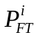, 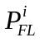 and 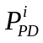 are three different reliability indices defined for power system components.
Table 2: List of vertex component of the power system diagram in Fig. 2
Name I.D. | BS-1 | BS-2 | BS-3 | BS-4 | BS-5 | BS-6 | BS-7 | BS-8 | BS-9 | BS-10
Number | 17 | 18 | 19 | 20 | 21 | 22 | 23 | 24 | 25 | 26
Fault Prob. | Error! Objects cannot be created from editing field codes. | Error! Objects cannot be created from editing field codes. | Error! Objects cannot be created from editing field codes. | Error! Objects cannot be created from editing field codes. | Error! Objects cannot be created from editing field codes. | Error! Objects cannot be created from editing field codes. | Error! Objects cannot be created from editing field codes. | Error! Objects cannot be created from editing field codes. | Error! Objects cannot be created from editing field codes. | Error! Objects cannot be created from editing field codes.

is the probability that component has a ground fault contingency and means the probability that the component fails and has to be forced out from operation. Since fault contingency is only one of different modes of failure, must be greater than or equal to. is called per demand fail probability, i.e. the conditional probability that the component fails to perform an action when the component is demanded to perform that action. Not all components need all the three reliability indices. Both and are defined for non bus-section and non switching-components (line, capacitor and generator) because these components have many failure modes in addition to ground fault. Since these components are stagnant devices that do not receive any command from control and perform any action, they do not have an 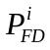 index. Only is defined for bus sections since they are stagnant and fault is virtually the only possible failure mode for them. Only is defined for switching components (breakers and switches) as they receive command from protection relay to connect or disconnect actions. Although it is possible for a switch component to have ground fault or other mode of failure, this probability is transferred to that of the two components the switch component connects by increasing the and. The value of depends on the switching status of the component. If the component is already in OPEN (or OFF) state, then is zero, otherwise, it is the conditional probability that the component fails to open when required.
Table 3: List of edge components for the power system diagram in Fig. 2
Name I.D. | No I.D. | Connected  Bus Sections |  | Status | Probability
Name I.D. | No I.D. | from | To | Status | Fault | Fail | Per Demand
G-1 | 1 | BS-1 | Ground | Online | Error! Objects cannot be created from editing field codes. | Error! Objects cannot be created from editing field codes. | —
LN-1 | 2 | BS-5 | other system | Online | Error! Objects cannot be created from editing field codes. | Error! Objects cannot be created from editing field codes. | —
LN-2 | 3 | BS-6 | other system | Online | Error! Objects cannot be created from editing field codes. | Error! Objects cannot be created from editing field codes. | —
LN-3 | 4 | BS-8 | other system | Online | Error! Objects cannot be created from editing field codes. | Error! Objects cannot be created from editing field codes. | —
LN-4 | 5 | BS-9 | other system | Online | Error! Objects cannot be created from editing field codes. | Error! Objects cannot be created from editing field codes. | —
LN-5 | 6 | BS-10 | other system | Online | Error! Objects cannot be created from editing field codes. | Error! Objects cannot be created from editing field codes. | —
TR-1 | 7 | BS-2 | BS-3 | Online | Error! Objects cannot be created from editing field codes. | Error! Objects cannot be created from editing field codes. | —
CAP-1 | 8 | BS-4 | Ground | Online | Error! Objects cannot be created from editing field codes. | Error! Objects cannot be created from editing field codes. | —
BR-1 | 9 | BS-1 | BS-2 | On | 0 | 0 | Error! Objects cannot be created from editing field codes.
BR-2 | 10 | BS-3 | BS-4 | On | 0 | 0 | Error! Objects cannot be created from editing field codes.
BR-3 | 11 | BS-4 | BS-5 | On | 0 | 0 | Error! Objects cannot be created from editing field codes.
BR-4 | 12 | BS-9 | BS-10 | On | 0 | 0 | Error! Objects cannot be created from editing field codes.
SW-1 | 13 | BS-4 | BS-6 | On | 0 | 0 | Error! Objects cannot be created from editing field codes.
SW-2 | 14 | BS-6 | BS-7 | Off | 0 | 0 | Error! Objects cannot be created from editing field codes.
SW-3 | 15 | BS-7 | BS-8 | Off | 0 | 0 | Error! Objects cannot be created from editing field codes.
SW-4 | 16 | BS-8 | BS-9 | On | 0 | 0 | Error! Objects cannot be created from editing field codes.

Since each functional group is tripped by protection relay as a whole entity, any fault or failure of a component within the group will cause the whole group to be tripped. The probability a functional group is tripped can be calculated as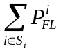, where the elements of 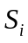 are the indices of all the components in functional group. The probability that a functional group is tripped due to fault can be calculated as Error! Objects cannot be created from editing field codes. in the same way.
The equations for each individual group are summarized in the last two columns of Table 4. We assume the availability of the connection data for each power substation and the components within and between them, as summarized in the 3rd and 4th columns of Table 3. We perform a graph search using this information to identify the functional groups. The results of this search for this example are provided in the first four columns of Table 4.
The fifth column of Table 4 provides the failure probabilities of the functional groups, which are the summation of the failure probabilities of the non-interfacing components comprising the functional group.

Table 4: List of functional groups and identified their failure probabilities
Functional  Group  FG-i | Interfacing  Components  (breaker or  Open switch) | Per Demand Fail Prob. Of  Interfacing  Components | Non-interfacing  Components  Error! Objects cannot be created from editing field codes.= | Fault/Failure Prob. of  Functional groups
 |  |  |  | Fault:  Error! Objects cannot be created from editing field codes. | Failure: Error! Objects cannot be created from editing field codes.
FG-1 | BR-1 | Error! Objects cannot be created from editing field codes. | Error! Objects cannot be created from editing field codes.= {1,17} | Error! Objects cannot be created from editing field codes. | Error! Objects cannot be created from editing field codes.
FG-2 | BR-1, BR-2 | Error! Objects cannot be created from editing field codes., Error! Objects cannot be created from editing field codes. | Error! Objects cannot be created from editing field codes.= {7,18,19} | Error! Objects cannot be created from editing field codes. | Error! Objects cannot be created from editing field codes.
FG-3 | BR-2, BR-3, SW-2 | Error! Objects cannot be created from editing field codes., Error! Objects cannot be created from editing field codes. | Error! Objects cannot be created from editing field codes.= {8, 20, 13, 22, 3} | Error! Objects cannot be created from editing field codes. | Error! Objects cannot be created from editing field codes.
FG-4 | BR-3 | Error! Objects cannot be created from editing field codes. | Error! Objects cannot be created from editing field codes.= {2, 21} | Error! Objects cannot be created from editing field codes. | Error! Objects cannot be created from editing field codes.
FG-5 | SW-2, SW-3 | Error! Objects cannot be created from editing field codes., Error! Objects cannot be created from editing field codes. | Error! Objects cannot be created from editing field codes.= {23} | Error! Objects cannot be created from editing field codes. | Error! Objects cannot be created from editing field codes.
FG-6 | SW-3, BR-4 | Error! Objects cannot be created from editing field codes., Error! Objects cannot be created from editing field codes. | Error! Objects cannot be created from editing field codes.= {24, 4, 16, 25, 5} | Error! Objects cannot be created from editing field codes. | Error! Objects cannot be created from editing field codes.
FG-7 | BR-4 | Error! Objects cannot be created from editing field codes. | Error! Objects cannot be created from editing field codes.= {26, 6} | Error! Objects cannot be created from editing field codes. | Error! Objects cannot be created from editing field codes.

A careful observation of shows that it can be reduced to the smaller graph in Fig. 4 if we take each functional group as a graph theoretic vertex, and any component (a breaker or an open switch) between two functional groups as an edge. If we define Error! Objects cannot be created from editing field codes. to be the component joining Error! Objects cannot be created from editing field codes. and Error! Objects cannot be created from editing field codes., the new graph can be expressed by Error! Objects cannot be created from editing field codes.
where Error! Objects cannot be created from editing field codes.
and Error! Objects cannot be created from editing field codes.
Error! Objects cannot be created from editing field codes.
Error! Objects cannot be created from editing field codes.
Fig. 4 shows the graph defined byError! Objects cannot be created from editing field codes.. Since the graph is an undirected graph, the pairs in Error! Objects cannot be created from editing field codes. are defined as exchangeable, i.e. Error! Objects cannot be created from editing field codes..

Error! Objects cannot be created from editing field codes.
Fig. 4: Reduced functional group graph for Fig. 3
The results of the graph search also enable identification of the interconnections between functional groups, as summarized in Table 5. Each column in the table corresponds to a functional group, while each row corresponds to an interfacing component. There are two ones in each row, which indicate the interfacing component joint the two corresponding functional groups. The rest of the elements are all zeros. The array of elements in Table 3 can be represented via a matrix B in equation (1) where each row of B corresponds to an interfacing component, and each column corresponds to a functional group. This matrix is also called incidence matrix in graph theory [17]

Table 5: Connections for the interfacing components and the functional group (1- connected, 0-not connected)
— | FG-1 | FG-2 | FG-3 | FG-4 | FG-5 | FG-6 | FG-7
BR-1 | 1 | 1 | 0 | 0 | 0 | 0 | 0
BR-2 | 0 | 1 | 1 | 0 | 0 | 0 | 0
BR-3 | 0 | 0 | 1 | 1 | 0 | 0 | 0
SW-2 | 0 | 0 | 1 | 0 | 1 | 0 | 0
SW-3 | 0 | 0 | 0 | 0 | 1 | 1 | 0
BR-4 | 0 | 0 | 0 | 0 | 0 | 1 | 1

Error! Objects cannot be created from editing field codes. (1)
If a component within either of the neighboring functional groups FG-i and FG-j has a fault and the breaker connecting FG-i and FG-j fails to open, generally, all the components in the two neighboring functional groups will be taken out of service. The probability that the functional group G_{i} and G_{j} both fail during the time interval Δt can be expressed as:
Error! Objects cannot be created from editing field codes.
Error! Objects cannot be created from editing field codes.
Error! Objects cannot be created from editing field codes. (2)
where 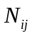is the index of the interfacing component that joining functional group and functional group. Active failure rate (failure to open as required) of the interconnecting components between functional groups G_{i} and G_{j} (given by the failure rate of the interconnecting component), Δt is the next time interval considered, and P_{k} is the sum of the failure probabilities of all components in functional groups G_{i} and G_{j}.
The last column of Table 3 provides the per demand failure probabilities of the interfacing components. We denote the vector of failure rates of interfacing component as
Error! Objects cannot be created from editing field codes. (3)
where and diag indicates a square matrix having diagonal elements equal to the argument of the diag function and zeros elsewhere. The index of each is the same as the index of the interfacing component.
Then all the equations in form of equation (2) can be summarized in matrix form as:
Error! Objects cannot be created from editing field codes. Error! Objects cannot be created from editing field codes. (4)
or
Error! Objects cannot be created from editing field codes. (5)
where
Error! Objects cannot be created from editing field codes. (6)
D is given by equation (3),
B is given by equation (1),
Error! Objects cannot be created from editing field codes.
As we mentioned previously, SW-2 and SW-3 are open, so it is not possible for the two switches to fail to open. Therefore we set 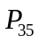 and 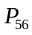 to zeroes. Now the above developed probability calculation method will be illustrated through five substation configurations discussed below.
- Estimating the Reliability of Typical Substations
The five substation configurations discussed in this report are taken from [14]. All calculations assume that none of the substation components are in maintenance or out of service for any reason before a contingency. Furthermore, all the five configurations have four out-going or incoming connection points, so the apparent functions of them are the same i.e. serving as a hub to join four branches. In terms of N-1 contingencies, the performances of all five configurations are the same. If any line has a fault and it is tripped correctly, all the three other lines will be still functional. The difference lies in that their robustness to high order contingencies. Some substations are obviously more reliable than others for higher order contingencies, for example, the double-bus-double-breaker (DBDB) configuration is more reliable than the single-bus-single-breaker (SBSB) configuration in Fig. 5. A bus fault outage can defunct all the four lines from/to the SBSB station while the DBDB station can withstand such a disturbance without interrupting the service of any of the four lines. Usually, power system engineers study the reliability of substation using state diagram with Markov model or Monte Carlo method [4][5][6] The full state diagram is not practical for a substation with many components. In this case, many simplifications have to be made so that the approach is feasible. But proposed approach provides a new way to study substation reliability and the algorithm is not restricted by the number of components in a substation. The graphical functional group model described above is used to analyze the reliability of the five basic substations as shown in Fig. 5.
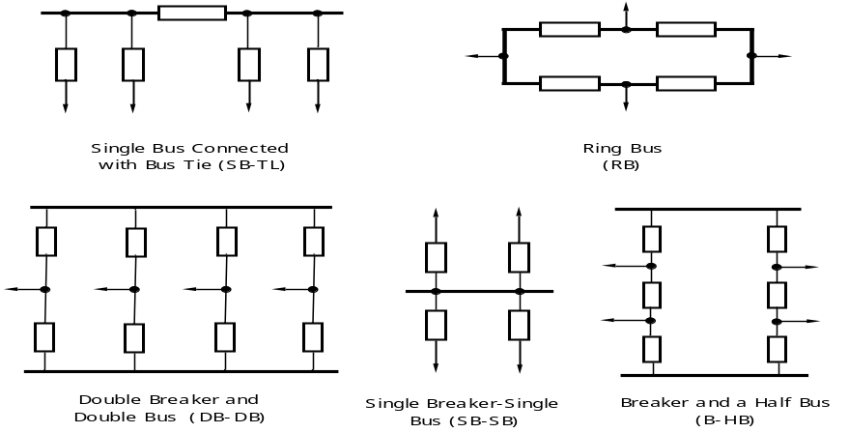

FU3

FU4

B3

B4
Fig. 5: Five typical substation configurations
Some of the notations used are defined below.
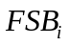: contingency caused by fault plus breaker i stuck;
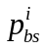 : failure probability of bus section i. It is assumed to be zero for this discussion, i.e., 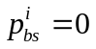 for all i;
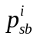: conditional stuck probability (per demand failure rate) of breaker . It is assumed to be the same (denoted as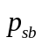) for all breakers in the five substations;
: diagonal matrix whose elements are 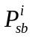’s;
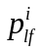 : fault probability of line. It is assumed to be the same (denoted as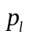) for all transmission lines;
: connection matrix of all function groups in a substation. Its elements are defined in equation (1);
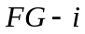: functional group ;
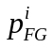: fault probability of the 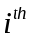functional group;
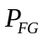: column vector representing the fault probabilities of all functional groups;
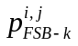: the aggregate probability of a group of contingencies caused by a fault within any of the two neighboring functional groups of breaker and followed by the stuck failure of breaker . The fault could happen on either side of the breaker. It could be a single line outage as well as a multiple line outage.
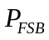: column vector made up of 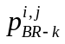, the length of the vector is the same as the number of breaker in the study case;
    - Single Breaker and Single Bus (SB-SB)
This configuration is simple and straightforward. From Fig. 6, there are a total of five functional groups and 4 breakers, implying four stuck breaker contingencies. The B-matrix representing the connectivity of the four functional groups is shown in the right side of Fig. 6. Clearly, with this single-bus-single-breaker substation diagram, any stuck breaker failure will cause the loss of all the four lines. The functional group fault probability, which is the summation of the fault probability of each component in the functional group, is calculated from equation (8), assuming the failure probability of bus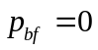.
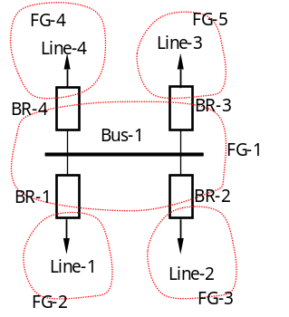 | 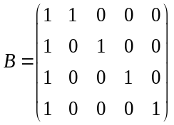
Fig. 6: Single breaker single bus substation and its B-matrix

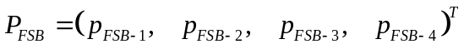 (7)
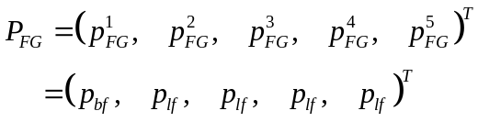 (8)
(9)
With D, B, P_{FG} known, the probabilities of all the stuck breaker contingencies can be calculated by
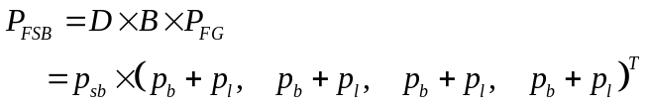 (10)
The total probability of having a fault plus stuck breaker contingency in the SB-SB substation is ∑P_{FSB-i}=4×p_{sb}×p_{lf}.

    - Ring Bus
This configuration is simple and straightforward too. From Fig. 7 there are a total of four functional groups and four breakers. The B-matrix representing the connectivity of the four functional groups is shown in the right side of Fig. 7. With this ring bus configuration, any stuck breaker failure will outage at most two lines. The functional group fault probability is calculated as from equation (12), assuming the failure probability of bus.

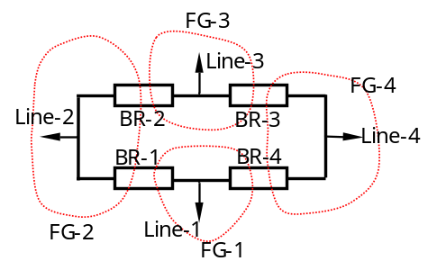 | 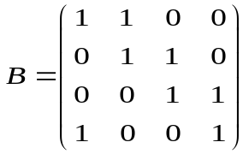
Fig. 7: Ring bus substation and its B-matrix
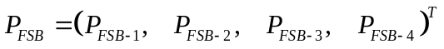 (11)
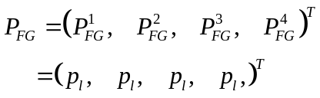 (12)
(13)
With D, B, P_{FG} known, the probabilities of all the stuck breaker contingencies can be calculated by
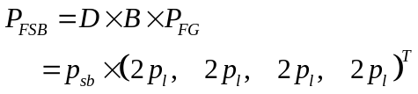 (14)
The total probability of having a fault plus stuck breaker contingency for the ring bus station is ∑P_{FSB-i}=8×p_{sb}×p_{lf}.

    - Single Bus Connected with Tie Breaker (SB-TL)
This configuration SB-TL in Fig. 8 is adapted from SB-SB by splitting the bus and adding a tie-breaker between the two buses. When breakers 1-4 get stuck, only two lines will be lost at most. Note we assume Bus-1 and Bus-2 will never have a fault (p_{sb}=0), so it does not matter whether Breaker-5 gets stuck or not. The B-matrix representing the connectivity of the four functional groups is shown in the right side of Fig. 8. The functional group fault probability is calculated as from (16), assuming the failure probability of bus.
(15)
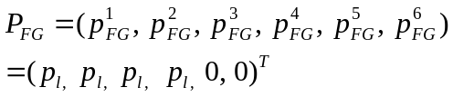 (16)
(17)
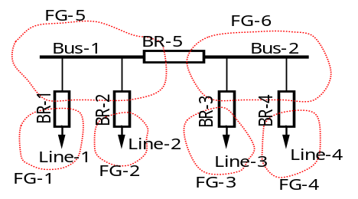 | 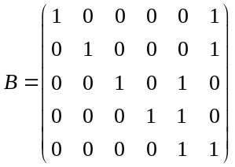
Fig. 8: Single bus connected with tie breaker and its B-matrix
With D, B, and P_{FG} known, the probabilities of all the stuck breaker contingencies can be calculated by
(18)
The total probability of having a fault plus stuck breaker contingency for the SB-TL substation is ∑P_{FSB-i}=4×p_{sb}×p_{lf}.
    - Double Breaker and Double Bus (DB-DB)
The configuration of DB-DB is shown in Fig. 9, and there are a total of six functional groups and eight breakers, much more than other types of substations. The B-matrix representing the connectivity of the four functional groups is shown in the right side of Fig. 9. With this DB-DB configuration, any stuck breaker failure will outage at most one line. The functional group fault probabilities are calculated from (20), assuming the failure probability of bus.
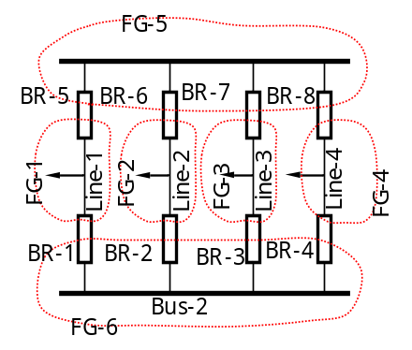 | 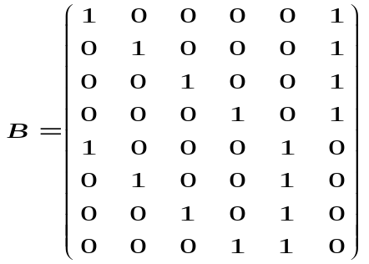
Fig. 9: Double breaker and double bus and its B-matrix
(19)
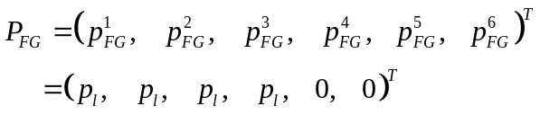 (20)
(21)
With D, B, P_{FG} known, the probabilities of all the stuck breaker contingencies can be calculated by
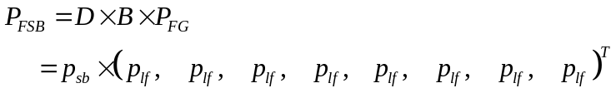 (22)
The total probability of having a fault plus stuck breaker contingency for DB-DB substation is ∑P_{FSB-i}=8×p_{sb}×p_{lf}. Among all fault plus stuck breaker contingencies, none of them involves more than one line.

    - Breaker and a Half Bus (B-HB)
The configuration of B-HB is shown in Fig. 10, having a total of six functional groups and six breakers. The B-matrix representing the connectivity of the four functional groups is shown in the right side Fig. 10. With this B-HB configuration, any stuck breaker failure will outage at most two lines. The functional group fault probabilities are calculated as from equation (24), assuming the failure probability of bus.

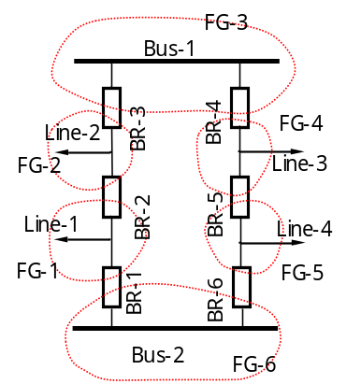 | 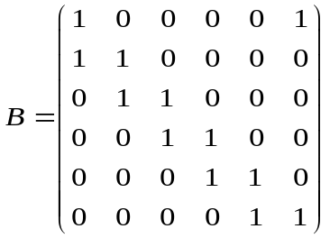
Fig. 10: Breaker and a half bus and its B-matrix

(23)
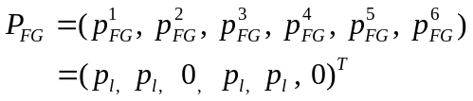 (24)
(25)

With D, B, P_{FG} known, the probabilities of all the stuck breaker contingencies can be calculated by
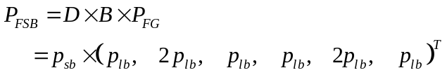 (26)

The stuck of breaker 2 and breaker 5 will cause the removal of two lines while other breaker stuck will cause the outage of only one line. The probability of having a fault plus stuck breaker contingency is ∑P_{FSB-i}=8×p_{sb}×p_{lf}. Among all fault plus stuck breaker contingencies, only the stuck of breaker 2 or breaker 5 could involve more than one line.
- High-order Contingencies due to inadvertent tripping
Inadvertent tripping after an initial fault or failure often leads to higher order contingencies. Inadvertent tripping generally occurs in the vicinity of the initial fault. So it is assumed that only line or functional group connected to the initial contingent functional group or line will suffer inadvertent tripping. If there is more than one functional group that can suffer inadvertent tripping than it is assumed that they are disjoint or in other words only one of then can suffer inadvertent tripping at a time. We have no information of more than one simultaneous inadvertent trippings from the open literature. However without extra effort one can extend the equations developed below to take that into account in case the situation demands. A systematic methodology for the probability calculation of inadvertent tripping is developed and illustrated through five substation topology discussed above.
The total probability of an inadvertent tripping contingency (ITC) involving line and line can be calculated by
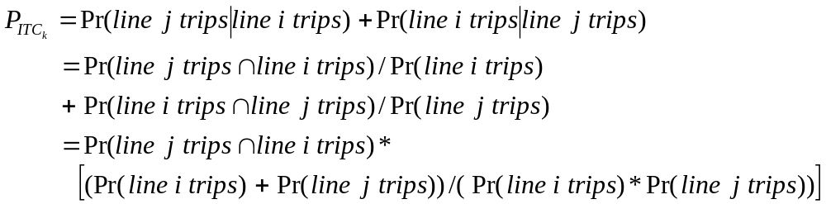 (27)

Assuming that the probability of failure/fault to be same for each line. Let
: fault probability of line. It is assumed to be the same (denoted as) for all transmission lines;
Therefore
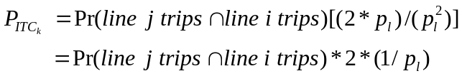 (28)
The result generalized in terms of the functional group concept discussed earlier. Let us consider two functional groups represented by FG-i and FG-j. The probability that a functional group FG-i is tripped due to failure of a component can be calculated as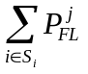, where the elements of are the indices of all the components in functional group. The probability that a functional group is tripped due to fault can be calculated as 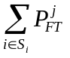 in the same way.
The probability of an ITC due to failure that involved FG- and FG- can be calculated by
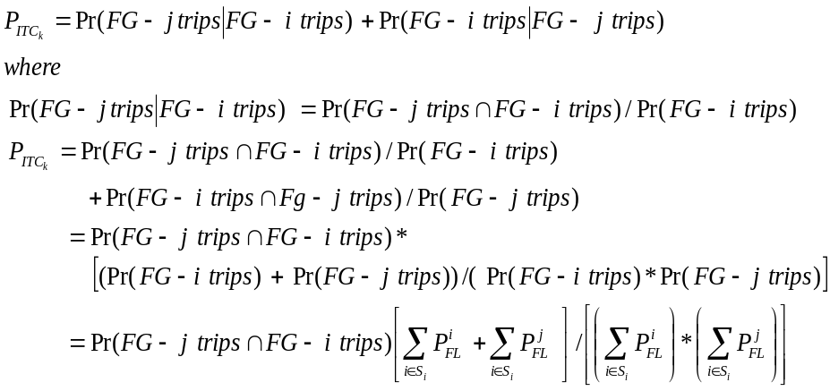 (29)
Similarly the probability of an ITC due to fault that involved FG- and FG- can be calculated by
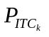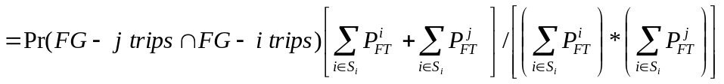 (30)
In the above case it was considered that there is a possibility of only one additional functional group suffering inadvertent tripping. When there are more functional groups which can trip inadvertently then one can similarly find an expression of the total probability by conditioning on each functional group sequentially and adding their probabilities. For example when the failure of one can initiate inadvertent tripping of either of the two then the expression for total ITC probability will look like
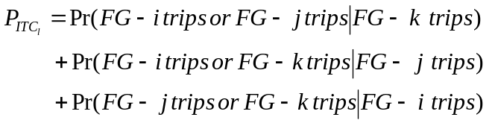 (31)

Generalized form for Inadvertent Tripping Contingency
In this section a generalized method from the system topology to find the total probability of ITC after an initial contingency is developed. As it was discussed above, the power system can be represented as an undirected graph with functional groups as the vertices and the interfacing elements as the edges. The graph search algorithm developed enables identification of the interconnections between functional groups. The methodology will be illustrated with the example of the power system shown in Fig. 2 and the result generalized. For the power system shown in Fig. 2, the result of the graph search is summarized in Table 5. Each column in the table corresponds to a functional group, while each row corresponds to an interfacing component. There are two ones in each row, which indicate the interfacing component joining the two corresponding functional groups. The rest of the elements are all zeros. The is represented as the incidence matrix in equation 1 which is reproduced below

Error! Objects cannot be created from editing field codes. (32)
The new matrix 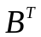in equation 33 is obtained by taking the transpose of the matrix B in equation 1
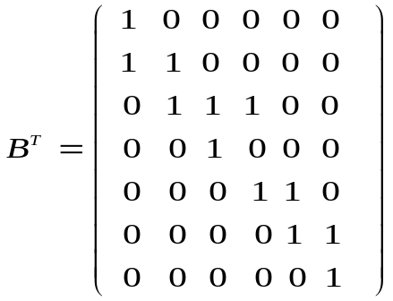 (33)
Each column in equation 33 corresponds to an interfacing component, while each row corresponds to a functional group.
(34)
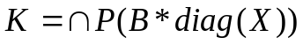 (35)
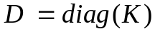 (36)
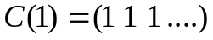 (37)
where C(1) is the unit column matrix of order (1*7), 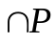is the joint probability of failure of the functional groups in each row of the matrix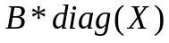 which can be approximately calculated from the outage data base available in the utilities for past many years.
Then all the equations in (30) and (31) can be summarized in the matrix form as

(38)
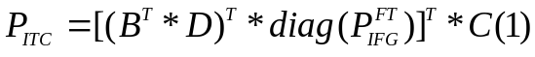 (39)
where 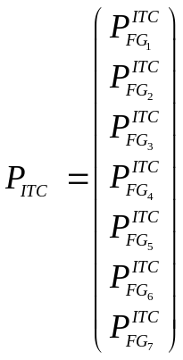 (40)
and 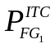is the total probability of ITC given the fault/ failure in functional group 1. It is assumed that 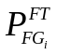 is not identically equal to zero. In other words it is not a bus section. The case where 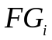 is a bus section is discussed as a special case below.
Equation (39) is the general formula for any power system whose topology is known in terms of the switching elements and components of the functional group. So for the power system example in Fig. 2 the ITC probability for each functional group can be calculated as below.
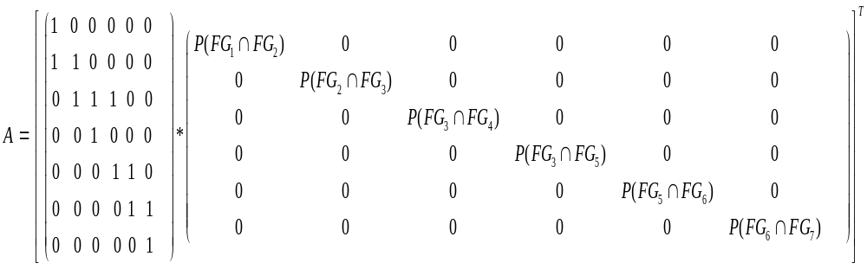

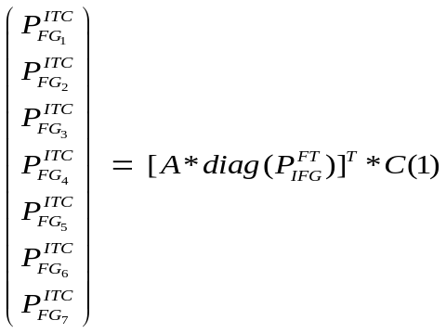 (41)
In the same way the ITC can be found for any power system once the functional groups are identified. With the changing topology of the power system the functional groups can be identified in an updating mode and continuous tracking of increased ITC probability can be very useful in real time operations.
Special Case
When all the functional group(s) connected by the interfacing element(s) of the failed or faulted functional group contains/contain only bus sections as their components then all the functional groups connected to these bus sections will have equal probability to suffer inadvertent tripping. This special case is incorporated by modifying the matrix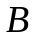. The modified matrix is obtained by subtracting the column corresponding to the faulted functional group from the sum of the columns of the functional groups connected to the faulted functional group through the interfacing elements of the faulted functional group. In the next step the columns corresponding to the functional groups connected to the faulted functional group are made zero. To find the ITC corresponding to this special case only the transpose of the column corresponding to the faulted functional group in thematrix is needed. This gives the ITC probability of the functional group which is connected only to the bus section through all interfacing elements. From practical experience the probability of a fault in a bus section is once in a lifetime and is ‘almost zero’ compared to other components fault probability. Thus the probability of bus fault is assumed to be zero. Similarly the probability of simultaneous outage of two functional groups where one of the functional group is a bus section is zero. Hence the ITC probability for a initial contingency on a bus section is zero and is not calculated.
Although the equations above give a concise mathematical form to calculate the probability of inadvertent tripping contingencies, it depends on the availability of matrix B, which is not easy to obtain. In addition, the size of B is very large and sparsity technology has to be used to handle it efficiently. Other matrix operations in case of a functional group connected only to the bus sections through the interfacing elements are memory intensive. However, a computer algorithm is developed to search for functional groups, its components, the interfacing elements and to get the ITC without formulating the B matrix.
In the next section the probability calculation for the typical substation topologies are illustrated directly from the topology and with the help of the formula developed. This will illustrate the effectiveness of the concise formula developed for a large system where it is not easy to enumerate all the different possibilities easily. A systematic method is indispensable for a large system.
Probability calculation illustration for the Typical Substation Topologies

    - Ring Bus
This configuration is simple and straightforward. From Fig. 11 there are a total of four functional groups and four breakers. In this simple configuration from the topology it is evident that a fault on a single line can trigger inadvertent tripping on either of the two lines connected to the same bus through an electrical distance of one breaker. For illustration purposes it is assumed that the fault occurs on line 3 or FG-3 and is tripped correctly.
Fig. 11: Ring bus substation with B matrix

Now one of the two functional groups FG-2 or FG-4 can trip inadvertently. The functional group fault probability is calculated as in equation (12), and assuming the failure probability of bus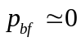. So the probability of ITC contingency when FG-3 trips is
(42)
Since the inadvertent tripping of any of the functional groups is independent of each other and assuming they are disjoint the above expression becomes.
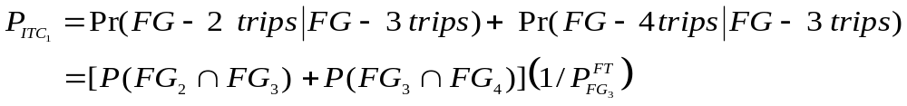 (43)
The ITC probability calculations using equations (34)-(40) are also shown below. 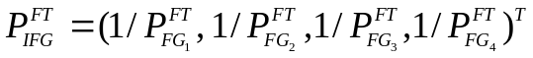 (44) (45)
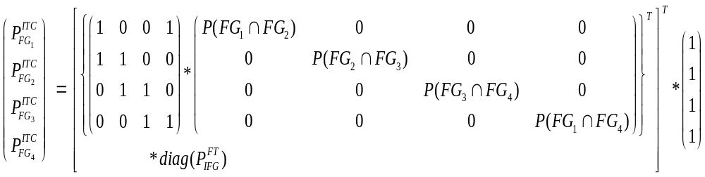
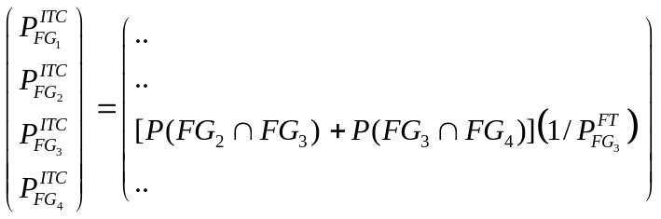 (46)
Which is same as obtained from the topology in equation 43.

    - Breaker and a Half Bus (B-HB)
The configuration of B-HB is shown in Fig. 12, having a total of six functional groups and six breakers. In this simple bus configuration a fault on a single line can trigger inadvertent tripping on only lines connected between the same pair of buses through an electrical distance of one breaker and on the same side. For illustration purposes it is assumed that the fault occurs on line 3 or FG-4.
Fig. 12: Breaker and a half bus
Now only FG-5 can trip inadvertently which is on the same side as FG-4 and between the same pair of buses. The functional group fault probabilities are calculated as from equation (24), assuming the failure probability of bus.
So the probability of ITC contingency when FG-4 trips
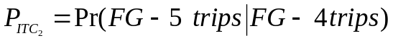 (47)
= 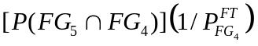
Now from equations (34)-(40) the corresponding equations for a breaker and half are as follows
(48)
Where 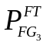and 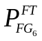are zero. But all the terms of the form 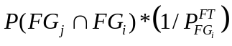are zero where i = 3, 6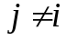.
(49)
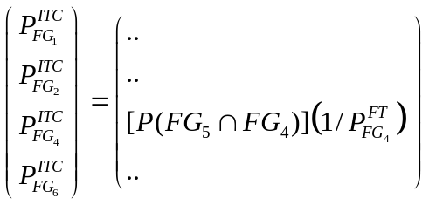 (50)
Which is same as calculated from the topology. In the final expression the terms 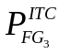and 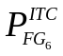are not included because they are bus sections and ITC corresponding to them is zero as explained earlier.

    - Single Bus Connected with Tie Breaker (SB-TL)
This configuration SB-TL in Fig. 13 is adapted from SB-SB by splitting the bus and adding a tie-breaker between the two buses. From the topology it is evident that a fault on a single line can trigger inadvertent tripping on only lines connected to the same bus through an electrical distance of one breaker and on the same side of the tie breaker. For illustration purposes it is assumed that the fault occurs on line 1 or FG-1.
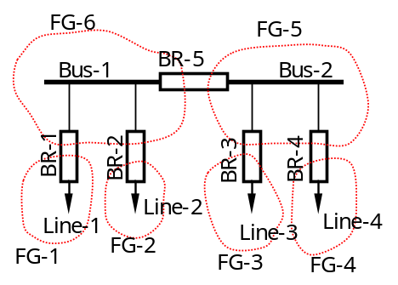
Fig. 13 Single bus connected with tie breaker and its B-matrix

So now only FG-2 can trip inadvertently. The functional group fault probability is calculated as in (16), assuming the failure probability of bus.
So the probability of ITC contingency when FG-1 trips is
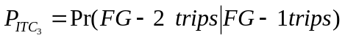 (51)
= 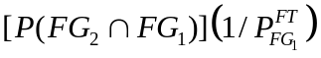
Now from equations (34)-(40) the corresponding equations for this configuration are as follows
(52)
Where 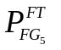and are zero. But all the terms of the form are zero where i = 5, 6.
(53)
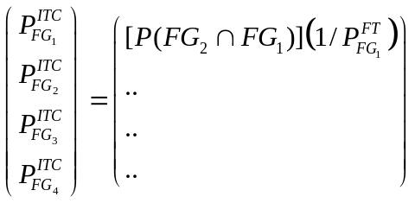 (54)
Which is same as calculated from the topology. In the final expression the terms 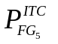and are not included because they are bus sections and ITC corresponding to them is zero as explained earlier

    - Single Breaker and Single Bus (SB-SB)
In this simple configuration in Fig. 14 a fault on a single line can trigger inadvertent tripping on any one of the remaining three lines since all are connected to the same bus through an electrical distance of one breaker. For illustration purposes it is assumed that the fault occurs on line 3 or FG-3.

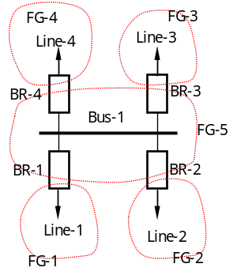 | 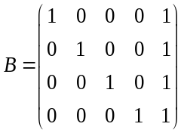
Fig. 14: Single breaker single bus substation and its B-matrix

Now one or more of the remaining functional groups can trip inadvertently. The functional group fault probability, which is the summation of the fault probability of each component in the functional group, is calculated from equation (8), assuming the failure probability of bus. So the probability of ITC contingency when FG-3 trips is
(55)
Since the inadvertent tripping of any of the functional groups is independent of each other and assuming they are disjoint the above expression becomes.
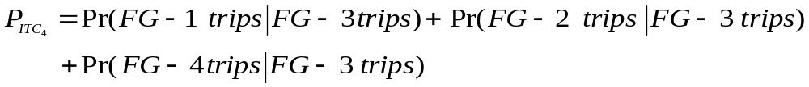 (56)
(57)
This configuration falls under the category of special case where the faulted functional group is connected only to a bus section. So to calculate its ITC probability through equations (34)-(40) the matrix B is modified as explained earlier. So in this case the B matrix for ITC probability of FG-3 becomes
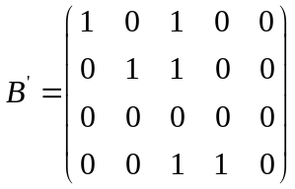 (58)
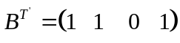 row corresponding to FG-3 (59)

(60)
where is zero. But all the terms of the form are zero where i = 5 and.
(61)
(62)
Which is same as calculated from the topology. In this configuration all the non bus section functional groups are connected only to the bus section and ITC is calculated similarly for each of them.

    - Double Breaker and Double Bus (DB-DB)
The configuration of DB-DB is shown in Fig. 15 , and there are a total of six functional groups and eight breakers, much more than other types of substations. In this configuration a fault on a single line can trigger inadvertent tripping on any one of the remaining three lines since all are connected to the same bus through an electrical distance of one breaker. For illustration purposes it is assumed that the fault occurs on line 1 or FG-1. The functional group fault probabilities are calculated from (20), assuming the failure probability of bus.
Fig. 15: Double breaker and double bus and its B-matrix
So the probability of ITC contingency when FG-1 trips is
(63)
Since the inadvertent tripping of any of the functional groups is independent of each other and assuming they are disjoint the above expression becomes.
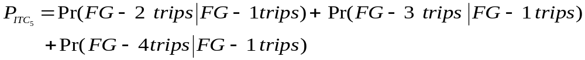 (64)
(65)
This configuration is similar to SB-SB in that the faulted functional groups are connected only to functional groups containing a bus section. So to calculate its ITC probability the matrix B is modified as explained earlier. So in this case the B matrix for ITC probability of FG-1 becomes
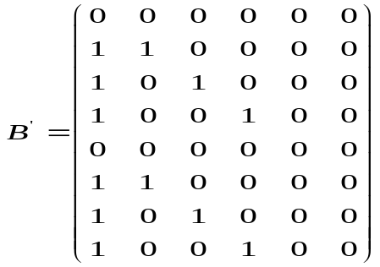 (66)
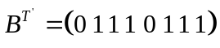 row corresponding to FG-1 (67)
(68)
Where and are zero. But all the terms of the form are zero where i = 5, 6 and.
(69)
(70)
This is twice as calculated from the topology. This makes sense since both the functional groups connected to the faulted functional group are in turn connected to same set of functional groups. And with large number of breakers, relays and overlapping zones of protection, along with advantages comes disadvantages of higher likelihood of misoperation or inadvertent tripping. So ITC probability after an initial contingency is higher than expected. Similarly the ITC probabilities for other non bus section functional groups are computed.
Table 6 gives a summary of the topological analysis results for higher order stuck breaker and inadvertent tripping contingencies. In Table 6 the smallest ITC probability (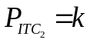) is much smaller than the smallest stuck breaker contingency probability (4×p_{sb}×p_{lb}).

Table 6: The probability of high-order contingency for different substations
Substation  Type | Prob.  (Fault plus Stuck  breaker) | Prob.  (Fault plus ITC) | number of breakers |  | Fault plus stuck breaker  Contingency set
SB-SB | 4×p_{sb}×p_{lb} | 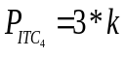 | 4 |  | FG₁ and FG₅ , FG₂ and FG₅, FG₃ and FG₅ , FG₄ and FG₅
Ring Bus | 8×p_{sb}×p_{lb} | 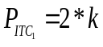 | 4 |  | FG1 and FG2, FG2 and FG3, FG3 and FG4, FG4 and FG1
SB-TL | 4×p_{sb}×p_{lb} | 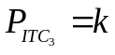 | 5 |  | FG1 and FG5, FG2 and FG5, FG5 and FG6, FG3 and FG6, FG4 and FG6
DB-DB | 8×p_{sb}×p_{lb} | 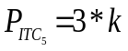 | 8 | FG1 and FG5, FG2 and FG5, FG3 and FG5, FG4 and FG5, FG1 and FG6, FG2 and FG6, FG3 and FG6, FG4 and FG6
B-HB | 8×p_{sb}×p_{lb} |  | 6 |  |  | FG1 and FG2, FG2 and FG3, FG3 and FG4, FG4 and FG5, FG5 and FG6, FG6 and FG1
- Conclusion

This report documents the research carried out at Iowa State University on developing a systematic method for computing probability order of different contingencies as a function of the switch-breaker data commonly available within the EMS. In many decision problems, knowledge of the “probability orders” of the significant events is sufficient to distinguish between alternatives because probability order is a reasonable measure of event’s probability. Rare event approximations (Appendix A) unpin the selection of high order contingencies for online security assessment. This makes sense because the probability of a compound event is dominated by lowest order terms.
Five substation configurations, including single-bus connected with bus tie, ring bus, double breaker-double bus, single breaker-single bus, and breaker and a half are used in the illustrations of the probability calculation approach developed for N-k (k>2 implied) contingencies and the results are summarized in Table 6.
The methodology developed for probability calculation is simple and needs no extra information other that switch-breaker data which is available in most control centers. The approach can be used in an updating mode with the changes in the topology of the system, taking into consideration of the changes in the status of the switch-breaker which normally results in formation of one or more new functional groups or merging into smaller number of functional groups. Thus continuous tracking of system topology generates the higher order contingencies based on probability order for online security assessment.

APPENDIX A

Rare Event approximation

Suppose p₁, p₂, …, p_{n} are the individual probabilities of a group of independent events E₁, E₂, ...E₃. The probability of a compound event, i.e., a combination of events E₁, E₂, …, E_{n}, can always be expressed as a polynomial of p₁, p₂, …, p_{n}. For example, the probability of the event (E₁∩ E₂)∪E₃ is p₃+p₁p₂-p₁p₂p₃ Further suppose that p₁, p₂, …, p_{n} are all of approximately the same order of magnitude, then the order of magnitude of each product term in the polynomial will depend on how many terms are in the product. We call the number of terms in the product the probability order. Thus, the probability of (E₁∩E₂)∪E₃ is composed of three different terms p₃ (probability order 1), p₁p₂ (probability order 2), and p₁p₂p₃ (probability order 3). In many decision problems, knowledge of the “probability orders” of the significant events is sufficient to distinguish between alternatives.
The basic idea of rare event approximation is that, if the individual probabilities of a group of independent events are very small, we can always simplify the calculation by omitting the higher order terms of the polynomial without much loss of precision [13]. In the given example, if we knew that p₁, p₂, and p₃ were very small, then the probability of (E1 ∩ E2)∪E3 could be approximated as p₃+p₁p₂, or even as p₃.
Often, the failure probability of an individual component is very small for a well-managed system such as a power system. The fault probability of a power system component is usually at the magnitude of 10⁻⁶ per hour (or <1% per year) [18]. Suppose the fault probability of a line is p₁ per hour and the failure probability of a breaker is p₂/hour. Obviously, they are not exclusive events. The probability of a fault (p₁), breaker in a failed state (p₂), or both can be expressed as p₁+p₂-p₁p₂, assuming the two events are independent. Considering the small nature of p₁ and p₂, if we ignore the probability component of simultaneous occurrence of the two events, the error is only about 10⁻¹².
The implication is that when dealing with rare events, the probability of a compound event is dominated by the lowest order terms, and thus the probability order is a reasonable measure of event’s probability.
Based on this idea, we focus on the high order events with higher probability first, then lower probability, since, as the order of contingency increases, the probability of its occurrence decreases sharply to infinitesimal. A complete discussion of rare event systems can be found in [13].

APPENDIX B
Pseudo Code for graph search algorithm For Functional Group decomposition

This is a Breath-first search algorithm.

- Beginning of decomposition;
- Label all components (bus section, non switching components (lines, capacitors, generators, transformers etc),switching components ( switches, breakers etc) as unvisited;
- Arbitrarily choose one unvisited vertex (bus section) as a starting component;
- Initialize functional group and bus indices;
- Establish a new empty functional group object without any component in it;
- Add the chosen bus section to the functional group object as its first component;
- Starting from this vertex, merge the functional group's immediate neighboring components (lines, capacitors, generators, transformers and other non switching components) into the group and label them as visited;
- The step 2 continues until the group expands to its border, where the bordering components are all switching components (breakers and open switches);
- If all components in the power system are visited, stop searching and go to the last step; else choose another unvisited bus section and return to step 2 all over again;
- End of decomposition.
REFERENCE

- P. Jian, J. McCalley, “On-line analysis of high-order contingencies,” in Proc. North Amer. Power Symp., Oct. 15-16, 2001, pp. 297-302
- Allen J. Wood, Bruce F. Wollenberg, “Power generation, operation and control,” John Wiley & Sons, Inc., 1996
- A. O. Ekwue, “A review of automatic contingency selection algorithms for online security analysis,” The Third International Conference on Power System Monitoring and Control, pp 152-155, June 26-28, 1991
- R. N. Allan, A. N. Adraktas, “Terminal effects and protection system failures in composite system reliability evaluation,” IEEE Transactions on Power Apparatus and Systems, Vol. PAS-101, No. 12, pp 4557-4562, Dec. 1982
- R. Billinton, T. K. P. Medicherla, “Station originated multiple outages in the reliability analysis of a composite and transmission system,” IEEE Transactions on Power Apparatus and Systems, Vol. PAS-100, No. 8, pp 3870-3878, Dec. 1982
- R. Billinton, P. K. Vohra, Sudhir Kumar, “Effect of Station originated outages in a composite system – adequate evaluation of the IEEE reliability test system,” IEEE Transactions on Power Apparatus and Systems, Vol. PAS-104, No. 10, pp 2649-2656, Oct. 1985
- A. G. Phadke, J.S. Thorp, “Expose hidden failures to prevent cascading outages in power systems,” IEEE Comput. Appl. Power, vol. 9, no. 3, pp. 20-23, Jul. 1996.
- D. C. Elizondo, J. de La Ree, A. G. Phadke, S. Horowitz, “Hidden failures in protection systems and their impact on wide area disturbances,” in Proc. IEEE power Eng. Soc. Winter Meeting, vol. 2, 28 Feb. 2001, pp. 710-714
- Qiming Chen, “The probability, identification and prevention of rare events in power system” PhD Thesis, ECE, Iowa State University, 2004
- McCalley, J.D.; Vittal, V.; Abi-Samra, N., “An overview of risk based security assessment,” IEEE Power Engineering Society Summer Meeting, Vol. 1 ,pp 173-178, 1999
- Mohammad Modarres, Mark Kaminskiy, Vasiliy Krivtsov, “Reliability Engineering and Risk Analysis,” Marcel Dekker, Inc., 1999
- Arnljot Hoyland, Marvin Rausand, “System Reliability Theory Models and Statistical Methods,” John Wiley & Sons, Inc., 1994
- W.A. Thompson, Jr., “Point Process Models with Applications to Safety and Reliability,” Chapman and Hall, 1988
- J. Lewis Blackburn, “Protective relaying, principles and applications,” Marcel Dekker, Inc., 1987
- NERC (North American Reliability Council) Disturbance Analysis Working Group Database, “http://www.nerc.com/~dawg/database.html,” 1984-2001
- Xiumu Li, “Introduction to Graph Theory”, Publishing House of Huazhong Institute of Technology, China, 1986
- Harary, F., Graph Theory. Reading, MA: Addison-Wesley, 1994
- Probabilistic Methods Work Group, WSCC Reliability Subcommittee, “Probabilistic Based Reliability Criteria Phase I: Event Probability Development and Implementation Plan,” June 25, 1998

