HEIDELBERG INSTRUMENTS User Guide: PART II
Reference Manual

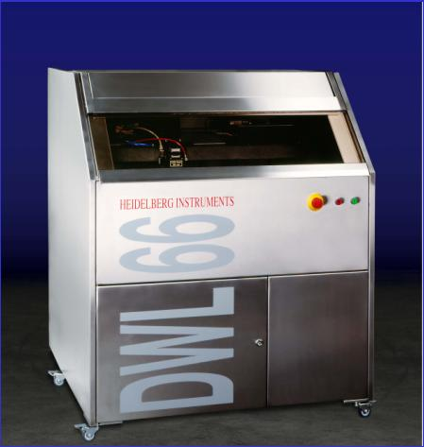
DWL 66

Copyright Notice

© Copyright Heidelberg Instruments Mikrotechnik 2002

TABLE OF CONTENTS

RELATED DOCUMENTATION………………………………………………….......... | 14
IF YOU NEED ASSISTANCE………………………………………………….............. | 14
CHAPTER 1 – MAIN MENU…………………………………………….....……. | 15
INTRODUCTION………………………………………………………………....……. | 15
File………………………………………………………………………..…………….. | 16
Job…………………………………………………………………….……………….. | 16
View…………………………………………………………………….……………… | 16
Setup………………………………………………………………….……………….. | 16
Measure…………………………………………………………….……………….... | 16
Tools…………………………………………………………………...……………….. | 16
Service……………………………………………………………….………………... | 16
Help………………………………………………………………….……………….... | 17
CHAPTER 2 – FILE MENU……………………………………….......…………… | 18
DESIGN DATA………………………………………………...………………...…….. | 18
INTRODUCTION………………………………………………………………...…….. | 18
DESIGN DATA BUFFERS BUTTONS………...………………………………........….. | 19
Convert.cfg........................................................................................................... | 19
Expose.cfg........………………………………………………………………………. | 19
Refresh..........................…………………………………………….......................... | 19
To Job......……..........……………………………………………………………….… | 19
Cancel...................…………………………………………………………………… | 19
ENVIRONMENT FILES…………………………………………………………............ | 20
INTRODUCTION..……………………………………………………..………………. | 20
ENVIRONMENT FILES UNDER FILE COMMANDS…………………......………..... | 21
Job File...............................................................…………………...………………. | 21
Map File...……………………………………………………………………………... | 21
Field Alignment.....................……………………………………………………….. | 21
CHAPTER 3 – JOB CONTROL……………………………......……………...… | 22
EXPOSURE CONTROL COMMANDS………………………….....……………...… | 22
JOB COMMANDS……………………………………………….…………………… | 22
Make Job................………………………………………………………………….. | 22
Run Job.................................................................................................................. | 22
EXPOSURE MAPS………………………………………………………………....…... | 23
EXPOSURE MAP DISPLAY…………………………………………………....……… | 23
MAP COMMANDS……….…………………………………………........................ | 24
Select Fields.......................................................................................................... | 24
Clear Fields…………………………………………………..................................... | 24
Show Positions........………………………………………………………………...... | 24
Jump Positions………………………………………………………......................... | 24
MAP – SCALE COMMANDS………………………………………………………... | 24
Automatic………………………………………………………................................ | 24
EDIT JOB……………………………………………………....................................... | 25
INTRODUCTION..............................................……………………………………... | 25
FORMAT OF THE JOB FILE………………………………………………………....... | 26
COLUMNS…………………………………………………………............................ | 26
Field................................................………………………………………………..... | 26
do.......................................…………………………………………………………... | 26
Ali...................…………………………………………………………………………. | 26
Xoff....................................………………………………………………………….... | 27
Yoff............…………………………………………………………………………….. | 27
LicBuf.............................…………………………………………………………….... | 27
Defoc...................................…………………………………………………………. | 28
Energy…………………………………………………………………………............ | 28
Command......……………………………………………………………………… | 28
EDIT JOB – FILE COMMANDS………………………………………………............. | 29
New……………………………………………………………………………............. | 29
New Map......…………………………………………………………………………. | 29
Open................……………………………………………………………………….. | 29
Save……………………………………………………………………....................... | 29
Save As……………………………………………………………………………....... | 29
Exit.....................................………………………………………………………….... | 29
EDIT JOB – EDIT COMMANDS…………………………………………………….... | 30
Cut, Copy, Paste…………………………………………………………………... | 30
Fill Down……………………………………………………………......................... | 30
Fill Marked............................................................................................................. | 30
Formula Fill Marked………………………………………………......................... | 30
Replace........…………………………………………………………………............ | 30
Set Marks…………………………………………………………............................. | 30
Set Marks Conditionally…………………………………………………………… | 31
Remove Marks…………………………………..…….......................................... | 31
LISTS AND BUTTONS……………………………………......................................... | 31
Use…………............…………………………………………………………………... | 31
EXPOSE………………………………………..............................…………………... | 32
INTRODUCTION……………………………………………………………………..... | 32
EXPOSE – BUTTONS...............................………………………………………......... | 32
Load..................................................................…………………………………..... | 32
Focus……………………………….......…………………………………..…............. | 32
Find Center..………………………………………………………………………….. | 33
Manual Align...................…………………………………………………………… | 33
Center Stage...........……………………………………………………………….. | 33
Auto Align.............................................................................................................. | 33
Set X=0, Y=0......................................……………………………………………...... | 33
Expose.................................................................................................................... | 33
Measure................................................................................................................. | 34
Test Align…………………………………………………………………………….. | 34
Unload.......................…………………………………….............……………….... | 34
Edit Report…………………………………………………………………………... | 34
Exit...........................................................………………………………………….... | 34
OPTIONAL CHECKMARK FUNCTIONS………………………………………...... | 35
Auto Unload…………………………………………………................................. | 35
Job Log…………………………………………………………………................... | 35
CHAPTER 4 – JOB SETUP…………………………………………………......... | 36
SETUP COMMANDS……………………………………………………………........ | 36
New................................……………………………………………………………... | 36
Exposure Map................…………………………………………………………….. | 36
Simple Cross Alignment..………………………………………………………..... | 36
Field Alignment Method…………………………………………………….......... | 36
Test Field Alignment…………………………………………………….................. | 36
Define Template.................……………………………………..………………….. | 36
NEW EXPOSURE MAP............................................................................................ | 37
INTRODUCTION……………………………………………………………………..... | 37
NEW EXPOSURE MAP BUTTONS……………………………..……………….......... | 38
Create Map...........................................................………………………………... | 38
Remove Map............................…………………………………………………….. | 38
Edit File.......……………………………………………………..…………………...... | 38
Delete File.......…………………………………………………..………………….... | 38
Set Environment......……………………………...………………………………….. | 38
EXPOSURE MAP DESIGN…………………………..……………………………....... | 39
INTRODUCTION....................………………………………………………………... | 39
EXPOSURE MAP DESIGN BUTTONS……......…………………………………........ | 40
New..................................……………………………………………………………. | 40
Draw.........................…………………………………………………………………. | 40
Exit............................………………………………………………………………….. | 40
SIMPLE CROSS ALIGNMENT………..........................................…………….......... | 41
FIELD ALIGNMENT METHODS................................................................................ | 42
INTRODUCTION..................................................................................................... | 42
FIELD ALIGNMENT PROCESS................................................................................ | 43
MACRO LANGUAGE FUNCTIONS....................................................................... | 43
Camera................................................................................................................. | 43
Delay...................................................................................................................... | 43
Manual Alignment............................................................................................... | 43
Alignment to a Vertical Line............................................................................... | 44
Alignment to a Cross-by Outline........................................................................ | 44
Alignment to a Horizontal Line........................................................................... | 44
Focus Offset........................................................................................................... | 44
Camera Gain........................................................................................................ | 45
Lamp Intensity....................................................................................................... | 45
Move in X Absolute.............................................................................................. | 45
Move in X and Y Absolute.................................................................................. | 45
Move in Y Absolute.............................................................................................. | 45
Move in X Relative............................................................................................... | 45
Move in X and Y Relative.................................................................................... | 45
Move in Y Relative............................................................................................... | 46
Camera Offset...................................................................................................... | 46
Alignment to a Cross-by Video Profiles............................................................. | 46
Alignment Using A Template.............................................................................. | 46
Example Using Macro Language Functions.................................................... | 47
EDIT BUTTONS......................................................................................................... | 48
Use.......................................................................................................................... | 48
Cam....................................................................................................................... | 48
Here........................................................................................................................ | 48
Pos.......................................................................................................................... | 48
Cut.......................................................................................................................... | 48
Paste....................................................................................................................... | 48
Insert....................................................................................................................... | 49
Next........................................................................................................................ | 49
TEST BUTTONS......................................................................................................... | 49
Execute Line.......................................................................................................... | 49
Execute Site........................................................................................................... | 49
Test.......................................................................................................................... | 49
Exit........................................................................................................................... | 49
TEST FIELD ALIGNMENT.......................................................................................... | 50
INTRODUCTION..................................................................................................... | 50
MANUAL MODE.................................................................................................... | 51
Prepare.................................................................................................................. | 51
1, 2, 3, 4.................................................................................................................. | 51
Test Here................................................................................................................ | 51
Refresh................................................................................................................... | 51
RESULT ANALYSIS.................................................................................................. | 52
Nominal Positions.................................................................................................. | 52
Measured Positions.............................................................................................. | 52
Deviation............................................................................................................... | 52
Previous Measurement........................................................................................ | 52
Repeatability......................................................................................................... | 52
DEFINE TEMPLATE................................................................................................... | 53
INTRODUCTION..................................................................................................... | 53
DEFINE TEMPLATE BUTTONS.................................................................................. | 54
Load Template from File..................................................................................... | 54
Box Position............................................................................................................ | 55
Box Size................................................................................................................... | 55
Save Template in IPC.......................................................................................... | 55
Test Template........................................................................................................ | 55
Show Template..................................................................................................... | 55
Save Template on File......................................................................................... | 56
Template #............................................................................................................ | 56
Fit Level.................................................................................................................. | 56
Fit Level Save........................................................................................................ | 56
FIND MANUAL........................................................................................................ | 57
INTRODUCTION..................................................................................................... | 57
FIND MANUAL WINDOW...................................................................................... | 58
Mouse and Fine Adjust........................................................................................ | 58
Panel...................................................................................................................... | 58
Auto........................................................................................................................ | 58
Cancel................................................................................................................... | 58
OK........................................................................................................................... | 59
CHAPTER 5 – METROLOGY............................................................................ | 60
METROLOGY COMMANDS................................................................................. | 60
Overlay.................................................................................................................. | 60
Distance................................................................................................................. | 60
Positions.................................................................................................................. | 60
Linewidth............................................................................................................... | 60
Pitch, Stitching, Edge........................................................................................... | 60
OVERLAY MEASUREMENTS................................................................................... | 61
INTRODUCTION..................................................................................................... | 61
LARGE BOX in BOX METHOD............................................................................... | 61
SMALL BOX in BOX METHOD............................................................................... | 61
OVERLAY MEASUREMENTS – FILE COMMANDS................................................ | 62
Load....................................................................................................................... | 62
Save Measurement.............................................................................................. | 62
Exit........................................................................................................................... | 62
OVERLAY MEASUREMENTS – RESULTS COMMANDS......................................... | 63
View and Save..................................................................................................... | 63
To Excel.................................................................................................................. | 63
MODELS................................................................................................................. | 63
Large Box in Box-X................................................................................................ | 63
Large Box in Box-Y................................................................................................ | 63
Box in Box-XY Model1.......................................................................................... | 64
Box in Box-XY Model2.......................................................................................... | 64
OVERLAY MEASUREMENTS BUTTONS.................................................................. | 64
Set Up..................................................................................................................... | 64
Example of an Overlay Measurements Method............................................. | 65
Relative To............................................................................................................. | 65
Measure................................................................................................................ | 65
Results (Text Box)................................................................................................... | 65
DISTANCE MEASUREMENTS.................................................................................. | 66
INTRODUCTION..................................................................................................... | 66
DISTANCE MEASUREMENT BUTTONS................................................................... | 67
Set Up Measurement........................................................................................... | 67
Goto Site 1............................................................................................................. | 67
Goto Site 2............................................................................................................ | 67
Repeat Measurement # times........................................................................... | 67
Repeat Measurement......................................................................................... | 67
ALIGNMENT........................................................................................................... | 68
Make Template.................................................................................................... | 68
Exit........................................................................................................................... | 68
POSITION MEASUREMENTS................................................................................... | 69
INTRODUCTION..................................................................................................... | 69
POSITION MEASUREMENTS – FILE COMMANDS................................................ | 70
Load....................................................................................................................... | 70
Save Measurement............................................................................................. | 70
Exit........................................................................................................................... | 70
POSITION MEASUREMENTS – RESULTS COMMANDS......................................... | 71
View and Save..................................................................................................... | 71
To Excel.................................................................................................................. | 71
MODELS................................................................................................................. | 71
Using Field Alignment......................................................................................... | 71
Using Template #1............................................................................................... | 71
Manual.................................................................................................................. | 71
POSITION MEASUREMENT BUTTONS................................................................... | 72
Set Up.................................................................................................................... | 72
Example of a Position Measurement Method................................................. | 72
Relative To............................................................................................................ | 72
Measure................................................................................................................ | 73
Results (Text Box).................................................................................................. | 73
LINE WIDTH MEASUREMENTS................................................................................ | 74
INTRODUCTION..................................................................................................... | 74
LINEWIDTH MEASUREMENTS – FILE COMMANDS.............................................. | 75
Load..................................................................................................................... | 75
Save Measurement............................................................................................ | 75
Exit.......................................................................................................................... | 75
LINEWIDTH MEASUREMENTS – RESULTS COMMANDS....................................... | 76
View and Save..................................................................................................... | 76
To Excel................................................................................................................. | 76
MODELS................................................................................................................ | 76
LineWidth-X.......................................................................................................... | 76
LineWidth-Y........................................................................................................... | 76
Thick LineWidth-X................................................................................................. | 76
Thick LineWidth-Y................................................................................................. | 76
PROPERTIES........................................................................................................... | 77
Inside..................................................................................................................... | 77
Outside................................................................................................................... | 77
Minimum................................................................................................................ | 77
Threshold=............................................................................................................. | 77
Repeats=............................................................................................................... | 77
LINEWIDTH MEASUREMENTS BUTTONS................................................................ | 77
Set Up..................................................................................................................... | 77
Example of the LineWidth Measurement Method.......................................... | 78
Relative To............................................................................................................. | 78
Measure................................................................................................................. | 78
Results (Text Box)................................................................................................... | 78
PITCH MEASUREMENTS......................................................................................... | 79
INTRODUCTION..................................................................................................... | 79
PITCH MEASUREMENTS........................................................................................ | 79
STITCHING MEASUREMENTS................................................................................ | 79
EDGE MEASUREMENTS......................................................................................... | 79
PITCH MEASUREMENTS – FILE COMMANDS...................................................... | 80
Load....................................................................................................................... | 80
Save Measurement............................................................................................. | 80
Exit........................................................................................................................... | 80
PITCH MEASUREMENTS – RESULTS COMMANDS............................................... | 81
View and Save..................................................................................................... | 81
To Excel.................................................................................................................. | 81
MODELS................................................................................................................. | 81
Stitching-X............................................................................................................. | 81
Stitching-Y............................................................................................................. | 81
Pitch-X.................................................................................................................... | 81
Pitch-Y.................................................................................................................... | 81
Edge-X................................................................................................................... | 82
Edge-Y.................................................................................................................... | 82
PITCH MEASUREMENTS BUTTONS........................................................................ | 82
Set Up..................................................................................................................... | 82
Example of a Pitch Measurement Method...................................................... | 82
Relative To............................................................................................................. | 83
Measure................................................................................................................. | 83
Results (Text Box)................................................................................................... | 83
CHAPTER 6 – TOOLS........................................................................................ | 84
TOOLS..................................................................................................................... | 84
Analyze Report for Alignment............................................................................ | 84
Analyze Report for Measurement Results......................................................... | 84
View Job Log........................................................................................................ | 84
View Measurement Method.............................................................................. | 84
ANALYSE REPORT.................................................................................................. | 85
INTRODUCTION..................................................................................................... | 85
ANALYZE FOR...FUNCTIONS................................................................................. | 86
Alignment Results................................................................................................. | 86
Measurement Results........................................................................................... | 86
Analyze For... (Text Frame).................................................................................. | 86
Example of a Report File..................................................................................... | 87
ANALYZE REPORT BUTTONS................................................................................. | 88
Open..................................................................................................................... | 88
Edit......................................................................................................................... | 88
To Clip Board........................................................................................................ | 88
Exit.......................................................................................................................... | 88
VIEW JOB LOG FILE............................................................................................... | 89
VIEW JOB LOG...................................................................................................... | 89
VIEW MEASUREMENT METHOD............................................................................ | 90
VIEW MEASUREMENT METHOD........................................................................... | 90
CHAPTER 7 – SERVICE.................................................................................... | 91
SERVICE COMMANDS......................................................................................... | 91
Debug Window.................................................................................................... | 91
View OS9 Config.................................................................................................. | 91
DWL Control Panel F9..................................................................................... | 91
Edit Configuration File.......................................................................................... | 91
Video Calibration................................................................................................. | 91
Reset Stage........................................................................................................... | 91
SMALL TALK COMM DEBUG AND OS9 COMMANDS........................................ | 92
INTRODUCTION..................................................................................................... | 92
OS9 COMMANDS................................................................................................. | 93
Adjust_fi.................................................................................................................. | 93
Expodie.................................................................................................................. | 93
Hw........................................................................................................................... | 94
Init _dwl.................................................................................................................. | 94
Mov......................................................................................................................... | 95
IMAGE PROCESSING COMMANDS.................................................................... | 95
IPC.......................................................................................................................... | 95
Width...................................................................................................................... | 95
Center.................................................................................................................... | 95
Pitch........................................................................................................................ | 95
Tload....................................................................................................................... | 96
Tsave...................................................................................................................... | 96
DWL CONTROL PANEL.......................................................................................... | 97
INTRODUCTION..................................................................................................... | 97
STAGE BUTTONS.................................................................................................... | 98
Initialize.................................................................................................................. | 98
Load Position......................................................................................................... | 98
Set X=0, Y=0........................................................................................................... | 98
Move To 0, 0.......................................................................................................... | 99
Move To................................................................................................................. | 99
Move...................................................................................................................... | 99
CAMERA BUTTONS................................................................................................ | 99
Camera................................................................................................................. | 99
WRITEHEAD BUTTONS........................................................................................... | 99
Focus...................................................................................................................... | 99
Lens Up................................................................................................................... | 99
Move Z................................................................................................................... | 100
SCROLL SLIDES....................................................................................................... | 100
Foc (or Defocus)................................................................................................... | 100
Lmp (Lamp)........................................................................................................... | 100
Gn and Off (Gain and Offset)............................................................................ | 100
MENU BAR.............................................................................................................. | 100
Load / Save Panel Status.................................................................................... | 100
Quit......................................................................................................................... | 100
Options .................................................................................................................. | 100
Nanometer / Microns.......................................................................................... | 100
Relative / Absolute............................................................................................. | 101
Stage..................................................................................................................... | 101
Initialize.................................................................................................................. | 101
Load Position........................................................................................................ | 101
Reset...................................................................................................................... | 101
Motor ON / OFF................................................................................................... | 101
Move..................................................................................................................... | 101
Move to................................................................................................................. | 101
Move to 0, 0.......................................................................................................... | 102
Set X=0 Y=0......................................................................................................... | 102
Set X=_, Y=_......................................................................................................... | 102
Set rot=0................................................................................................................. | 102
StepSize................................................................................................................. | 102
Positions................................................................................................................ | 102
X-Y STAGE............................................................................................................. | 102
ARROWS................................................................................................................ | 102
CENTER ARROW................................................................................................... | 102
MOVEMENT COMMANDS................................................................................... | 103
Move...................................................................................................................... | 103
Step........................................................................................................................ | 103
Field........................................................................................................................ | 103
EDIT CONFIGURATION FILE.................................................................................. | 104
INTRODUCTION..................................................................................................... | 104
EDIT CONFIGURATION FILE BUTTONS................................................................. | 105
Save As.................................................................................................................. | 105
WinDwl.ini............................................................................................................... | 105
Change................................................................................................................. | 105
CHOOSE CONFIGURATION BUTTONS............................................................... | 105
Cancel................................................................................................................... | 105
Load it!................................................................................................................... | 106
CANCEL................................................................................................................. | 106
OK........................................................................................................................... | 106
PARAMETERS......................................................................................................... | 106
Info......................................................................................................................... | 106
Mode=................................................................................................................... | 106
Port=....................................................................................................................... | 106
AOMint=................................................................................................................. | 106
StartUpCommand=.............................................................................................. | 107
Defocus=............................................................................................................... | 107
Camera1=............................................................................................................. | 107
Camera2=............................................................................................................. | 107
CameraSelected=.............................................................................................. | 107
LastValues=........................................................................................................... | 107
LicDirectory=......................................................................................................... | 107
MicroKX#=............................................................................................................. | 107
MicroKY#=............................................................................................................. | 107
MacroKX#=........................................................................................................... | 107
MacroKY#=........................................................................................................... | 108
ScreenCenterX%=................................................................................................ | 108
ScreenCenterY%=................................................................................................ | 108
RotBiDirSupported=.............................................................................................. | 108
FitLevel=................................................................................................................. | 108
XBEAM#=............................................................................................................... | 108
YBEAM#=............................................................................................................... | 108
ZstepSize=.............................................................................................................. | 108
StageMoveDelay=.............................................................................................. | 109
StageType=........................................................................................................... | 109
StageLoad=........................................................................................................... | 109
Options=................................................................................................................ | 109
JobFile=.................................................................................................................. | 109
MapFile=................................................................................................................ | 109
WaferAliFile=......................................................................................................... | 109
FieldAliFile=............................................................................................................ | 109
Positions=.............................................................................................................. | 110
StepMove=............................................................................................................ | 110
CAMERA CALIBRATION........................................................................................ | 111
INTRODUCTION..................................................................................................... | 111
METHOD................................................................................................................. | 112
Manual................................................................................................................... | 112
Use Template........................................................................................................ | 112
ORIENTATION......................................................................................................... | 112
X-axis / Y-axis......................................................................................................... | 112
PARAMETERS......................................................................................................... | 113
Number of Points=................................................................................................ | 113
Fit Range=_%......................................................................................................... | 113
CAMERA CALIBRATION BUTTONS....................................................................... | 113
Calibrate................................................................................................................ | 113
Make Template.................................................................................................... | 113
Calculate.............................................................................................................. | 113
Replace Current Value....................................................................................... | 113
Quit......................................................................................................................... | 113
CHAPTER 8 – HELP SYSTEM........................................................................... | 114
HELP MENU COMMANDS.................................................................................... | 114
Main Subject Index.............................................................................................. | 114
Read Me................................................................................................................ | 114
About..................................................................................................................... | 114
ON-LINE HELP SYSTEM.......................................................................................... | 115
INTRODUCTION..................................................................................................... | 115
KEYWORDS............................................................................................................ | 116
HOW TO ADD “HELP TEXT”................................................................................... | 116
Example of Adding Text into the Help On Window........................................ | 117
HELP ON – FILE COMMANDS.............................................................................. | 118
Save........................................................................................................................ | 118
Save As.................................................................................................................. | 118
Exit........................................................................................................................... | 118



RELATED DOCUMENTATION

The following related documents are available:

- Preinstallation Guide

- User Guide, Part I

- Conversion Manual

IF YOU NEED ASSISTANCE

Should you need assistance, please call HEIDELBERG INSTRUMENTS during normal business hours (CET)

PHONE: +49-6221-3430-0

FAX: +49-6221-3430-30

You can also reach HEIDELBERG INSTRUMENTS via e-mail: himt@himt.de, or visit our site on the Internet: http://www.himt.de

NOTE:

Not all features described in this reference manual are available in all machine configurations, as some require rotation support and / or camera system.

CHAPTER 1 - MAIN MENU

INTRODUCTION

The DWL User Menu provides instant access to main functions via the control toolbar:

BUTTONS
Opens Control Panel

Opens current Exposure Map

Starts Manual Plate Alignment Sequence
(Only available in systems with camera unit and rotation support)

Opens Mini-terminal window for login and limited communication with OS9-system

Request Interferometer status
NOTE: The status shown in the label will only update when the button is pressed!

Resets Interferometer

NOTE: IF R also forces a stage reset!
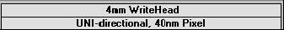
Configuration file in use; double-click to change

change configuration

The main menu bar offers a number of logical menus:

- File:

Drops a list of commands used for the transfer of prepared designs and for loading files that determine both position and alignment of features onto a substrate (Environment files).

- Job:

Drops a list of commands for preparing and editing job files, and process steps for an exposure or measurement.

- Setup:

Offers commands that can be used to prepare numerous automatic or semi-automatic sequences for alignment, map design and for capturing image templates to be used for alignment processes. All alignment options are only available in systems with camera unit.

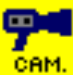
- Measure:

Commands allowing for control of exposure quality.

- Tools:

Contains presentation methods for measurement and job results.

- Service:

Offers a vast number of programs for testing and calibrating the DWL system. Some of these features are only available in system with camera unit.

- Help:

Opens an alphabetical list of subjects defining main characteristics of the system.

CHAPTER 2 - FILE MENU

DESIGN DATA

INTRODUCTION

A DWL can only write data in the machine’s internal format, called LIC. This data is normally prepared in an off-line workstation, where the program XCONVERT is installed. The XCONVERT program fractures original data and generates a file for every stripe to be written. Then, through the atrans program, these files (plus multiple control files) are transferred to the machine via an ethernet.

The amount of designs stored in a machine depends solely on the size of the data partitions on the hard disk. A number of test designs are permanently stored in the system partition.

The File menu command Design Data opens the Design Data Directories window (Window 1), which displays all the currently present LIC-directories in the default LIC path given in the configuration file.

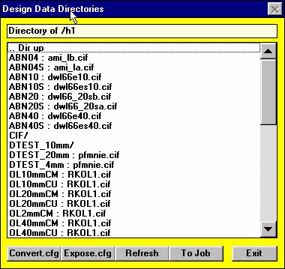
Window 1

DESIGN DATA BUFFERS BUTTONS

- Convert.cfg:

Shows the command file for the program XCONVERT.

Expose.cfg:

Shows the file expose.cfg for the specific design, which controls the exposure, and is generated by the conversion software. A design converted for a particular machine configuration usually cannot be used again when fundamental machine properties such as stripe width, or address grid have been changed; therefore, the working design must be re-processed and loaded.

Refresh:

The transfer of all the LIC buffer data to the Operator PC requires some time and will only be done the first time Window 1 is loaded. If LIC data is added in the meantime, this function will re-read the LIC directory contents.

- To Job:

Directly transfers the LicBuffer location of a design from the list to the Job file. Highlighting Make Job under Job in the main menu opens the Job file. Highlight the LICBuffer cells where the design name should be transferred to and then highlight the design name in the list and press To Job.

- Cancel:

Closes Design Data Directories window (Window 1), or closes the viewer after pressing Expose.cfg or Convert.cfg.

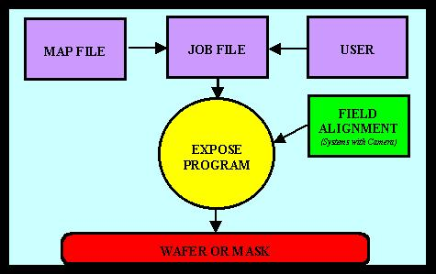
ENVIRONMENT FILES

INTRODUCTION

Multiple sub programs in the DWL menu require special job-dependent data files, which can be connected to a specific job as to avoid loading these files all the time. In many cases, entries within the files are altered automatically. If the DWL system is not running properly it may be caused by a changed entry into its environment and can be fixed by re-loading the original desired file. Not all four files are necessary to run all applications, the only exception being the direct writing of substrates featuring alignment markers.

ENVIRONMENT FILES UNDER FILE COMMANDS

- Job File:

Contains information for the system on what data is written in which field of the Map (Window 2) and under what conditions.

- Map File:

Contains geographic information on the location of the sub fields on the substrate.

- Field Alignment:

Describes the procedure used to determine field positions on a substrate by detecting alignment structures. The file has a specific format, written in a special macro-language.

CHAPTER 3 – JOB CONTROL

EXPOSURE CONTROL COMMANDS

After environment and setup procedures are prepared, highlighting Make Job enables an operator to adjust exposure parameters, such as Lic data selection, Defocus and Energy. Highlighting the Run Job panel allows for the final steps of an exposure to be performed.

For the following submenu options, the “Exposure Map” window (Window 2) will be opened beside the current window. Clicking on the Exposure Map icon located on the Main Menu toolbar will also access Window 2.

JOB COMMANDS

- Make Job:

Prepares and edits job files in the Edit Job spreadsheet.

- Run Job:

Loads and unloads plates, tests alignment procedures, runs exposures and measurements using the Expose window.

EXPOSURE MAPS
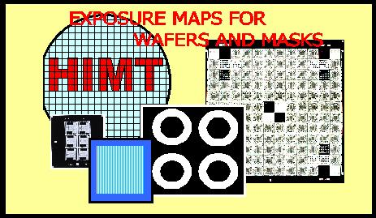
EXPOSURE MAP DISPLAY

Window 2 shows a graphical interpretation of the current Map file. If a design being exposed is to be stepped several times on a substrate, or if various patterns must be written onto numerous fields, the Window 2 map represents the order in which the fields are arranged on a substrate according to the current Map file. During an exposure, the Window 2 Map will display which field is being exposed. The zero field, marked with a cross, is used as the coordinate origin.

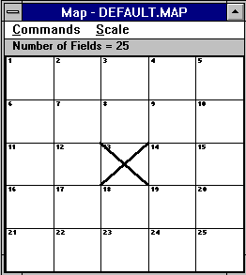
Window 2

MAP - COMMANDS

Select Fields:

Highlights fields in the Exposure Map that will automatically set marks on corresponding rows in the Make Job window and allows the operator to mark several fields at once (e.g., program a selected row of fields to have the same focus offset aided by the Make Job submenu). The zero field, marked with a cross, is used as a coordinate reference.

Clear Fields:

Removes selected flags and row marks in the Make Job program.

Show Positions:

Normally displays absolute coordinates in microns in reference to a selected field.

Jump Positions:

If the interferometer coordinate system is set and aligned to a substrate, the Jump Positions command may be used for leaping to a selected field. When the Jump Positions command is highlighted, a warning window will appear. The Jump Positions command is only to be used after substrate is aligned and its respective coordinates are set to the Map correctly; otherwise, the stage may leave the auto-focus regime, and moving it back may damage the nozzle.

MAP - SCALE COMMANDS

Select any of the absolute scale displays. All entries show the size of the entire Map area.

- Automatic:

Both the X and Y-axis are independently normalized and will show a distorted view of field distribution.

EDIT JOB

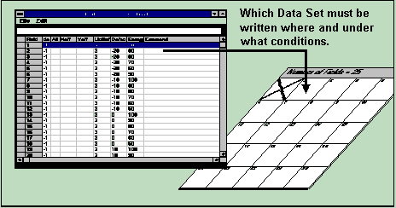

INTRODUCTION

With the Edit Job spreadsheet (Make Job command in the Job menu), the Job menu offers a tool to edit the Job File, which controls design positions according to the fields defined in the Exposure Map and the conditions of each exposure on the substrate.

Any Job File can be edited using various programs (i.e., Microsoft Excel), as long as the format description is being obeyed.

FORMAT OF THE JOB FILE

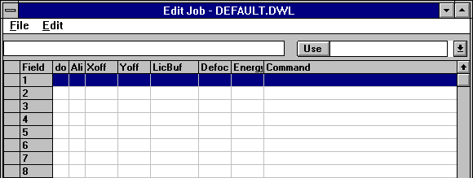
Window 3

A DWL Job File controls the entire exposure sequence and its organization is similar to a spreadsheet. Advanced work can be done using, e.g., Microsoft Excel.

A Job File consists of 9 columns, but the number of rows is equal to the amount of fields in the active Map. In the case of a simple Map featuring only one field, the spreadsheet will only contain one row.

COLUMNS

Field:
Contains a number referring directly to the field in the wafer map, which is viewed simultaneously with this spreadsheet. The order of the rows is generally synonymous with the field numbers, but is not essential. The fields will be exposed in the order of their positions on the spreadsheet, not the field number. Fields cannot be moved within the Edit Job spreadsheet; instead, use Microsoft Excel.

do:

Contains a flag, which will determine if the field corresponding to its row is going to be written. If the value entered in this column is –1 then the flag is true for this row and the corresponding field in the Map will be written. If the value in the row is 0, or empty, the field will be skipped.

Ali:

Only used with camera-equipped systems. For overlay exposures or measurements, an alignment procedure can be chosen according to the number of alignment marks per field which have been entered into the Map file. The maximum number of alignment marks is 4. If no alignment is chosen, leave fields blank.
ALI=: No Alignment

ALI=0: No Alignment

ALI=1: One Site Alignment

ALI=2: Two-Site Alignment

ALI=3: Three-Site Alignment

ALI=4: Four-Site Alignment

Xoff:

Entering a value in microns will shift the final position of where this field will be written in X. The value can be signed and can have a decimal point. The X-Shift in this column will always be added to the position provided by the Map.

Yoff:

Entering a value in microns will shift the final position where this field will be written in Y. The value can be signed and can have a decimal point. The Y-Shift in this column will always be added to the position provided by the Map.

LicBuf:

The Lic Buffer must contain the name of the directory where Lic data is stored.

Exposures:

It is possible to expose more than one design, or even the same design, several times by entering more buffers separated by a semicolon.

- Measurements:

The name of the measurement file must be entered proceeded by “M:” (i.e., M:test.msr). If several measurements are to be executed in the same field, the file names must be seperated by a semicolon.

- Defoc:

Enter a value between 0 and 4095 as a focus offset. A value of 2048 means no defocus. Calibration is usually such that one unit is 5nm. Before a final exposure is made, a series of fields with the same pattern at various defocus levels should be used to find the best focus offset for an exposure. This is the only correct defocus procedure for substrates with relatively thick resists. If the cell in the Defoc column is empty, no defocus is made.

WRITE LENS | FOCUS DEPTH
2mm | ~ 1.0µm
4mm | ~ 1.8µm
10mm | ~ 8µm
20mm | ~ 50µm
40mm | ~ 200µm

- Energy:

The name of an intensity correction file is entered in the Energy column. Such a name consists of a number only. The file 100 sets the energy to 100% and the file 70 to 70%, etc. Normally not all values are available. Similarly to finding the best focus, the Energy column is used for finding the best energy by varying the energy across an array of fields

- Command:

Executes multiple commands before and after an exposure, or measurement. A list of available commands will drop by clicking on the ▼scroll arrow located on the right hand corner of the Use box, shown in Window 3. Select any of the available commands and enter a numeric, or string value-if required. All commands executed before an exposure or measurement must be preceded by highlighting, “BEFORE:” Commands executed after an exposure or measurement must be preceded by highlighting, “AFTER:” Both selections must only appear once, but can be followed by any number of commands. A semicolon must separate each command. Any command chosen from the table will be automatically added to the current command sequence by pressing the Use button.

EDIT JOB - FILE COMMANDS

New:

Creates a fresh sheet with the number of rows corresponding to the number of fields by the current Map file.

New Map:

Loads a new Map from the \VBMENU\WAFER\ directory. The new Map will appear and a new Job file stating: "NONAME.DWL" will be created. The name of the new Map will also be entered into the list of environment files (See CHAPTER 2: ENVIRONMENT FILES).

NOTE: Not all corresponding alignment files will necessarily be loaded. Check before executing a new Job file.

Open:

Opens an existing Job file from the \VBMENU\WAFER\ directory. If its corresponding Map file is not loaded in the environment then only the number of rows to cover the fields of the current Map file will be displayed. A more logical approach would be to load the corresponding Map file first.

Save:

Saves the current Job file. An overwrite warning will appear.

Save As..:

Saves the current Job file under a new name.

- Exit:

Exits Edit Job window.

EDIT JOB – EDIT COMMANDS

A highlighted cell is called “focused,” and can be edited while its contents are displayed in the upper-left line. The row corresponding to a focused cell is automatically selected and can be seen by the two crosses displayed in the leftmost cell of the row as well as in the Exposure Map window, where the field correponding to the selected row turns blue. If several cells are to be selected at the same time (i.e., a row or column), the corresponding rows can be marked as to remain selected while the focus is being shifted.

Cut, Copy, Paste:

Copies and clears cells, or a range of cells. The Windows Clipboard is used as an intermediate, for communicating with other applications.

Fill Down:

Copies the content of the uppermost cell, or cells, of a certain selected area, into all selected cells below.

Formula Fill Marked:

Generates a sequence of numbers, which may be combined with both a leading and trailing string. In the first dialogue box, enter the starting value, followed by the step size, separating the two values with a comma. In the following dialogue box, enter the preceding and trailing strings seperated by a comma. If a string is not necessary, only enter a comma.

Replace:

Searches for a specific string in the selected area, though not the whole file, and will replace it with a new string.

Set Marks:

Normally, only the row of a cell with the focus is selected. If the Set Marks command is selected, then all rows corresponding to the cells clicked on will remain marked until the selection is removed. Once set, the corresponding option in the (commands - Select Fields), is set automatically.

Set Marks Conditionally:

Will mark all cells that satisfy a specific string condition. Such a condition must be provided in the dialogue box.

Remove Marks:

Clears all marks previously set. Can also be done by highlighting the Clear Fields command on the Map.

LISTS AND BUTTONS:

- Use:

Places a selected command into the spreadsheet. A command is selected by opening the commands list (click arrow on the right-hand side of the text box) and by highlighting the command; the command will be transferred into the text box. The command will be transferred to any selected “command” cell once the Use button is pressed.

EXPOSE

INTRODUCTION

Highlighting Run Job under Job in the main menu opens the Expose window (Window 4), which is is kept as simple as possible and may be used to routinely run pre-defined jobs. The environment must be modified first before changing designs, then multiple functions can be used in a logical sequence as shown in Window 4 below.
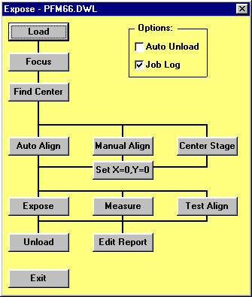
Not available in systems without camera
Window 4

EXPOSE - BUTTONS

Load:

Moves up the writehead, performs a stage initialization- if necessary, and moves the stage to the load position.

- Focus:

Focuses on a substrate.
After a substrate is manually loaded and focused upon, a number of alignment methods are available:

Find Center:

Starts the Find Center () procedure, which detects the edges of a plate using the auto-focus sensor and calculates the plate center from the results. Once the routine is finished, the stage moves to the position detected and requests if the stage coordinate system origin should be set there.

Manual Align:

This preprogrammed sequence interactively aligns a substrate along the X-axis, or along the Y-axis.

Center Stage:

Moves the stage to the center of the interferometer field.

- In situations where it is unnecessary to make an alignment, this position may be used as a reference point.

- Auto Align:

This option is deactivated, as the corresponding functions are as of now, incomplete.

Set X=0, Y=0:

Sets the origin of the coordinate system to the current position.

- If none of the above commands are used, the control panel is necessary for moving to a specific position, i.e., a point with a certain distance from the plate center or to a corner of the substrate.

NOTE: Highlight Make Job under the Job menu to re-inspect or make last minute changes in the Job file.

Expose:

Exposes a plate exactly as instructed by the Edit Job file, including a possible multi-site field alignment. The Map (Window 2) is continuously updated during an exposure. While exposing one field, the User PC is simply waiting and displays how many stripes must still be written for the field. In case of an emergency, clicking on the BREAK button in the “Scanning...” window will interrupt a current exposure, where all other controls will deem invalid during this time. After BREAK is clicked the current stripe will be completed but all processes necessary for the exposure will be stopped.

Measure (Only available in systems with camera):

Starts a measurement sequence for jobs containing measurement references in the Lic Buffer column. Measurements results are entered into the Report file, which can be analyzed for a variety of properties using some of the functions under the Tools menu. Clicking on the Measure button a second time will interrupt a measurement sequence.

- Test Align (Only available in systems with camera):

Performs all functions of an exposure exactly as the real expose sequence would, only the Expodie command will not be given to the OS9 System. A test exposure is extremely important for debugging complete alignment sequences, while a report will be made containing all details about the alignment results etc. Use with caution, this sequence cannot be interrupted.

- Unload:

Moves up writehead and moves stage to the unload position.

Edit Report:

Allows operator to view a report about the (test) exposure and save it under a different name (optional).

- Exit:

Closes Expose window (Window 4).

(OPTIONAL) CHECKMARK FUNCTIONS:

Auto Unload:
If checked, the Unload function will be executed after the exposure is finished.

Job Log:

If checked, the name of an exposure / measurement control file is entered into a list, followed by the first Lic- or M:file name encountered. Next, both start time and date / stop time and date are listed, and this information is entered into the file, "JOBLOG.TXT" -which can be found under VBMENU\WINDWL.

CHAPTER 4 - JOB SETUP

SETUP COMMANDS

A large number of submenu commands are available for the preparation of complex exposure jobs, including procedures for field alignment. In addition, the Setup submenu contains commands for preparing a fresh exposure map.

- New:

Installs a new environment directory and necessary root files for further customization.

- Exposure Map:

Creates and displays new exposure maps and defines the relative coordinates of alignment sites.
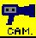

The following options are only available in systems equipped with cameras

- Simple Cross Alignment (The following options are only available in systems equipped with cameras):

Offers two ways of automatically preparing simple field alignment procedures for alignment to crosses.

- Field Alignment Method:

Develops and tests automatic field alignment methods for field-by-field exposures.

- Test Field Alignment:

A multiple site alignment testing method, used to find and test suitable alignment sites.

- Define Template:

Used to teach the system specific, clear-cut image features that can be recalled and used as an alignment template.

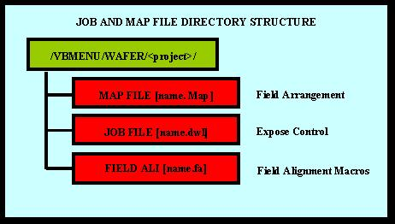
NEW EXPOSURE MAP

INTRODUCTION

All files for one project are located in the same directory along with report files for a certain job. In the New Exposure Map window (Window 5), an existing environment may be loaded or a new environment directory can be created.

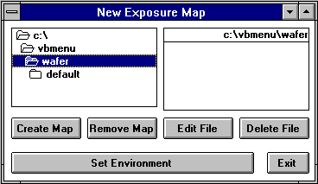
Window 5

NEW EXPOSURE MAP BUTTONS

Create Map:

Upon starting a new project, set the main directory to \VBMENU\WAFER using the directory select box and then click on the Create Map button. A name of maximal 8 characters is requested, used as a project name. A directory is created and will be filled with three root files, which are copied from the VBMENU\WINDWL\ default.map, default.wa, and default.fa.

Remove Map:

Completely removes the directory and all files selected out of the directory box after a confirmation.

Note: Directory may not be the current environment.

Edit File:

Loads the file selected in the right file box (of Window 5) into a small editor and may be used to view a file or to make minor changes.

Delete File:

Deletes a selected file from the file box after confirmation.

Set Environment:

Upon selection of a Map file from the file box, the complete environment can be set to this project. This button will display which project has been selected. Click on the button to load.

EXPOSURE MAP DESIGN

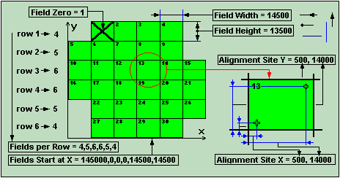

INTRODUCTION

Described in the Map file, the Exposure Map has a very specific format as shown in the example below:

Line 1: Field Width = 14500 (in µm)

Line 2: Field Height = 13500 (in µm)

Line 3: Alignment Site X = 500, 14000 (in µm)

Line 4: Alignment Site Y = 500, 14000 (in µm)

Line 5: Fields per Row = 4,5,6,6,5,4

Line 6: Fields Start at X = 14500,0,0,0,14500,14500 (in µm)

Line 7: Field Zero = 1

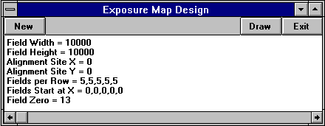
Window 6

NOTE: Spaces are not important, but upper- or lower-case of the characters are. Meanings of various entries are shown in the figure at beginning of sub-chapter. Upon starting the Exposure Map Design window, data from the current map is loaded. All positions and sizes are to be entered in micrometers. In lines 5 and 6, a value must be entered for each row.

EXPOSURE MAP DESIGN BUTTONS

- New:

If a new map is loaded the map description will default, where all prepared numbers will disappear.

- Draw:

Will cause a map as described by the current text to be shown in a seperate window.

- Exit:

Exits Window 6.
NOTE

In the case of a single layer, single field Mask exposure, Window 6 must be modified as shown below:

Field Width = 100000
Field Height = 100000
Alignment Site X = 0
Alignment Site Y = 0
Fields per Row = 1
Fields Start at X = 0
Field Zero = 1

SIMPLE CROSS ALIGNMENT

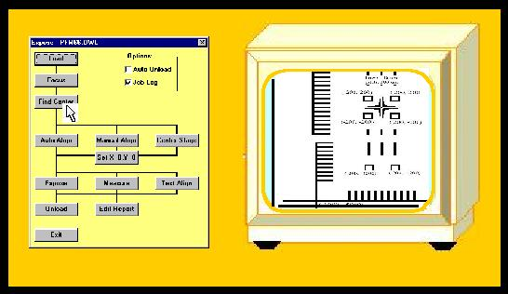
The Simple Cross Alignment command offers two modes of automatically generating a field alignment method if the alignment mark to be used is a cross. These two modes are:

- Using Find XY

- Using Pos XY

The camera settings must be optimized for best contrast and then, when requested to, indicate dimensions of the cross by clicking on certain parts of the pattern (as requested in the Point to... window heading). After that, a standard field alignment procedure is automatically created using the method chosen and the values gained before.

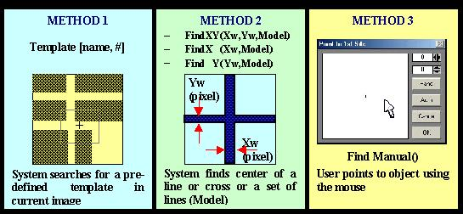
FIELD ALIGNMENT METHODS

INTRODUCTION

Field alignment of an object must be done specifically to some structure on a pre-exposed layer and can be very different for many substrates. Therefore, numerous methods are available for many applications. The field alignment procedure at a certain site may be the outcome of various steps and altering sequences. However, the Field Alignment Method, developed using Field Alignment Macros (Window 8), applies to one site only. For multi-site alignment, the full sequence is determined by the relative positions of the sites as is given in the Map file, and by the selection of the number of alignment sites to be used, which is done in the Edit Job spreadsheet (Ali column). The DWL menu contains a special macro-language for the purpose of field alignment. This macro language is allows for the development of special alignment procedures, which are optimized for unique applications.

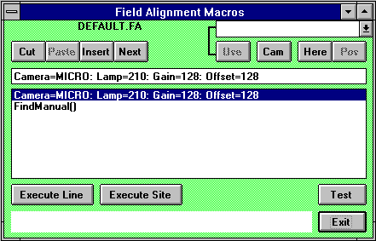
Window 8

FIELD ALIGNMENT PROCESS

The Field Alignment Method must be stored in a file with the extension ".fa". After generating a New Exposure Map, a directory is generated containing a "name.map" file and two alignment files, "name.wa" and "name.fa". The Field Alignment Method stored in "name.fa" is executed by means of the Expose program (depending on the instructions previously fed into in the Job menu), which accepts only a specific format of the method.

MACRO LANGUAGE FUNCTIONS

Camera:

[Camera= Macro or Micro] Selects the Macro or the Micro Camera

Delay:

[Delay=#] Will wait for the designated number of seconds necessary for the stage to relax after a move. If a camera image is captured too soon after a move, stage position will not be correct.

Manual Alignment:

[FindManual()] Sets cursor in the video image. The cursor can be positioned on a specific part of a structure. The cursor position is then used to obtain the position information (see section Find Manual further in this chapter).

Alignment to a Vertical Line:

[FindX(Xwidth, Model)] Determines the center of a vertical line in the video image, where the Value Xwidth must be the width of the vertical line in camera pixels. The model parameter selects the algorithm (See Alignment to a Cross by Outline for example).
.

Alignment to a Cross by Outline:

[(FindXY(Xwidth,Ywidth,Model)] Determines the center of a cross with two lines in the video image, where the Value Xwidth must be the width of the vertical line in camera pixels, and the Value Ywidth must be the width of the horizontal line in camera pixels. The model parameter selects the algorithm where for simple crosses the numbers 0... 2 should be used. The different models are:

0 – for a cross with a clear, thin outline

1 – for a cross for a clear thick outline

2 – for a cross with sharp defined edges

- Alignment to a Horizontal Line:

[FindY(Ywidth, Model)] Determines the center of a horizontal line in the video image. The Value Ywidth must be the width of this line in camera pixels. The model parameter selects the algorithm (See Alignment to a Cross by Outline for example).

Focus Offset:

[Focus=#] Sets the focus offset to a value. The range is between 0 and 4095. Normal value = 0.

Camera Gain:

[Gain=#] Sets the video amplifier gain to a value. The range is between 0 and 255. Normal value = 128.

Lamp Intensity:

[Lamp=#] Sets the camera illumination intensity to a value. Range is between 0 and 255.

Move in X Absolute:

[MovToX(Xvalue)] Absolute moves to the position Xvalue. Xvalue can be represented in microns by including a "U" in the number; Otherwise, Xvalue is represented in interferometer ticks.

Move in X and Y Absolute:

[MovToXY(Xvalue, Yvalue)] Absolute moves to the position Xvalue, and Yvalue. Xvalue and Yvalue can be represented in microns by including a "U" in the number; Otherwise Xvalue and / or Yvalue are represented in interferometer ticks.

Move in Y Absolute:

[MovToY(Yvalue)] Absolute moves to the position Yvalue. Yvalue can be represented in microns by including a "U" in the number; Otherwise, Yvalue is represented in interferometer ticks.

Move in X Relative:

[MovX( Xvalue)] Relative moves over the distance Xvalue. Xvalue can be represented in microns by including a "U" in the number; Otherwise Xvalue is represented in interferometer ticks.

Move in X and Y Relative:

[MovXY(Xvalue ,Yvalue )] Relative moves over the distance Xvalue and Yvalue. Xvalue, or Yvalue can be represented in microns by including a "U" in the number; Otherwise, Xvalue and Yvalue are represented in interferometer ticks.

Move in Y Relative:

[MovY(Yvalue)] Relative moves over the distance Yvalue. Yvalue can be represented in microns by including a "U" in the number; Otherwise, Yvalue is represented in interferometer ticks.

Camera Offset:

[OffSet=#] Sets the video amplifier offset to a value. Range is between 0 and 255.

- Alignment to a cross by Video Profiles:

[PosXY(Xwidth,Ywidth,Dist)] Determines the center of a cross by defining the centers of the video profiles of the bars on both sides of the center. Measurement boxes of the size given will appear right, left, above and below the center of the monitor image in the distance from the center obtained.

Alignment Using A Template:

[Template(Name, #] Determines the position of a template, stored with both the name, "Name," and the number, "#".

Example Using Macro Language Functions:

An alignment to a cross is done where the cross is larger than the camera field. The stage is slightly moved to step across a substrate obtaining as much data as possible.

Line 1: Camera=MICRO: Lamp=210: Gain=128: Offset=128

Line 2: FindXY(45,45,2)

Line 3: MovX(-30U): FindY(45,2)

Line 4: MovX(60U): FindY(45,2)

Line 5: MovXY(-30U,-30U): FindX(45,2)

Line 6: MovY(60U): FindX(45,2)

Line 7: MovY(-30U)

Line 8: FindXY(45,45,2)

In this case, the reactions are:

Line 1: Set Camera to MICRO and choose Lamp, Intensity, Camera, Gain and Offset

Line 2: Search for a cross of about 45 pixels in width in X and in Y applying model 2

Line 3: Move stage in X by 30 microns and find the center of a horizontal line with a width of 45 pixels.

Line 4: Move stage in X by -60 microns and find the center of a horizontal line with a width of 45 pixels.

Line 5: Move stage in X by 30 microns and in Y by 30 microns. Find the center of a vertical line with a width of 45 pixels.

Line 6: Move stage in Y by -60 microns and find the center of a vertical line with a width of 45 pixels.

Line 7: Move stage in Y by 30 microns.

Line 8: Search for a cross of about 45 pixels in width in X and in Y applying Model 2

The DWL system will analyze the position of a large cross by stepping along the cross in all directions, obtaining accurate results. The values of each alignment are averaged producing a result, unless an alignment is non-successful, in which case this particular measurement will be ignored.

EDIT BUTTONS

The Command buttons in the Field Alignment Macros window (Window 8) are made so that the Field Alignment Method can be developed, tested, and saved upon Exit. The Field Alignment Method is loaded upon opening Window 8. The box in the center of Window 8 consists of a list of commands. Use the cursor keys or mouse to highlight a line. The content of the selected line is copied into the text-line above the list so that the text may be edited. While pressing the Carriage Return Key, the edited line is checked for syntax and other errors, and unless there is a problem the line is copied onto the list. In order to aid in the development of new lines, an entire program vocabulary is available to scroll down through from a list box on the upper-right corner of Window 8. Any command highlighted from the program vocabulary is then shown in the text-line.

Use:

Copies the text in the select box onto the edit-line.
Normally entering values for the parameters is necessary.

- Cam:

Loads all necessary commands to set both the current camera conditions and lamp intensity in the edit-line.

- Here:

Saves current absolute position as reference position for relative positions calculated using the Pos button.

Pos:

Loads a relative Mov command to the current stage position respectively to the position marked with the “Here” button.

Cut:

Removes the highlighted line from the list and places it in an intermediate store. Please note that Windows Clipboard is not used here.

Paste:

Will insert a line in front of the currently selected line to be loaded with the content of the intermediate store.

Insert:

Inserts an empty line in front of the currently selected line.

Next:

Hangs an empty line on the end of the list.

TEST BUTTONS

Test functions are not useful and can be dangerous if the stage is not initialized. Test functions can therefore not be used until a stage initialization has been done.

Execute Line:

Executes a highlighted line from the list. If an alignment statement is included in the line, the result of this alignment is shown in the lower area of Window 8. If an alignment could not be done, an illogical value will be shown instead.

Execute Site:

Will execute the entire procedure, meaning all lines will be executed. In such a case, the average result of all alignment statements will be displayed.

Test:

Tests entire Field Alignment Method, just as it would run during normal execution.

Exit:

Will overwrite the current field alignment file with the developed method after a confirmation and then close Field Alignment Macros window (Window 8).

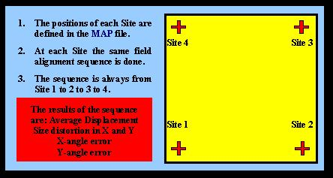
TEST FIELD ALIGNMENT

INTRODUCTION

The Test Field Alignment window (Window 9) utilizes the current Map file and Field Alignment file. Site 1 has a special function when testing as it is used as a reference, meaning that if a test is started, site 1 must be within the view of the camera being used for the Field Alignment Method.

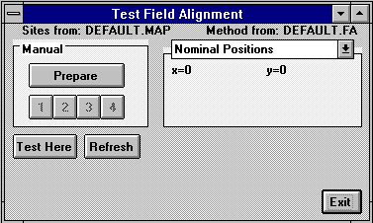
Window 9

Upon starting the testing process, nominal positions of the alignment sites will be displayed in the right box (Window 9). If only one alignment position is defined in the Map file then only one alignment position will be seen, etc. In some cases, exact alignment positions are not known and must be measured using MANUAL MODE.

MANUAL MODE

Before MANUAL MODE can begin, use the Control Panel to move the stage to a position where the first alignment site is in clear view of the camera.

Prepare:

Will start the manual process of getting nominal positions (up to four) for the alignment sites. After an alignment site has been accepted, move to the next site, or click on the Cancel button in the Manual Alignment window (Window 11, defined in more detail under FIND MANUAL). Nominal positions will appear after alignment sites have been defined.

1,2,3,4:

Causes the system to move to the positions of these pre-defined alignment sites.

Test Here:

Once a camera has moved into position of the first site, the Test Here command will begin an automatic multi-site alignment test. Depending on the number of available sites, the results for up to six parameters will then be displayed in the lower part of Window 9:

Xshift(µm)= Yshift(µm)= (1 site)
Xsize(ppm)= Ysize(ppm)= (2 sites)
Xrot(µrad)= Yrot(µrad)= (4 sites)

The same results will be used in a multi-site alignment and correction procedure during an exposure.

Refresh:

Used after editing an alignment procedure or selecting new Environment files. Clicking the Refresh button will cause Window 9 to reload the aforementioned files.

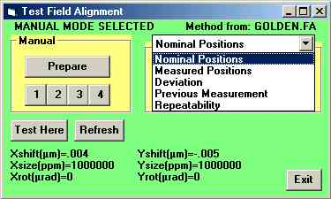
RESULT ANALYSES

The commands in the following list determine which set of parameters is being shown in the text box underneath it.

Nominal Positions:

Alignment positions from the Map file, or those manually measured.

- Measured Positions:

Results from the last full alignment sequence.

Deviation:

Deviation between the latest measurement and the nominal values.

Previous Measurement:

Results of the measurement taken before the last full alignment sequence.

Repeatability:

Deviation between the latest measurement results and measurement results from the previous measurement.

DEFINE TEMPLATE

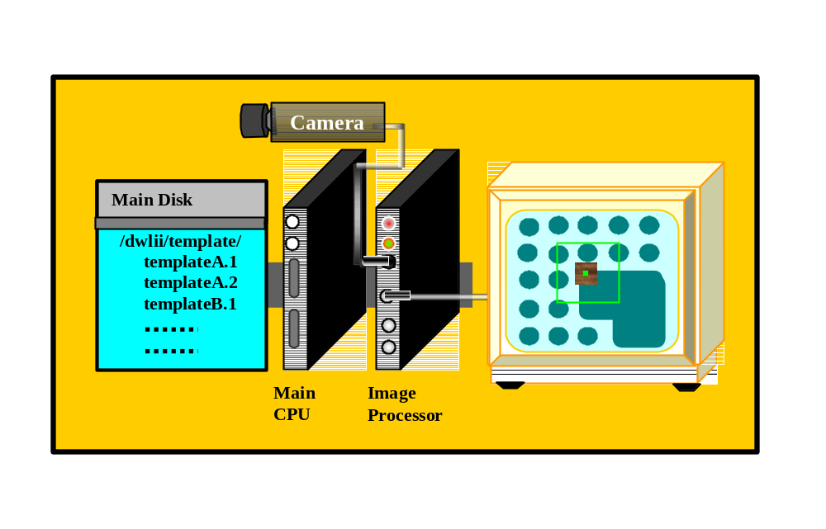
INTRODUCTION

This procedure is made for an interactive template definition. Before the program can begin, a substrate from which a template will be made must be on the stage and in-focus, and the camera with which the template will be processed, must be selected in the Control Panel. Contrast and illumination should be as well as possible. For more information on the image alignment by means of a template search, see Field Alignment. The multiple sub-commands in this program are logically arranged and will normally be executed from top to bottom.

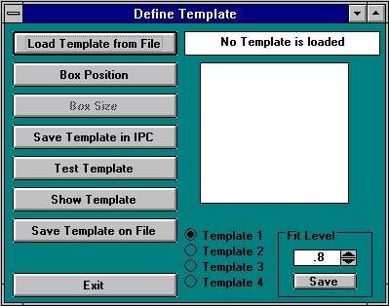
Window 10

DEFINE TEMPLATE BUTTONS

Load Template from File:

Shows the already defined templates that can now be selected. Be aware of the way in which templates are stored on the main system hard disk /USER/DWLII/TEMPLATE directory. Templates are stored under a name and a number as an extension. The image processor only knows templates by their number. For example, the Os9 directory will show files in a manner as such:

Calibr.1
Calibr.2
Calibr.3
XLD5050r.1
XLS5050x.1

After selection of a file - Calibr.1, Calibr.2, or Calibr.3, all templates stating Calibr will be loaded to the template locations represented by the corresponding number in the extension. If only one template is defined, only one template will be loaded; thus, selecting XLS5050.1 - for example, will cause a template to be loaded in template register number 1.

Box Position:

Normally begins a template definition sequence after the camera has been selected and the image area where a template is to be defined is visible and not too close to the edge of the screen. After selection, the image is frozen and a cross appears in the center of the screen, which can be moved while holding down the left button of the mouse.

Box Size:

After definition of template position, its size is set using the slides that appear. The best template is relatively small, yet contains unique information for both axes.

Save Template in IPC:

Saves the defined template in the RAM of the image processor card IC40 under the number previously set with the template # checkbox.

Test Template:

Tests a defined template on the current image. The result is printed below the cursor block in means of the following format:

FOUND TEMPLATE At:
R-Fit = 0.7
Xabs=-914-325
Yabs= 644 230

The R-Fit value gives the reliability of the result; an R-Fit of 1 is a perfect match. For each axis’ the absolute template position in tics is shown, followed by the template position in camera pixels.

If a sought after template is not found an error message will appear. As a remedy, optimize contrast, uniqueness, or lower Fit Level.

Show Template:

Templates are stored in the IC40 as a series representation at various pixel resolutions. The first search is done with a very course template image where 16x16 pixels are combined, followed by the next image with 8x8 pixels, etc. The Show Template command is used to ensure that the information in a course image still contains unique features so that a template may be found unambiguously. Particularly if there is too much detail in a template, the low-resolution image may contain only a blur and is then impossible to find unambiguously.

Save Template on File:

All templates defined and stored in the IC40 under the numbers 1 through 4 can be stored under a common name. After a [name] has been entered into the dialogue box, the templates are stored under the names: <name>.1 through <name>.4 in the Os9 directory /USER/DWLII/TEMPLATE.

- Template #:

Selects, which image processor template register, is used for storing and loading.

- Fit Level:

Using the arrows, the current fit level given in the box can be changed. The new fit level will only be used for template testing unless it is being transferred to the configuration file using the Fit Level Save button. The Fit Level decides the reliability, that a result from a template search procedure that must have to be accepted as O.K. Usually set to 0.8 (= 80% reliability); should never be lower than 0.6.

Fit Level Save:

Causes the currently entered fit level to be stored into the configuration file, where the value will be used for all future alignments - be careful when changing the Fit Level.

FIND MANUAL

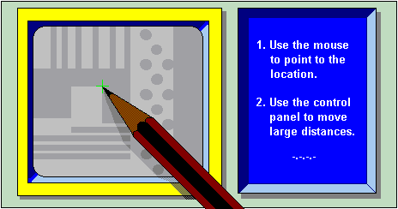

INTRODUCTION

The Find Manual Method is a much used service routine to determine the exact interferometric position of any structure within the current camera image by pointing to the location of interest. The results are best near the center of the camera image and are automatically adjusted for the camera selected. Good results can only be expected if every camera has been calibrated. This Method is not directly accessible to an operator and will only appear when it is necessary to determine the exact location of a specific feature (Window 11), which can be done by pointing a cursor. The Find Manual Method is used in alignment procedures as well as some measurement methods.

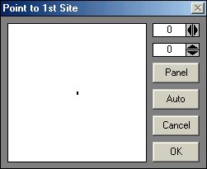
Window 11

FIND MANUAL WINDOW

Whenever a procedure requires the manual determination of a structure position, the Find Manual window (Window 11) will open and an instruction on which feature to point to may appear in the title bar.

- Mouse and Fine Adjust:

Rough adjustment of the cursor cross on the monitor is done by moving the cursor in the left field of Window 11 (hold down left button of mouse to move cursor). The two adjustment boxes on the upper-right hand side of Window 11 show the current position of the cursor in camera pixels, where 0,0 is the center of the camera image. For fine adjustment, the pixel values may be changed with the arrow buttons.

Panel:

(Invokes the Control Panel) If the region of interest is outside the camera field, or changing camera settings is necessary, the Control Panel must be activated with this button, since all other methods of starting the control panel will not work in such a situation.

- Auto:

Current field alignment will be used to determine the structure position.

Cancel:

Closes the Window 11 and causes an error signal to return to the calling program (as if the template was not found).

OK:

Quits Window 11 and returns the final absolute position of the cursor in the interferometer coordinate system to the calling program for further processing.

CHAPTER 5 - METROLOGY

METROLOGY COMMANDS

A number of measurement procedures to quantify exposures are listed under Measure in the main menu. Some of these commands are specifically developed to aid with the measurement of parameters important for system specific adjustments and calibrations. Most metrology commands require top illumination, which will lower quality measurement of emulsion plates if using the high magnification objectives with 4mm and 10mm focal lengths.

- Overlay:

Measures the relative positioning accuracy of two overlayed exposures on a single plate by utilizing a number of models, such as box-in-box structures, etc.

- Distance:

Offers both an automatic and a manual metrology method for measuring the distances between two features on a substrate.

- Positions:

Measures die-to-die alignment of a feature in order to ensure that the machine coordinate system is linear and orthogonal.

- Linewidth:

Measures and analyzes the line width of a feature based on its video profile.

- Pitch, Stitching, Edge:

Measures the distance between two identical features by associating video profiles of the images and then searching for the maximum in the correlation function.

OVERLAY MEASUREMENTS

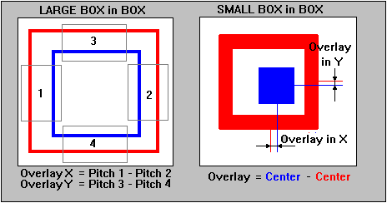
Figure 5

INTRODUCTION

The purpose of overlay measurements is to determine the position shift between two printed layers. To use the measurement methods offered under this command, specific structures must be written as shown in Figure 5, where the red structures are written in one layer, while the blue structures are part of the other layer. Overlay measurements are designed to measure the registration between these two layers. There are two different models:

LARGE BOX in BOX METHOD:

Two lines of equal thickness are written on two layers. For the measurement, boxes must be defined over these lines, two for -X and two for -Y. Within each of these boxes the pitch, or distance between the two lines is measured. Overlay is calculated by the difference between pitches. The Large Box in Box structure is usually greater than the micro-camera field so the stage will move to each measuring box before doing a pitch measurement.

SMALL BOX in BOX METHOD:

The Small Box in Box structure consists of two box shaped areas placed within each other. Measuring symmetry axes and comparing the differences will determine the overlay.
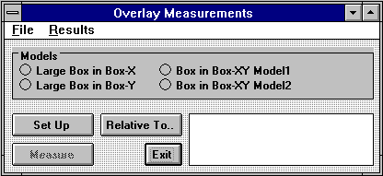
Window 12

OVERLAY MEASUREMENTS - FILE COMMANDS

Load:

Loads an already existing measurement file, which must have the extension ".msr", and is normally found in the directory \MEASURE. Upon loading, a model option is read from the file and is automatically switched on. After loading, a window will appear requesting that the operator, “Point to the reference site,” to which all recorded measurement positions will correspond. If the measurement method is executed automatically through a Job file, the chosen reference site can also be the alignment site of the respective field.

Save Measurement:

Saves the current measurement method under a requested file name. This measurement method can then be reloaded later or used within an automatic measurement procedure. If a reference site was not previously marked, a window will appear requesting to “choose a reference site”.

Exit:

Closes the Overlay Measurements window (Window 12).

OVERLAY MEASUREMENTS - RESULTS COMMANDS

After a measurement series has been made, results may be inspected and saved using the Results commands.

View and Save:

Loads an editor with the current measurement results. The file can then be saved as a text file within the editor.

To Excel:

Copies the measurement results to the Clipboard. Upon opening Excel, they may be loaded onto the spreadsheet by pressing Control-V, or highlighting the Paste Function. Data can be further processed and displayed using Microsoft Excel.

MODELS

The result of an overlay measurement depends on the contrast of structures, which in many cases is far from ideal; therefore, a number of measurement strategies have been developed, where two fundamentally different principles are being used: Pitch Measurement -determines the distance between two similar structures, and Center Measurement -determines the main symmetry axis of a structure.

Large Box in Box-X:

A Large Box in Box structure will consist of two frames with similar thickness’, each written on a separate layer (as shown on the left-side in Figure 5). Upon set up, a window will request the placement of a measurement box over two vertical lines at one location (1). The distance between these lines will now be measured using the pitch method. Next, the same box must be placed over the corresponding right side of the alignment structure (2). The overlay is determined by the difference between these distances. The stage will always move the location where the measurement box has been placed to the center of the screen before a measurement is started.

Large Box in Box-Y:

A Large Box in Box structure will consist of two frames with similar thickness’, each written on a separate layer. Upon set up, a window will request the placement of a measurement box over two horizontal lines at one location (3). The distance between these lines will now be measured using the pitch method. Next, the same box must be placed over the corresponding lower part of the alignment structure (4). The overlay is determined by the difference between these distances. The stage will always move the location where the measurement box has been placed to the center of the screen before a measurement is started.

Box in Box-XY Model1:

A Small Box in Box structure consists of a filled block, framed by a relatively thick line. Comparing the symmetry axis of the small block with the symmetry axis of the frame does a measurement. The size of the whole structure is typically between 10 to 20-microns.

Box in Box-XY Model2:

Box in Box-XY Model2 is applied if there is a rather weak contrast, or if a structure is covered with a layer of resist and only the edges of the structure are detectable. Overlay is measured in a similiar way as with the Large Box in Box structure, but without moving the stage to the measurement positions.

OVERLAY MEASUREMENTS BUTTONS

Set Up:

Before a measurement can be executed it must be pre-programmed with the Set Up model. Depending on which method has been selected, measurement boxes are required to be placed over the structures, and then a series of measurements can be made by continuation. Cancel Set Up model if sufficient measurements have been made. Once Set Up is complete, the whole measurement process can be saved and viewed in View Measurement Method under the Tools menu.

Example of an Overlay Measurement Method:

A typical program should follow the format of the model below:

Method=Small Box in Box-XY
Camera=Macro
InnerBox-X=100
InnerBox-Y=100
OuterBox-X=200
OuterBox-Y=200
Reference=Center of First Structure
{ 'Indicates start
0,0 'X,Y of 1. site
100,0 'X,Y of 2. site
200,0 'X,Y of 3. site
300,0 'X,Y of 4. site
400,0 'X,Y of 5. site
500,0 'X,Y of 6. site
} 'End of series

Relative To..:

Before a measurement can be saved a reference position must be selected. If no reference position is selected, then the current stage position will be used as a reference position. For a local series of measurements the location of the first structure is normally used as a reference point. If the measurement method is ready to be used for automatic measurements in the Job file, the field alignment sight may be used.

Measure:

Starts the currently active measurement sequence.

Results (Text Box):

The results text box, located on the lower right-hand side of Window 12, posts the actual overlay results and at the end of the measurement averages appear. The complete results can be viewed using the View and Save command.

DISTANCE MEASUREMENTS

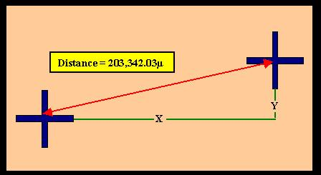
INTRODUCTION

The measurement of distances on a substrate can be small as to fall within a camera image, or large as to encompass the entire stage travel range. Precision of measurement is enhanced by repeating several times and will result in additional statistical information. The best values are obtained if automatic template recognition is used for the real measurement.

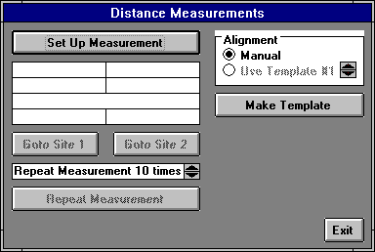
Window 13

DISTANCE MEASUREMENT BUTTONS

Set Up Measurement:

Before a distance measurement can be made, the two points to be measured must be defined. A window will request the operator “to point to the first site” with the cursor by means of the mouse, then repeat for the second site. Use the Control Panel to move over large distances, for switching between cameras, and for the adjustment of contrast, etc. Once the measurement has been setup, the distance between the two points (or, sites) will be shown in microns.

Goto Site 1:

Moves stage to the site of the first measurement point.

Goto Site 2:

Moves stage to the site of the second measurement point.

Repeat Measurement # times

Repeat measurement should be set to at least 5 times for a satisfactory measurement accuracy.

Repeat Measurement:

Starts a measurement series.

ALIGNMENT

Select either Manual mode, which is also used for Set Up, or the Use Template mode. A template must be defined, before the Use Template mode may be chosen.

Make Template:

Opens Define Template window. If the template defined here will only be used for the current distance measurement, it would be sufficient to store the template in one of the four buffers of the IPC module.

Exit:

Closes Distance Measurements window (Window 13).

POSITION MEASUREMENTS

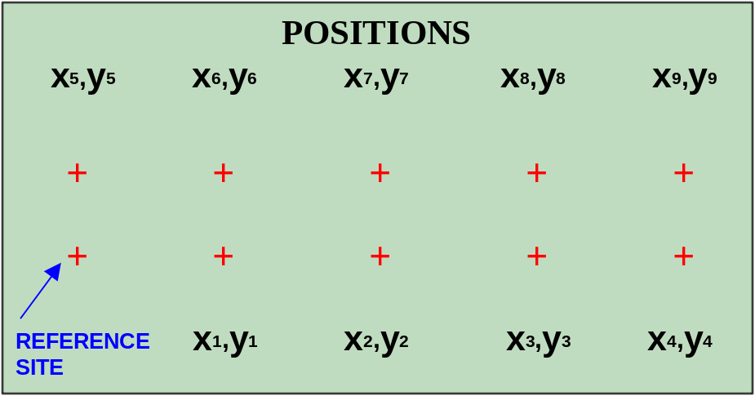

INTRODUCTION

Position measurements provide information, not only about distances, but angular distortions or non-linearity over a substrate as well. Position measurements are therefore an important tool for initial system calibration and exposure quality control.

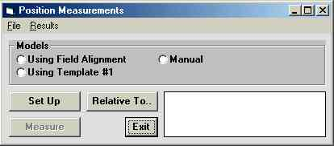
Window 14

POSITION MEASUREMENTS - FILE COMMANDS

Load:

Loads an already existing measurement file, which must have the extension ".msr", and is normally found in the directory \MEASURE. Upon loading, a model option is read from the file and is automatically switched on. After loading, a window will appear requesting that the operator, “Point to the reference site,” to which all recorded measurement positions will correspond. If the measurement method is executed automatically through a Job file, the chosen reference site can also be the alignment site of the respective field.

Save Measurement:

Saves the current measurement method under a requested file name. This measurement method can then be reloaded later or used within an automatic measurement procedure. If a reference site was not previously marked a window will appear requesting to “choose a reference site”.

Exit:

Closes the Position Measurements window (Window 14).

POSITION MEASUREMENTS - RESULTS COMMANDS

After a measurement series has been made, results may be inspected and saved using the Results commands.

View and Save:

Loads an editor with the current measurement results. The file can then be saved as a text file within the editor.

To Excel:

Copies the measurement results to the Clipboard. Upon opening Microsoft Excel, will load the current measurement onto the spreadsheet by pressing Control-V, or highlighting the Paste Function. Data can be further processed and displayed using Microsoft Excel.

MODELS

If the distribution of identical structures on a substrate should be measured, a template or –if the structure is e.g., a cross –a field alignment method can be used. If the positions of several different structures should be measured, this must be done either manually or with several separate measurements relating to the same point of reference.

- Using Field Alignment:

Uses current field alignment for position detection. Highlight Field Alignment Method under Setup in the Main Menu.

- Using Template #1:

This method uses the template currently stored in buffer #1of the IPC for the detection of structure positions. To define a new template, highlight Define Template under Setup in the Main Menu.

- Manual:

In manual mode, the operator is prompted to “Point to the Site to be Measured” for each structure position measurement, similar to the setup procedure.

POSITION MEASUREMENT BUTTONS:

- Set Up:

Before a Position Measurement may be done, the stage positions at which the structures to be measured are well within the camera field must be determined to program the measurement procedure. When the Set Up function is started the operator is prompted to “Point to First Site” to be measured using the mouse and, if necessary, the Control Panel. This has to be repeated for each structure to be measured. Finish the measurement setup by choosing Cancel in the Define Measurement dialogue box. Now the measurement method can be saved and viewed in View Measurement Method under Tools in the Main Menu.

Example of a Position Measurement Method

A typical program should follow the format of the model below:

Method= Using Template #1
Camera= Micro
Box Width= 0
Box Height= 0
Reference= Lower Left Corner of Pattern
{ 'Indicates start
0,0 'X,Y of 1. site
100,0 'X,Y of 2. site
200,0 'X,Y of 3. site
300,0 'X,Y of 4. site
400,0 'X,Y of 5. site
500,0 'X,Y of 6. site
} 'End of series

Relative To..:

Before a measurement can be saved a reference position must be selected. If no reference position is selected, then the current stage position will be used as a reference position. For a local series of measurements the location of the first structure is normally used as a reference point. If the measurement method is ready to be used for automatic measurements in the Job file, the field alignment sight may be used.

Measure:

Starts the currently active measurement sequence.

Results (Text Box):

The results text box, located on the lower right-hand side of Window 14, posts the actual measurement result. The complete results can be viewed using the View and Save command.

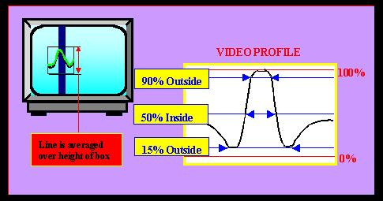
LINE WIDTH MEASUREMENTS
INTRODUCTION

Linewidth measurements are done through the camera system where the video camera must show the line structure to be measured either in X or in Y. Measuring the diameter of a circle is possible by either lowering the box height, or tightening the width of the box. The contrast should be clear, and if contrast is not clear, modify Lamp, Gain and Offset of the camera to improve the contrast. Two of the available analysis models are based on a linear fit to a small range of video signals around a requested threshold value, followed by a determination of the intersection between the horizontal threshold line and the fitted lines. Thereby, values are considerably more accurate than just the camera pixel size. The third model determines the positions of the two signal minima using a parabolic fit.

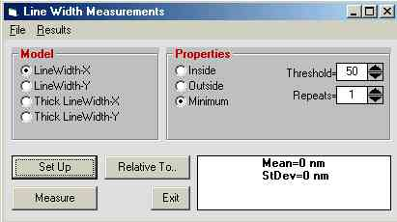
Window 15

LINEWIDTH MEASUREMENTS - FILE COMMANDS

Load:

Loads an already existing measurement file, which must have the extension ".msr", and is normally found in the directory \MEASURE. Upon loading, a model option is read from the file and is automatically switched on. After loading, a window will appear requesting that the operator, “Point to the reference site,” to which all recorded measurement positions will correspond. If the measurement method is executed automatically through a Job file, the chosen reference site can also be the alignment site of the respective field.

Save Measurement:

Saves the current measurement method under a requested file name. This measurement method can then be reloaded later or used within an automatic measurement procedure. If a reference site was not previously marked a window will appear requesting to “choose a reference site”.

Exit:

Closes the Line Width Measurements window (Window 15).

LINE WIDTH MEASUREMENTS - RESULTS COMMANDS

After a measurement series has been made, results may be inspected and saved under Results commands.

View and Save:

Loads an editor with the current measurement results. The file can then be saved as a text file within the editor.

To Excel:

Copies the measurement results to the Clipboard. Upon opening Microsoft Excel, will load the current measurement onto the spreadsheet by pressing Control-V, or highlighting the Paste Function. Data can be further processed and displayed using Microsoft Excel.

MODELS

LineWidth-X

Select the X method for vertical lines.

LineWidth-Y

Select the Y method for horizontal lines.

- Thick LineWidth-X:

Selects the measurement method for thick verticle lines (larger than ½ monitor image).

- Thick LineWidth-Y:

Selects the measurement method for thick horizontal lines (larger than ½ monitor image).

PROPERTIES

Inside:

Analysis is done by looking for the intersection between the video profile and the threshold level, starting from the center of the box.

Outside:

Analysis is done by looking for the intersection between the video profile and the threshold level, starting from the two edges of the measurement box.

Minimum:

Beginning at the center of the measurement frame, searches for the two extremes. The location of extremes is found by locally fitting a parable.

- Threshold=

Enter a value between 0 and 100% of the amplitude of the video profile. For most purposes the value should be between 25% and 50%.

Repeats=

The measurement method averages over all the video lines within the height, or width of a box before making threshold analysis. In adiition, the whole measurement can be repeated and averaged a number of times by entering the desired number of repeats in this box. However, no statistical information is deduced from this type of averaging.

LINEWIDTH MEASUREMENTS BUTTONS

Set Up:

Before a measurement can be executed it must be pre-programmed with the Set Up model. Depending on which method has been selected, measurement boxes are required to be placed over the structures, and then a series of measurements can be made by continuation. Cancel Set Up model if sufficient measurements have been made. Once Set Up is complete, it can be saved and viewed in View Measurement Method under the Tools menu.

Example of the LineWidth Measurement Method:

A typical program should follow the format of the model below:

Method=LineWidth-X
Camera=Micro
BoxWidth=100
BoxHeight=84
Model=Inside
Threshold=50
Repeats=1
Reference=Low Left Corner PFM Pattern
{ 'Indicates start
0,0 'X,Y of 1. site
100,0 'X,Y of 2. site
200,0 'X,Y of 3. site
300,0 'X,Y of 4. site
400,0 'X,Y of 5. site
500,0 'X,Y of 6. site
} 'End of series

Relative To..:

Before a measurement can be saved a reference position must be selected. If a current reference position is not manually selected, then an arbitrary location may automatically select the current position. For a local series of measurements the location of the first structure is normally applied. If a method for including a fully automatic program is pre-prepared, the alignment site can be employed.

Measure:

Starts the currently active measurement sequence.

Results (Text Box):

The results (text box), located on the lower right-hand side of Window 15, posts the actual measurement results and at the end of the measurement averages appear. The complete results can be viewed using the View and Save command.

PITCH MEASUREMENTS
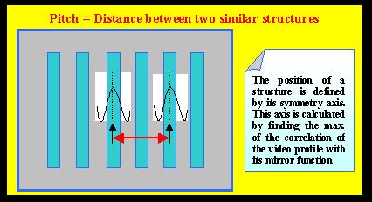
INTRODUCTION

In many cases it is important to measure the distance between two structures, located relatively near to each other. If such structures are identical in appearance, the distance being measured- or pitch is uniquely defined by a numerical comparison of the two video profiles of each structure. A cross correlation will yield the pitch with an extremely high repeatability.

PITCH MEASUREMENTS:

The pitch measuring method is applied for finding the horizontal distance of two vertical lines or for finding the vertical distance of two horizontal lines. This method may be extended to measure whole sets of equidistant lines.

STITCHING MEASUREMENTS:

Determines the vertical position of two horizontal lines or for finding the horizontal distance of two vertical lines and is designed to run DWL stitching performance measurements in both X and in Y, using the system test pattern.

EDGE MEASUREMENTS:

The measurement of edge roughness in an exposure; for example, the average position of a vertical line is measured at a number of positions. Each position is determined by the location of the maximum in the cross-correlation function of the local video profile through its mirror image. The RMS deviation of a fit through these position measurement results will determine edge roughness.
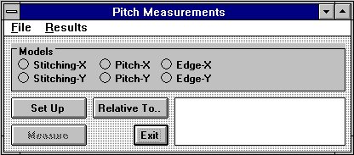
Window 16

PITCH MEASUREMENTS - FILE COMMANDS

Load:

Loads an already existing measurement file, which must have the extension ".msr", and is normally found in the directory \MEASURE. Upon loading, a model option is read from the file and is automatically switched on. After loading, a window will appear requesting that the operator, “Point to the reference site,” to which all recorded measurement positions will correspond. If the measurement method is executed automatically through a Job file, the chosen reference site can also be the alignment site of the respective field.

Save Measurement:

Saves the current measurement method under a requested file name. This measurement method can then be reloaded later or used within an automatic measurement procedure. If a reference site was not previously marked, a window will appear requesting to “choose a reference site”.

Exit:

Closes the Pitch Measurements window (Window 16).

PITCH MEASUREMENTS - RESULTS COMMANDS

After a measurement series has been made, results may be inspected and saved using the Results commands.

View and Save:

Loads an editor with the current measurement results. The file can then be saved as a text file within the editor.

To Excel:

Copies the measurement results to the Clipboard. Upon opening Excel, they may be loaded onto the spreadsheet by pressing Control-V, or highlighting the Paste Function. Data can be further processed and displayed using Microsoft Excel.

MODELS

Stitching-X:

Measures the distance between two vertical lines, on both left and right sides of a stripe border, and will repeat the measurement in other locations on the substrate, if required. The RMS deviation of the results from the resulting average will determine stitching quality in -X.

- Stitching-Y:

Measures the vertical distance between the sections of two horizontal lines, on both left and right sides of a stripe border, and will repeat the measurement in other locations on the substrate, if required. The RMS deviation of the results from the resulting average will determine stitching quality in –Y. This value depends on the stage velocity and therefor must be minimized by optical adjustment for each configuration individually.

Pitch-X:
Compares the distance between two vertical lines or a row of equidistant lines over a programmed area.

Pitch-Y:
Compares the distance between two horizontal lines or a row of equidistant lines over a programmed area.

Edge-X:

Determines the roughness of a vertical edge due to position fluctuations, but can only be applied to a comparatively thin vertical line. The result is insensitive for line width fluctuations.

Edge-Y:

Determines the roughness of a horizontal edge due to position fluctuations, but can only be applied to a comparatively thin horizontal line. The result is insensitive for line width fluctuations.

PITCH MEASUREMENTS BUTTONS

Set Up:

Before a measurement may be executed it must be pre-programmed with the Set Up model. Depending on which method has been selected, measurement frames are required to be placed over the structures, and then a series of measurements can be made by continuation. Cancel Set Up model if sufficient measurements have been made. Once Set Up is complete, the method programmed may be saved and viewed in View Measurement Method under Tools in the Main Menu.
Example of a Pitch Measurement Method

A typical program should follow the format of the model below:

Method=Pitch-X
Camera=Micro
BoxWidth=100
BoxHeight=275
BoxDistance-X=201.44098189792
Reference=Lower Left Corner of PFM Pattern
{ 'Indicates start
0,0 'X,Y of 1. site
100,0 'X,Y of 2. site
200,0 'X,Y of 3. site
300,0 'X,Y of 4. site
400,0 'X,Y of 5. site
500,0 'X,Y of 6. site
} 'End of series

Relative To..:

Before a measurement can be saved a reference position must be selected. If no reference position is selected, then the current stage position will be used as a reference position. For a local series of measurements the location of the first structure is normally used as a reference point. If the measurement method is ready to be used for automatic measurements in the Job file, the field alignment sight may be used.

Measure:

Starts the currently active measurement sequence.

Results (Text Box):

The results text box, located on the lower right-hand side of Window 16, posts the actual measurement result. The complete results can be viewed using the View and Save command.

CHAPTER 6 - TOOLS

TOOLS

A number of tools have been prepared for the further processing and display of collected data.

The following options are only available in systems equipped with cameras

- Analyze Report for Alignment:

Extracts relevant alignment information from a job report file, where the data can then be sent to a spreadsheet for further evaluation.

- Analyze Report for Measurement Results:

Extracts relevant measurement information from a job report file, where the data can then be sent to a spreadsheet for further evaluation.

- View Job Log:

Displays content of the Job Log File.

- View Measurement Method:

Displays present measurement method and will enable an operator to edit the method (i.e., to manually add more measurement points).

ANALYSE REPORT
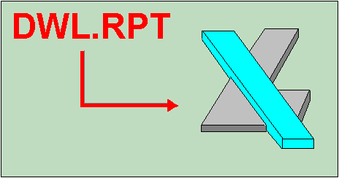

INTRODUCTION

After each exposure and measurement procedure, a Report file is produced containing information regarding the inspection and qualification of an exposure. Since all the various information stored in a Report file are printed in a sequential order, extracting specific data may be necessary before further evaluation may be done. This data extraction may be done either manually or automatically using the Analyze Report window (Window 17).

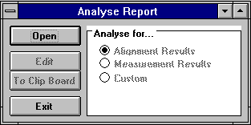
Window 17

ANALYZE FOR…FUNCTIONS

- Alignment Results:

Extracts and groups all relevant alignment data into a table to be processed in Microsoft Excel.

- Measurement Results:

Extracts and groups all measurement results into a table to be processed in Microsoft Excel. The Measurement menu is followed by all stage positions and current measurement results used to produce a plot of measurement results as a function of the location on the substrate.

- Analyse For... (Text Frame):

Displays which option for report file data extraction is currently active.

Example of a Report File:

A Report file for a multi-field exposure / alignment opens with a header, containing the job file name, the date, and the starting time of exposure. Relevant information pertaining to the job file is repeated and followed by the alignment results in each field. If automatic measurements were taken, the results would be listed after each alignment.

HEADER: Exposure of Job=C:\PERF207.DWL

(C:/VBMENU/WAFER/PERF=20=/PERF207.DWL)

: Date=01-21-1995

: Start Time=17:38:44

FIELD1: Alignment Field #=1 Number Of Sites=1

: Site=1 X=-250 Y=1020

: Site=1 DeltaX=-75 DevX=0 DeltaY=127 DevY=0

: 1 sites used, Xshift=74.9 Yshift=-127.0 Xsize=1 Ysize=1 Xrot=0 Yrot=0

: Start Field # 1 at t=12:15:12
: 1 -1 /h0/USER/DWLII/lic/acc10 SCAN:AOD0=2029
-97 120 OS9:dg_ramp –f=7494

: Expodie /h0/USER/DWLII/lic/acc10 SCAN:AOD0=2029 dieX=-3210208 dieY=-59
SCAN: TSX=9.89032570238 SCAN: TSY=9.89032570238

FIELD2: Alignment Field #=2 Number Of Sites=1

: Site=1 DeltaX=-67 DevX=0 DeltaY=115 DevY=0

: Xshift=66.5 Yshift=-115.0 Xsize=1 Ysize=1 Xrot=0 Yrot=0

: Expodie /h0/USER/DWLII/lic/acc10 SCAN:AOD0=2029 dieX=-25277 dieY=-59
SCAN: TSX=9.89032570238 SCAN: TSY=9.89032570238

FIELD3: Alignment Field #=3 Number Of Sites=1

: Site=1 DeltaX=-65 DevX=0 DeltaY=114 DevY=0

: Xshift=64.8 Yshift=-114.0 Xsize=1 Ysize=1 Xrot=0 Yrot=0

: Expodie /h0/USER/DWLII/lic/acc10 SCAN:AOD0=2029 dieX=-3260761 dieY=-59
SCAN: TSX=9.89032570238 SCAN: TSY=9.89032570238

TAIL: Exposure Finished at 09.21.2001 t=17:46:47

ANALYSE REPORT BUTTONS

Open:

Directly after an exposure, or measurement, the last report made is loaded by default and it is not necessary to open a file. The Open command will analyze a previously written report. All report files have the extension .rpt and are normally recorded in their corresponding Job directory.

Edit:

Loads the requested data under a different name into an editor where it may be inspected and saved.

To Clip Board:

Writes extracted data to the Clipboard as to immediately inspect the data using (i.e., Microsoft Excel). Without exiting the DWL menu, start Microsoft Excel and press Control-V, or highlight the Paste command under the Microsoft Excel -Edit menu. The data will be loaded onto the current spreadsheet.

Exit:

Closes the Analyze Report window (Window 17).

VIEW JOB LOG FILE

VIEW JOB LOG

If Job Log is highlighted in the Run Job submenu, then the name of the current job, start time, and stop time for each exposure or automatic measurement is entered in the file "C:\VBMENU\WINDWL\JOBLOG.TXT". The View Job Log function loads this file into the Windows Notepad where it can be inspected, altered, printed or saved under another name, or on another medium. The content of the Job Log is useful for accounting purposes.

VIEW MEASUREMENT METHOD

VIEW MEASUREMENT METHOD

Opens the Windows Notepad for inspecting, editing, saving, and printing measurement method files. Once a specific measurement method is created and is to be repeated over a number of sites, extending the list of measurement locations using the editor can expand the method, which is easier than having to prepare each individual measurement. Use Microsoft Excel to construct a measurement location table for an extremely large number of measurements, but be careful to use the correct format when transferring it to the measurement method.

CHAPTER 7 - SERVICE

SERVICE COMMANDS

- Debug Window:

Monitors communication between the User PC and the DWL Main CPU. This function is only to be used during a test, since it will considerably slow down the performance of the entire DWL system.

- View OS9 Config:

Shows actual machine configuration.

- DWL Control Panel F9:

Opens window with manual controls for most system functions, particularly stage initialization and focus.

- Edit Configuration File:

Opens editor to check and edit current system configuration. Provides access to the Configuration Change window as well as the windwl.ini menu startup file for viewing.

Video Calibration

Calibrates the micro- and macro-camera position against the interferometer. This procedure must be repeated whenever modifications to the optics system have been made.

- Reset Stage:

Initializes the stage after confirmation from the operator by moving it back into the Home position and resetting the interferometer coordinate system.

SMALL TALK COMM DEBUG AND OS9 COMMANDS
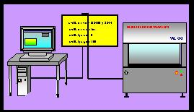

INTRODUCTION

The DWL main system is controlled by a number of programs running concurrently. The User PC simply generates command strings in a useful sequence where decisions depend on a response from the main system. Communication usually runs along one serial COM port, and before the system can be operated, the PC port must be logged in as a user for the Os9 operating system, by clicking on the Mini Terminal icon located below the main menu toolbar. User name and password are factory preset to: “dwlii”. If the PC is not logged in or there is no connection to the system, opening the Debug Window will display commands that would have been sent by the PC to the DWL system.

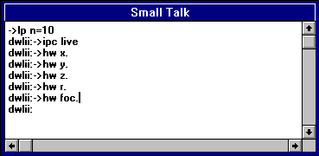
Window 18

OS9 COMMANDS

If the DWL system is connected and the PC is logged on, detailed information on every Os9 command may be obtained by opening the Mini Terminal window and typing in commands with the -? option.

GENERAL COMMANDS:

adjust_fi {[<opts>] <filename>} [<opts>]
Version: 1.02
Function: Download|Create frequency & intensity data for ECU
Options:
-c Create new fi database file
-u Update from existing database
-p adjust Intensity Profile
-i Init with default values
-s[=][<fac>] Scale Int.Profile to <fac>%
-t[=][<range>] Defl.Area Test (+/-<range>%)
<range> 0-100 (%)
-d[=]<hex> debug flag:
$0800 program variables
$0400 Parser

expodie [<opts>] {<design> [<opts>]}
Version: 1.03
Function: Exposure Control Program
Options:
-i[=]<value> Exposure Intensity (0-100)[%]
-s[=]<name> list of stripes
-x[=]<value> X position (nm)
-y[=]<value> Y position (nm)
-k keep SDist from expose.cfg
-d[=]<hex> debug flag:
$0800 program variables
$0400 Parser
$0100 Messages
$0004 calculated values

hw [<opts>] [<cmds>]
Version: 2.00
Function: User Interface for DWL hardware
Commands:
ifstat ckeck status of IF-System
ifreset reset IF-System
hecd[+|-] open|close HeCD shutter
afix[+|-] fix|release Auto Focus
movz display actual <zpos>
movz=<zpos> move write head to <zpos>
movz[+|-]<zsteps> move write head +|- <zsteps>
movz:=<zpos> set write head position to <zpos>
adc.<cname> read value from ADC <cname>
hilo (CH4)
piezo (CH5)
intens (CH7)
IN_0 (CH0)
IN_1 (CH1)
IN_2 (CH2)
IN_3 (CH3)
IN_4 (CH6)
dac.<cname>=<value> set <value> for DAC <cname>
lamp (CH_A)
defoc (CH_D)
OUT_0 (CH_B)
OUT_1 (CH_C)
Options:
-d[=]<hex> debug flag:
$0800 program variables
$0400 Parser

init_dwl [<opts>]
Version: 1.03
Function: init DWL data structures
Options:
-f[=]<file> configuration file (default: dwl.cfg)
-u force update with conf. file
-r[e|u] remove installed memory modules & events
e remove only events
u unlock all events
-d[=]<hex> debug flag:
$0800 program variables
$0400 Parser
$0100 Messages

mov [<opts>]
Version: 1.02
Function: Interface to stage control
Options:
home move stage to home position
-u force move home
[x|y]. show x|y position in nm
[x|y]:=<num> set x|y abs. position to <num> nm
[x|y]:[+|-]<num> set x|y pos. to actual [+|-]<num> nm
[x|y][+|-]<num> move x|y [+|-]<num> nm from act. pos.
[x|y]=[+|-]<num> move x|y to pos. [+|-]<num> nm
-d[=]<hex> debug flag:
$0800 program variables
$0400 Parser
$0100 Messages
$0080 Communication
$0008 Events

IMAGE PROCESSING COMMANDS:

-IPC
Function: execute image processor commands
Syntax: ipc<command>
Commands: dc db offset gain snap live cam tmpl dspt delt fast findy findy cross tpos

-WIDTH
Function: Measure width of video profile
Syntax: width x y xb yb repeats model 2 theshold

-CENTER
Function: Measure symmetry axis of video profile
Syntax: center x y xb yb repeats

-PITCH
Function: Measure distance between two similar video profiles
Syntax: pitch x y xb yb repeats estimate

-TLOAD
Function: Load templates from disk to ipc
Syntax: tload -w=<file>

-TSAVE
Function: Save templates to disk
Syntax: tsave -p=<path -tn=<template number> -w=<file>

DWL CONTROL PANEL

INTRODUCTION

The most important commands for direct, interactive operation are made available through the DWL Control Panel (Window 19), featuring options for stage control, focusing, simple measurement capabilities, camera adjustments, etc. The DWL Control Panel can be opened by clicking on the Control Panel icon located below the main menu toolbar, or by highlighting the DWL Control Panel F9 submenu under the Service heading.

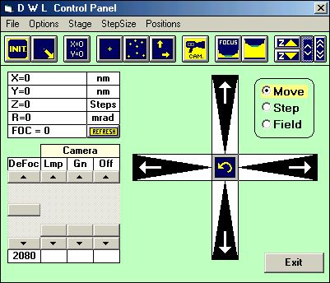
Window 19

STAGE BUTTONS

- INITIALIZE:

Initializes stage coordinates, where the writehead moves until it reaches its upper endswitch and the XY stage moves to the home position. After setting the X and Y position registers to zero, the stage moves to the center position.

- LOAD POSITION:

This function performs a stage initialization as described above and then moves the stage to the load position.

- SET X=0, Y=0:

Sets both X and Y coordinates to zero at the current position.

- MOVE TO 0, 0:

Moves stage to the latest set 0,0 position

- MOVE TO...:

Moves stage to an absolute X / Y position, where the required position is entered in microns.

- MOVE...:

Moves stage to a relative X / Y position, where the required position is entered in microns.

CAMERA BUTTONS

CAMERA:

Selects micro- or macro-camera and correspondingly, adjusts the video values for the selected camera to the latest values that were used.

WRITEHEAD BUTTONS

- FOCUS:
Moves down the writehead until it reaches the airflow auto-focus position while continuously displaying the current Z-stage position. Pressing the Cancel button will abort the Focus command if there are any doubts regarding the correct position of the airflow auto-focus. The nozzle can be permanently damaged if the stagemoves while performing the Focus function, or if focusing is done on the edge of a substrate.

- LENS UP:

Moves the writehead into its upper end position. Use if there are doubts about the surface flatness of the substrate and a test focusing on different locations and comparing the z-values must be done

MOVE Z:
The writehead moves up or down while one of the z-buttons is pressed. Using the arrow buttons, choose between slow or fast movement. It is not possible to move below the airflow focus position.

SCROLL SLIDES

- Foc (or, Defocus):

Slide to set a certain offset between the airflow focus position and the required optical focus. Value range is 0 to 4095. (200 units are approximately 1µm).

- Lmp (Lamp):

Slide to choose lamp intensity. Value range is 0 to 255

- Gn and Off (Gain and Offset):

Controls gain and offset of the image processing system and are normally set to 128. Only slide to a different setting if increasing contrast is necessary.

MENU BAR

- File:

  - Load / Save Panel Status:

Will refresh Configuration File with new values- or reload previous values.

- Quit:

Closes Control Panel (Window 19).

- Options:

- Nanometer / Microns:

Check desired metric representation of the stage position. The Result Panel displays selected metrology.

- Relative / Absolute:

Check desired representation of the stage position. The Result Panel displays selected representation. If Relative representation is marked then a ^{u}0ª button will appear and the stage position window is reset. Marking Absolute will return the display to absolute stage position coordinates. This feature can be used for rough distance measurements.

- Stage:

- Initialize:

Initializes stage coordinates, where the writehead moves until it reaches its upper endswitch and the XY stage moves to the home position. After setting the X and Y position registers to zero, the stage moves to the center position.

- Load Position:

This function performs a stage initialization as described above and then moves the stage to the load position.

- Reset:

Initializes the stage after confirmation from the operator by moving it back into the Home position and resetting the interferometer coordinate system.

- Motor ON / OFF:

Switches linear motors on or off.

- Move...:

Moves stage to a relative X / Y position, where the required position is entered in microns.

- Move to...:

Moves stage to an absolute X / Y position, where the required position is entered in microns.

- Move to 0, 0:

Moves stage to the latest set 0,0 position

- Set X=0 Y=0:

Sets both X and Y coordinate values of current position to the values given.

- Set X=_, Y=_:

Sets coordinate values of current position to the values given.

- Set rot = 0:

Resets rotation angle to 0 (including any rotational correction.

StepSize:

Shows field size, as extracted from the current Map file, which will be used for the fieldwise stage move function. Also shows current stepsize for stepwise motions, which can be changed by clicking on the numbers.

- Positions:

Offers the possibility to memorize up to 8 positions and move directly to the memorized positions by highlighting them in the list.

X-Y STAGE

ARROWS:

With each left-click on one of the arrow fields the stage moves stepwise. The stepsize depends on the click-position. It ranges from zero to a maximum of about one camera picture. Meaning, the maximum stepsize depends on the installed writehead and on the chosen camera. A right-click moves in the opposite direction.

CENTER ARROW:

Moves the stage back to the previous position.

MOVEMENT COMMANDS

- Move:

Stage movement with arrows is done in steps according to click position on the arrows.

Step:

Jumps the stage over preset steps independent of click-position. Set the stepsize with the StepSize Menu function.

Field:

Jump from field to field as defined in the exposure map.

EDIT CONFIGURATION FILE

INTRODUCTION

There's at least one configuration file for each writehead located in the directory /VBMENU/WINDWL.

NOTE: Some entries are set manually during setup and calibration, while others store menu or machine parameters used by the menu.

Highlighting Edit Configuration File under Service in the main menu will open the current configuration file, shown in the Edit Configuration File window (Window 20):

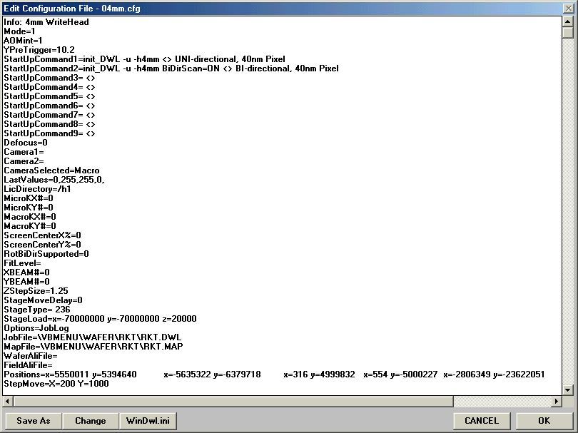
Window 20

EDIT CONFIGURATION FILE BUTTONS

- Save As:

Saves current configuration file under a new name.

- WinDwl.ini

The WinDwl.ini button opens the file WinDwl.ini, which only consists of two lines and sets the configuration file for the menu, which will be loaded at the menu startup. This file is automatically created whenever the configuration file is changed. The first line shows, which write head configuration was loaded, last.

The configuration should not be changed manually. There is a different configuration file available for each writehead, i.e., the file 04mm.cfg is the configuration file for a 4mm writehead, the file 20mm.cfg for a 20mm writehead. The second line shows which of the available write modes were chosen for the chosen write head.

- Change:

Opens the Choose Configuration window (also accessible from configuration information box in the main menu toolbar), in which a new configuration file can be loaded.

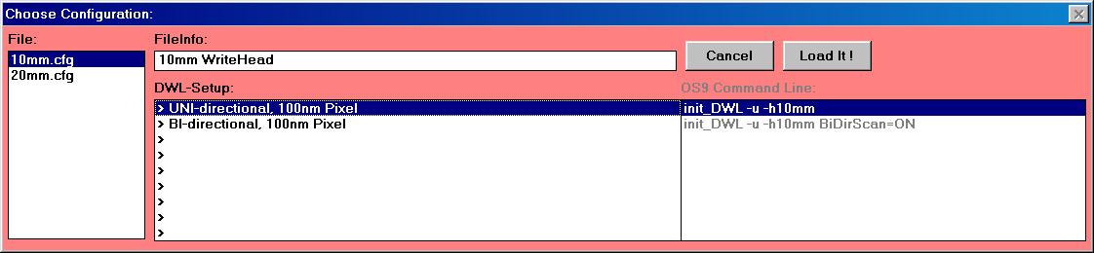

In the Choose Configuration window, the left text box shows which write head configurations are available. Once a write head has been chosen, the right text box displays the write modes available for the chosen write head.

CHOOSE CONFIGURATION BUTTONS

  - Cancel:

Closes Choose Configuration window and returns to the main menu.

  - Load it!:

Menu will restart with the new configuration.

- CANCEL

Closes Edit Configuration File window (Window 20) without testing for changes or updating the system.

- OK

Accepts modifications, saves changed configuration file, and resets all system parameters accordingly.

PARAMETERS

Note: Parameters for alignment or camera settings are only displayed if these features are available.

A detailed description of the global menu parameters and corresponding values are as follows:

- Info:

Will show the File Info line shown in Choose Configuration window if the file is highlighted

- Mode=

Mode=0 means DWL is available
Mode=1 can be used to test most functions

Port=

Indicates which COM port is being used

AOMint=

Type of intensity setting technique, which depends on a machine's hardware
Usually set to 1 for newer machines

StartUpCommand#=

Batch file on OS9 to be executed during Menu start
Usually used to adapt the OS9 software to different write heads and write modes

- Defocus=

Last selected offset to the airgauge focus value

- Camera1=

Last used values for lamp (lmp), offset (off) and gain (gn) for macro-camera

- Camera2=

Last used values for lamp (lmp), offset (off) and gain (gn) for micro-camera

- CameraSelected=

Indicates which camera has been selected (macro or micro)

- LastValues=

Last values for lamp (lmp), offset (off), gain (gn), and defocus (defoc) used in the Control Panel

LIC Directory=

Default path for design data on machine

- MicroKX#=

Micro camera calibration value in X direction, units is ticks per pixel

- MicroKY#=

Micro camera calibration value in Y direction, units is ticks per pixel

- MacroKX#=

Macro camera calibration value in X direction, units is ticks per pixel

- MacroKY#=

Macro camera calibration value in Y direction, units is ticks per pixel

- ScreenCenterX%=

Center pixel of the frame grabber in X

- ScreenCenterY%=

Center pixel of the frame grabber in Y

- RotBiDirSupported=

Set to 0 if system does not support coordinate system rotation for bi-directional writing; set to 1 if system does support it

- FitLevel=

The correlation level, which must be achieved so that a template is considered "found" Standard value is 0.8, but may be set to a lower value if contrast is poor

- XBEAM#=

Distance between the center of the micro-camera image and the position of the write beam in X -measured in micrometers
Typically, the value should be roughly half the scan width
Important for multi layer exposures
See Overlay Exposure Instruction in User Guide: PART I for information on how to set this parameter

- YBEAM#=

Distance between the center of the micro camera image and the position of the write beam in Y -measured in micrometers
The value should be close to zero
Important for multi layer exposures
See Overlay Exposure Instruction in User Guide: PART I for information on how to set this parameter

- ZStepSize=

Step size in micrometers for course write head motion

- StageMoveDelay=

Depending on the size of the stage a certain delay is necessary after the stage is stopped and a camera frame is frozen
The value can only be entered as an integer in seconds

StageType=

Certain menu functions are changed depending on what stage is built into a system
Stage types of the DWL 66 are: "206" for a DWL 66 without camera system and "236" for a DWL 66 with camera system

StageLoad=

The plate load position of the stage in nm Z is usually set to -20000; X and Y depend on the stage size.

- Options=

Contains a list of menu options, which should remain after the system is shut down
The menu options for which the keywords are present in the configuration file are activated
The keywords are separated by ",” i.e., AutoUnload, JobLog will cause the system to move to the unload position upon termination of the exposure and to make a record of all expose jobs

- JobFile=

Name and Path of the current Job File

- MapFile=

Name and Path of the current Map File

- WaferAliFile=

Name and Path of the current Global Alignment File (Not used)

- FieldAliFile=

Name and Path of the current Field Alignment File

- Positions=

A record of the 8 stage positions, which can be programmed by the user in the Control Panel
The format is: x=value y=value(TAB)x=value y=value(TAB)......…

- StepMove=

Last selected step size for stepwise stage movements in microns

CAMERA CALIBRATION
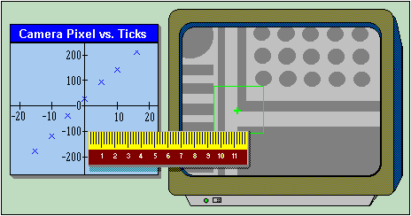

INTRODUCTION

The relation between camera pixels and interferometer ticks is necessary in applications such as alignment, measurements, and calibration. Camera calibration must be done after any modifications to the optical system, particularly if the camera systems are affected. A program will calibrate the cameras automatically aided by the image processor if a substrate with sufficient image contrast is available.

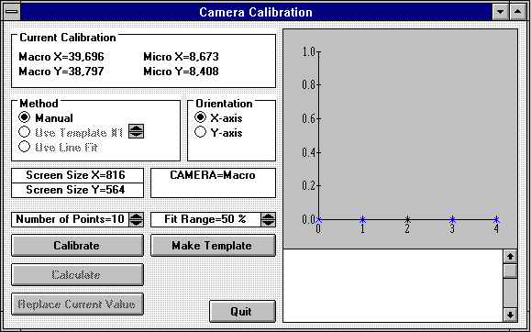
Window 21

Steps are available in User Guide: PART I, for the execution of the CAMERA CALIBRATION INSTRUCTION.

METHOD

- Manual:

Use if no reliable template could be defined.

- Use Template:

Uses last template defined and stored in the IPC template buffer chosen with the arrow buttons.

ORIENTATION

- X-axis / Y-axis:

Selects the axis to be calibrated.

PARAMETERS

Number of Points=:

Sets number of positions for calibration measurement.

Fit Range=__%:

Determines the range of the camera field over which the calibration will be done. Maximum number is 90%.

CAMERA CALIBRATION BUTTONS

- Calibrate:

Starts the automatic calibration procedure for the active camera (change cameras in the Control Panel). The data points are shown in graph during measurement.

- Make Template:

Opens the make template program, where saving the template, although not forbidden, is not necessary. Storing template in the IPC module is sufficient by using any of the four buffers, primarily buffer 1.

- Calculate:

Performs a linear regression analysis of measured curve, where the slope will be the new calibration factor. Results and reliability of the regression fit are shown in the text box below the graph.

- Replace Current Value:

Replaces the current calibration factor, shown on top of the form, with the latest calibration factor measurement.

- Quit:

Closes the Camera Calibration window (Window 21).

CHAPTER 8 - HELP SYSTEM

HELP MENU COMMANDS

Main Subject Index

Opens an alphabetical list of subjects. Highlight and double-click on an entry to display help text.

Read Me

Opens editor with Read Me file informing about the latest menu modifications.

About

Displays originator and version of the Menu. Please have this information ready when contacting HIMT in regarding any questions or concerns.

ON-LINE HELP SYSTEM

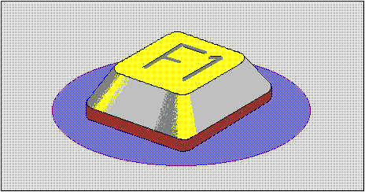

INTRODUCTION:
The On-Line DWL Help System extracts current information and hints on using the DWL menu and the direct write laser system. Pressing "F1" will always show information regarding the currently active application in a window similiar to Window 22 below. Press "Esc" to return to active applications.

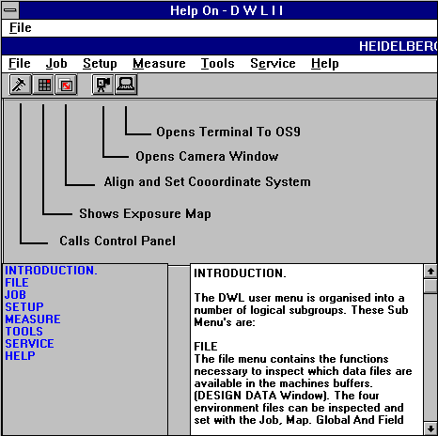
Window 22

KEYWORDS

By highlighting one of the keywords in the list on the left side of the Help Index, text scrolls automatically to show the text related to the chosen keyword. Keywords are always (sub) paragraph titles.

HOW TO ADD “HELP TEXT”

To make notes on items or clarify a help entry, either type in or change the text in the help entry. Entering a paragraph title on a separate line and typing the entire word in capitals will create a paragraph; for example, to add a paragraph on a checklist before an exposure, type the following remarks in the help text under the "Run Job" window:

Example of Adding Text into the Help On Window

: CHECK LIST (use only capitals in the help text and the word will be entered as a keyword)

: Load Plate

: Move Stage to Center

: Focus

: Level

: Check if Focus range is ok for entire plate

: Find plate center

: Set XY coordinate system to X=0.5*Pattern size and Y=0.5*Pattern size

: Use Job Hello.dwl

: Enter current job in Lic Buffer column

: Start

: Etc,..

: Etc,..

Highlight Save (to save new entry) under the File menu, or press ESC and accept the suggestion of system to update the file. Pictures cannot be altered.

While installing an update for the menu, all new entries will be overwritten.

HELP ON – FILE COMMANDS

Save:

Overwrites current file with the changed help text.

Save As:

Saves current file with changed help text under a new name (as requested).

Exit:

Closes Help On window (Window 22) and returns to current active application window.

