HEIDELBERG INSTRUMENTS User Guide: PART I
System Operation
Quick Start
DWL 66
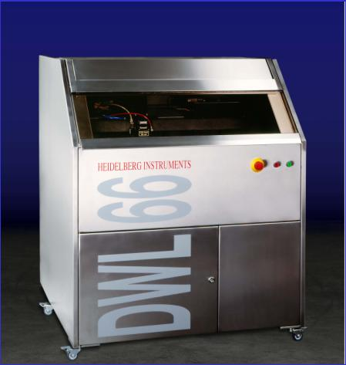

Copyright Notice

© Copyright Heidelberg Instruments Mikrotechnik 2002
TABLE OF CONTENTS

CHAPTER 1 – INTRODUCTION…………………………………………….... | 7
INTRODUCTION………………………………………………………………..….... | 7
SAFETY INFORMATION………...........................………………....…………........ | 8
RELATED DOCUMENTATION………………………………………...………….... | 8
IF YOU NEED ASSISTANCE……………………………………………....……....... | 8
SAFETY PRECAUTIONS……………………………………………….....…………. | 9
WARNINGS……………………………………………………………..…………… | 9
GENERAL PRECAUTIONS……………………………………………...………….. | 9
LASER CHARACTERISTICS………………………………………………....……... | 10
SAFETY DURING SERVICE AND INSTALLATION…………….....………………. | 10
ELECTRICAL SAFETY……………………………………………....……………….. | 11
CHAPTER 2 – GETTING STARTED……………………….......……………… | 13
INTRODUCTION…………………………………………………...……………….. | 13
GRANITE SYSTEM…………………………………………………...……………… | 14
INTRODUCTION...………………………………………………..………………… | 14
ELEMENTS OF THE GRANITE CONSTRUCTION………………........…………… | 15
SYSTEM SUPPORT........…………………………………………….....……............ | 15
MAIN BLOCK....................................................................................................... | 15
STAGE SYSTEM.....……………………….....……………………………................ | 15
OPTICS PLANE...............................………………………...…………………....... | 15
COVER BOX / FLOWBOX....……..........………………....…………………..…… | 16
COVER BOX OPTION....................……………………………………………..… | 16
FLOWBOX OPTION............................................................................................. | 17
ELEMENTS OF THE FLOWBOX............................................................................ | 17
Window........................…………………………………………………………...... | 17
Heating and Airflow System..…………………………………………………… | 17
Weather Station……………….......................................................…………..... | 17
Light...................................................................…………………...……………... | 17
OPTICS SYSTEM................................................................................................... | 18
FIVE MAJOR ELEMENTS THAT COMPRISE THE OPTICS SYSTEM..................... | 18
Laser Unit............................................................................................................. | 18
Multi-beam Modulator..................................................................................... | 18
Write Lens System.............................................................................................. | 19
Camera Unit...................................................................................................... | 19
Interferometer................................................................................................... | 20
ELECTRONIC CONTROL UNITS........................................................................... | 21
INTRODUCTION.................................................................................................. | 21
ELECTRONICS CONTROL................................................................................... | 22
USER PC............................................................................................................... | 24
INTRODUCTION.................................................................................................. | 24
BUTTONS.............................................................................................................. | 24
File........................................................................................................................ | 25
Job....................................................................................................................... | 25
Setup................................................................................................................... | 25
Measure.............................................................................................................. | 26
Tools..................................................................................................................... | 26
Service................................................................................................................. | 26
Help..................................................................................................................... | 27
CONVERSION SOFTWARE.................................................................................. | 28
INTRODUCTION...................………………………………………………..……… | 28
CONVERSION STATION..................................................................................... | 28
APPLYING POWER / POWERING DOWN......................................................…. | 29
APPLYING POWER INSTRUCTION.......................................…………......…….. | 29
POWERING DOWN INSTRUCTION...................……………………...…………. | 29
CHAPTER 3 – HOW TO DO EXPOSURES............……………......………. | 30
INTRODUCTION.............................……………………………………..………… | 30
PREPARING FOR EXPOSURE...................................………………….......……... | 31
INTRODUCTION...................…………………………………………..…………… | 31
PLATES.................................................................................................................. | 31
LIGHT.................................................................................................................... | 31
CHANGING WRITE HEADS................................................................................. | 32
INTRODUCTION...................………………………………………………..……… | 32
CHANGING THE HF-UNIT INSTRUCTION........................................................... | 32
CHANGING THE WRITEHEAD INSTRUCTION.................................................... | 33
CHANGING SYSTEM CONFIGURATION INSTRUCTION................................... | 34
MAIN MENU........................................................................................................ | 35
OPEN MAIN MENU INSTRUCTION..................................................................... | 35
SHUTTING DOWN MENU AND COMPUTER...................................................... | 35
LOGIN WITH THE MINI TERMINAL...................................................................... | 36
INTRODUCTION.................................................................................................. | 36
MINI TERMINAL LOGIN INSTRUCTION.............................................................. | 36
CHECK INTERFEROMETER STATUS...................................................................... | 38
LOADING............................................................................................................. | 39
LOADING INSTRUCTION....................................................................................  FOCUSING........................................................................................................... | 39  42
FOCUSING INSTRUCTION.................................................................................. | 42
PROCESSING THE DESIGN DATA....................................................................... | 44
INTRODUCTION.................................................................................................. | 44
PROCESSING INSTRUCTION.............................................................................. | 44
CREATE MAP....................................................................................................... | 44
JOB CONTROL FUNCTIONS............................................................................... | 49
INTRODUCTION.................................................................................................. | 49
JOB COMMANDS.............................................................................................. | 49
JOB CONTROL INSTRUCTION........................................................................... | 50
ALIGNING MANUALLY....................................................................................... | 58
MANUAL ALIGN PROCEDURE.......................................................................... | 58
SETTING THE ORIGIN.......................................................................................... | 60
INTRODUCTION.................................................................................................. | 60
ORIGIN INSTRUCTION........................................................................................ | 60
PREPARING FIELD ALIGNMENT SEQUENCES.................................................... | 61
INTRODUCTION.................................................................................................. | 61
SETUP OF A FIELD ALIGNMENT PROCEDURE.................................................. | 62
SETUP OF A SIMPLE CROSS ALIGNMENT......................................................... | 62
SETUP OF OTHER ALIGNMENT PROCEDURES.................................................. | 63
EXPOSING........................................................................................................... | 66
INTRODUCTION.................................................................................................. | 66
EXPOSE INSTRUCTION........................................................................................ | 67
OPTIONS.............................................................................................................. | 69
OVERLAY EXPOSURES........................................................................................ | 70
INTRODUCTION.................................................................................................. | 70
TESTING AND ADJUSTING OVERLAY ACCURACY......................................... | 70
OVERLAY EXPOSURE INSTRUCTION.................................................................. | 72
CHAPTER 4 – HOW TO DO METROLOGY…………………….....………. | 74
INTRODUCTION........................………………………………………..………….. | 74
OVERLAY MEASUREMENTS...................................................................……….. | 75
INTRODUCTION.............................……………………………………………...… | 75
LARGE BOX IN BOX METHOD.......………………………………………..……… | 76
SMALL BOX IN BOX METHOD......…………………………………………...….... | 77
OVERLAY MEASUREMENTS INSTRUCTION....................………………......…... | 77
DISTANCE MEASUREMENTS............................................................................... | 81
INTRODUCTION.................................................................................................. | 81
MEASUREMENTS USING MANUAL ALIGNMENT INSTRUCTION...................... | 82
MEASUREMENTS USING A TEMPLATE INSTRUCTION....................................... | 83
POSITION MEASUREMENTS................................................................................ | 84
INTRODUCTION.................................................................................................. | 84
POSITION MEASUREMENTS INSTRUCTION....................................................... | 84
LINEWIDTH MEASUREMENTS.............................................................................. | 87
INTRODUCTION.................................................................................................. | 87
MODEL..............................…………………………………………….…………… | 88
PROPERTIES......................………………………………………………....………. | 88
LINEWIDTH MEASUREMENTS INSTRUCTION…………………………........……. | 89
PITCH AND STITCHING…………………………………………............................ | 92
INTRODUCTION.....................................………………………………..………… | 92
MODELS.....................................………………………………………..…………. | 92
OTHER APPLICATIONS..............................................................................…….. | 93
PITCH MEASUREMENTS INSTRUCTION....................................................…….. | 94
CAMERA CALIBRATION………………………………………..………................ | 97
CAMERA CALIBRATION INSTRUCTION...........................……………….....….. | 97
CHAPTER 5 – ERRORS AND TROUBLESHOOTING............................... | 99
INTRODUCTION.....................……………………………………………...……… | 99
THE DWL WILL NOT IMAGE………………………………….................………… | 99
LINES NOT TO SIZE………………………………………………............................ | 99
FILM FOGGING………………………………………………………..................... | 99
THE DWL STOPS ANYTIME DURING THE EXPOSURE................................……. | 100
PLATES COME OUT ALL BLACK……………………………………...…….......... | 100
PLATES COME OUT COMPLETELY CLEAR……………………….....………...... | 100
ONLY HALF THE SCAN IS EXPOSED………………...........…..…….....………… | 100
CHAPTER 6 – OPERATOR MAINTENANCE………………......………….. | 102
INTRODUCTION...………………………………………………………..…………. | 102
SYSTEM CHECKS………………………………………………………................... | 102
ENVIRONMENTAL ADJUSTMENT.......…………...…………………....………..... | 102

CHAPTER 1 - INTRODUCTION

INTRODUCTION

The DWL 66 is an extremely high-resolution imaging system where over half a million dpi is achieved using a 40-nanometer writeable address grid for exposing chrome plates or wafers. Depending on the individual X/Y stage, a DWL 66 will accommodate media up to 6 x 6 inches or even 8 x 8 inches. Design data is produced on any program using DXF, HPGL, Gerber, GDSII, or CIF files and is converted into a LIC format that is outputted into the DWL system through a “CONVERT“ workstation.

SAFETY INFORMATION

CAUTION: Advises that you risk damaging your equipment if you do not heed instructions.

WARNING: Advises that you risk danger to personal health if you do not follow instructions carefully.

RELATED DOCUMENTATION

The following related documents are available:

- Preinstallation Guide

- User Guide, Part II

- Conversion Manual

IF YOU NEED ASSISTANCE

Should you need assistance, please call HEIDELBERG INSTRUMENTS during normal business hours (CET)

PHONE: +49-6221-3430-0

FAX: +49-6221-3430-30

You can also reach HEIDELBERG INSTRUMENTS via e-mail: himt@himt.de, or visit our site on the Internet: http://www.himt.de



Safety Precautions

WARNINGS

- The DWL machines use lasers and high voltage electronics.

- Please read this section carefully before operating the system!

- If instructions are not followed carefully, danger to personal health and damaging the equipment is at risk.

GENERAL PRECAUTIONS

The DWL 66 protects operators from exposure to moving parts and laser energy while operating equipment. All moving parts, lasers and their associated optics are enclosed within either a cover box or a laminar flowbox, depending on the system configuration. During operation, opening the coverlid / flowbox window will automatically stop an exposure. Please observe the following safety precautions while operating the DWL 66:

- Follow all warnings and instructions.

- Ensure that both the voltage and frequency of a power source match the voltage and frequency stated on the equipment’s electrical label.

- Except when loading media, never push objects of any kind through openings in the equipment. Dangerous voltage levels may be present. Conductive foreign objects could produce a short circuit resulting in a fire, electric shock, or permanent damage to your equipment.

- To reduce the risk of electrical shock, always plug the DWL 66 into an approved outlet with correct ground. Power requirements are described in the “DWL 66 Preinstallation Guide".

- Not all power cords have the same current ratings. Household extension cords do not have overload protection and are not meant for use with computer systems. Never use household extension cords with the DWL 66.

LASER CHARACTERISTICS

The DWL 66 employs a 442nm HeCd laser with an output power of between 20mW and 180mW, depending on the specific design. Laser light exhibits many characteristics that are different from those found in conventional light sources, where safe use depends on awareness of these characteristics and proper treatment of the laser instrument. If a beam passes directly into the eye, serious damage may occur, including vision loss. In addition, a beam remains coherent even when reflected, and it may cause eye damage when contacted indirectly from reflective surfaces.

SAFETY DURING SERVICE AND INSTALLATION

When conditions require that the removal of the sidewalls from the flowbox (such as for servicing or troubleshooting by trained service personnel), where accessible energy is of the class III b category, then personnel should observe all normal electrical and mechanical safety precautions as well as those applicable to the lasers.
BE ADVISED

- FOR ALL PREVIOUSLY STATED REASONS -
ONLY TRAINED SERVICE PERSONNEL MAY PERFORM SERVICE AND TROUBLESHOOTING ON THE EQUIPMENT.

WARNING: At all times during laser operation, avoid possible exposure to laser radiation.

WARNING: Misuse of controls, making adjustments, or altering performance of procedures other than those specified in this User Guide, may result in hazardous radiation exposure.

WARNING: Always have the power supply and the laser head cover in place when the laser is connected to the AC outlet.

WARNING: Limit access to the laser in regards to unauthorized service personnel. Keep access of the laser away from inexperienced, and / or untrained personnel.

WARNING: When laser is on and the output beam is not being terminated in an experiment or optics system, the beam should be blocked.
WARNING: Never look directly into the laser beam, never sight down a beam into its source.

WARNING: Do not allow reflective objects to be placed in, or near the laser beam. Laser light scattered by reflective objects can be as damaging as the original beam. Objects such as rings, watchbands, and metal pens or pencils can be hazardous.

WARNING: Post warning signs and limit access to the laser area when the DWL machine is in operation.

WARNING: Even while wearing laser safety glasses, there are two hazards that exist while operating continuous wave (CW) ion lasers:

- Safety glasses make the beam itself invisible, increasing the danger of skin burns.

- Laser glasses may not afford enough protection when directly viewing the laser beam.

WARNING: Never leave the laser on, especially when covers are open and unattended.

ELECTRICAL SAFETY

Operating power in the DWL 66 is supplied by a CEE type 220-240 V, 16 A connector. Alternatively, a CEE type 220-240 V, 16 A single-phase female cable connector can be used to connect a local-type cable to a local-type wall connector.

The following safety precautions should be observed when doors and covers are opened and the equipment is energized.

- Observe similiar electrical precautions as would be for any system consisting of 220-240 VAC dedicated circuit single-phase power and DC power supplies.

- If access to the interior power is necessary while laser is in operation, exercise extreme caution. Only qualified service personnel should have access to the interior.

WARNING: Both laser head and power supplies contain electrical circuits operating at high voltages. If access to the laser interior or power supply is necessary, exercise extreme caution to avoid contact with lethal high voltages.

CHAPTER 2 – GETTING STARTED
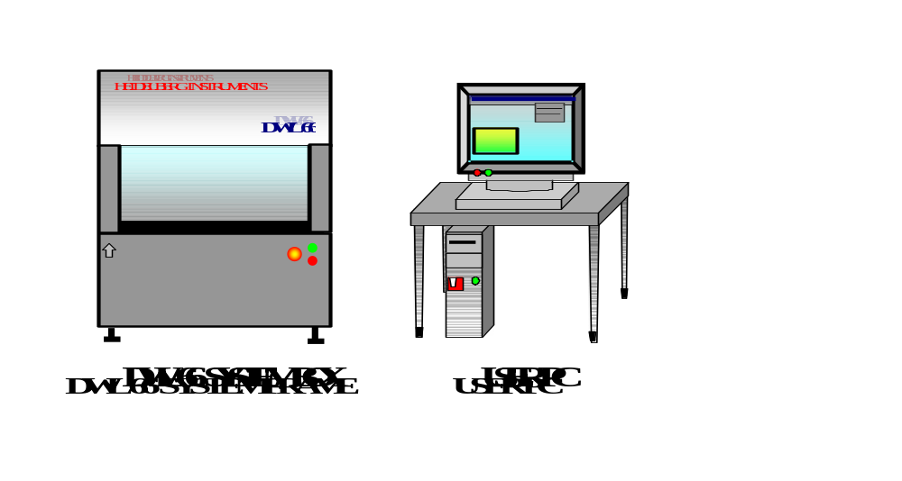
INTRODUCTION

The DWL system consists of the following main sub units:

- Granite System

- Cover / Flowbox

- Optics System

- Electronics Control Units

- User PC / Data processing conversion workstation

Granite System

INTRODUCTION

The DWL main system consists of a heavy granite construction. Granite has been selected for its weight and stability. These properties ensure that:

- Effective vibration isolation in connection with the air buffer system
- A low expansion coefficient

In order to maintain an even expansion coefficient, all other stage parts are constructed from granite as well. Although this material has certain advantages granite is not completely insensitive to external influences. Temperature and humidity play an important role in the stability of the machine, therefore its external environment must be kept extremely stable. The large mass of the system results in a long adaptation period before the machine may be utilized to produce consistent results. Hence, installation must be carried by means of the following two steps:

STEP 1: System set up and function tests.

- These tests can be performed when the granite system has been set in a final location for anywhere between 24 - 48 hours

- Until a system has completely adapted to its location, final calibration procedures will not prove useful

STEP 2: After about 1 to 2 weeks the system is calibrated and end tested.

- This procedure is often followed by a final acceptance test in cooperation with the customer

ELEMENTS OF THE GRANITE CONSTRUCTION

SYSTEM SUPPORT:

The granite base is supported by a heavy-duty aluminum construction and four air filled buffers for vibration isolation. These buffers are arranged in a quasi-three point system as to avoid any unnecessary bending forces in the granite.

STAGE SYSTEM:

The XY-stage system is an ANORAD X/Y-stage. The stage is driven by linear motors. Chosen for its reliability and ease of use, the systems’ motion is controlled using the X- and Y-interferometer system and the ANORAD controller.

The stage is equipped with a vacuum chuck.

OPTICS PLANE:

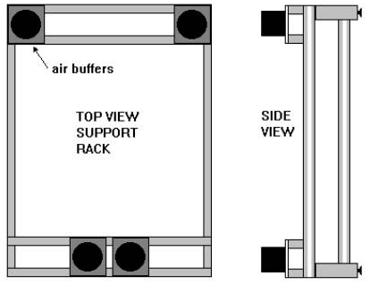
MAIN BLOCK:

The main granite block contains large holes to accept the air buffers so that the blocks’ center of gravity lies below the attachment points of the air buffers. This increases the stability of a system during writing. The block also contains screw holes as to accept other components of the granite system.

The optics plane contains all beam control elements, lenses and mirrors. The write lens is also mounted on the optics plane and is directed downwards onto the substrate. To minimize heat generation in this area the HeCd laser is mounted above the optics plane and in its own compartment.

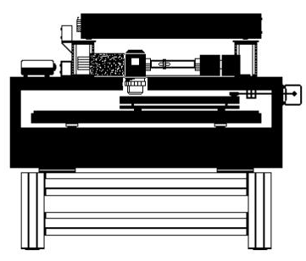

Cover Box / Flowbox

COVER BOX OPTION
The cover box lid is used for loading and unloading plates and will activate a security switch that immediately stops exposure and stage movement if opened during an exposure!

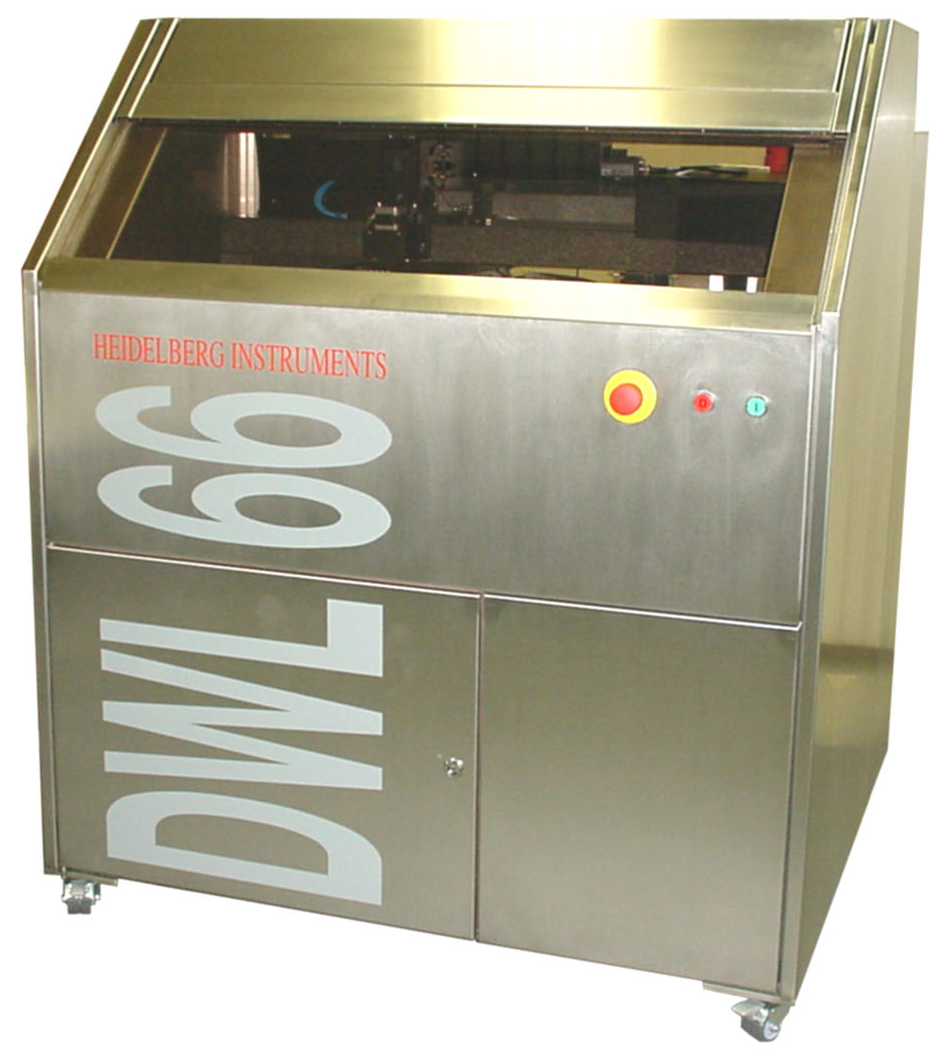

The outer frame protects the DWL 66. Located on the front are the ON and OFF switches as well as the EMERGENCY STOP switch.

FLOWBOX OPTION

The flowbox provides a stable environment for the DWL in terms of temperature, laminar airflow and clean air, guaranteeing constant exposure conditions and thus minimal variation of exposure parameters.

The front of the flowbox features buttons for powering up or down the system, an emergency STOP button, and a switch for lifting and lowering the window. The covers of the flowbox can be removed for service.

ELEMENTS OF THE FLOWBOX

- Window:

Used for loading and unloading the DWL; and must not be opened during operation (opening window will stop operation).
The switch on the front of the flowbox will lift and lower the window connected to the compressed air supply.

- Heating and Airflow System:

Airflow is adjustable to between 0.3 and 0.5m/s.
The heating system is situated below the top of the flowbox, and is regulated automatically by a temperature control unit.
The temperature stability, assuming (±1°C / ±1.8°F) outside the unit, is (±0.1°C / ±0.2°F) on the inside.

- Weather Station:

Measures temperature and pressure inside the flowbox.
Data is processed on the system controller and may be viewed from the User PC.

- Light:

Depending on the type of coating on the plates to be exposed, a red or yellow light may be switched on inside the flowbox.

CAUTION

Although provided with a standard plug, the heating system is not to be plugged into a standard outlet, rather into the designated outlet situated inside the flowbox. The heating is installed by service personnel and is not to be modified by the user. Improper installation can cause the system to overheat and to be damaged beyond repair.

Optics System

FIVE MAJOR ELEMENTS THAT COMPRISE THE OPTICS SYSTEM

- Laser Unit

- Multi-beam Modulator

- Write Lens System

- Camera System (on systems equipped for overlay exposures or measurements)

- Interferometer

LASER UNIT:

The laser unit is mounted directly above the granite base. The power supply is mounted away from the system, as it will generate heat. The DWL 66 runs a 442nm HeCd laser.

Field replacement of the HeCd laser is simple and can be done by local service engineers.
WARNING

- The HeCd laser is a class III b category, and under these conditions, personnel must observe safety precautions (i.e., sufficient eye protection)

- Never look directly into the laser beam

- Never sight down a beam into its source

MULTI-BEAM MODULATOR:

An extremely swift modulator system, generating up to 32 various beam positions, can digitally turn each beam position on and off.

The Multi-beam Modulator is factory adjusted and can only be worked on in the field by factory engineers.

WRITE LENS SYSTEM:

Five various write lenses can be utilized. The focal length of each lens is as follows:

2mm: Used for high-resolution chrome plates
4mm: Used for high-resolution chrome plates
10mm: Used for low-resolution chrome plates
20mm: Used for high-resolution emulsion plates and films
40mm: Used for low-resolution emulsion plates and films

The customer, when adapting a system to a unique application, can exchange any lens. (Usually, not all lenses are part of the shipment.)

An air gauge auto focus system is used to correct for variations in the glass plate thickness employing a piezo.
CAUTION

- Make sure that the nozzle of the air gauge autofocus system never touches the substrate, or the stage!

CAMERA UNIT:

Depending on the system configuration, a camera unit may be implemented. The camera unit is comprised of a micro camera, a macro camera, and a white light illumination. Such a unit can be used to inspect and measure plates and films. For chrome mask applications the cameras are employed for alignment. The cameras are connected to a video image processing system with a vast number of metrology functions.

INTERFEROMETER:

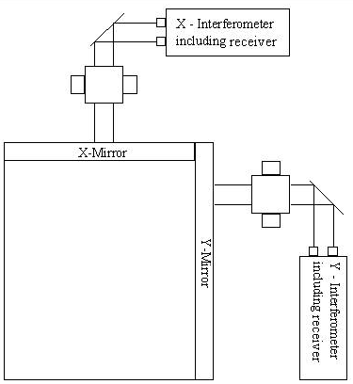
Only industry standard interferometer systems with proven qualifications are being utilized. A stage position measurement device provides the necessary information for its error correction processing system. Only through this function will a machine be able to achieve its required level of precision.
CAUTION

- Do not touch the mirrors for any reason!

- Touching the mirrors with bare hands will damage them beyond repair!
WARNING

- Never interrupt any of the interferometer laser beams, since this will cause the stage to stop

- If beams were interrupted, the interferometer must be reinitialized before machine operation may be resumed

Electronic Control Units
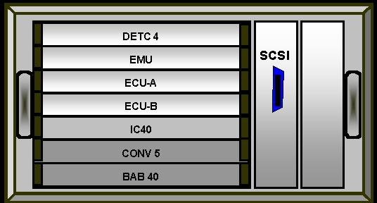
INTRODUCTION

The electronic control of the DWL66 consists of three main parts: a system control unit, a stage control unit and an RF unit. The IC40 is only installed on systems equipped with a camera system.

ELECTRONICS CONTROL
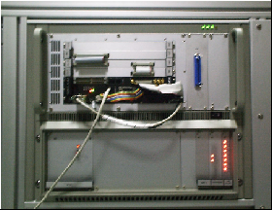
1.
2.
- System Controller Rack

- Main Processor:

The VME bus CPU contains a 68040 main processor placed on the BAB-40, and is running under a multitasking OS9 operating system

- CONV-5:

Interface for networks (10BASE-T or 10BASE-2)

- DETC Interface:

This is a multi channel AD/DA-Converter digital I/O card, which is used for sensors and actuators, e.g. the auto-focus control, interferometer initializing and the shutter

- Exposure Memory Unit (EMU):

A card controlling 1 MB 16-bit-SRAM modules for handling exposure data

- Exposure Control Units (ECU-A/B):

The ECU-A unit gets the data from the EMU card and controls functions like position-correction, intensity- and frequency-correction, while the ECU-B counts X-/Y-positions and controls the pixel-clock. The ECU-A2 card is an extended Version of the ECU-A, containing additional hardware for rotation support.

- VCO-DAC:

A hidden unit with two seperate channels incorporating two 8-bit Digital Analog Controllers for frequency and intensity. Data received from ECU-A will be processed and then routed to the HF-Control.

- IC40:

Systems with a camera unit employ an IC40 frame grabber-card for image processing.

HF-/DRV-Rack:

Contains the driver modules for the HF, auto-focus, and stepper motors.

- HF-Control:

Both channels of incoming analog signals received from the DAC will flow to seperate Voltage Controlled Oscillators to one signal and then amplified. The outgoing RF-signal is connected to the Acousto-Optical Modulator in the optical path of the laser.

- Auto-focus Servo:

Controls position of the write lens using a pressure sensor signal to correct the position of the lens piezo actuators.

Hidden Units:

Not visible are the main power unit including the emergency shutdown, relays and breakers, and a control unit for the stage.

User PC

INTRODUCTION

The user PC runs the Windows User Menu, converting user input into DWL commands, and thus controlling functions of the DWL 66. The User PC is a tool for making the DWL 66 easier to operate by minimizing handling errors.

The DWL 66 User Menu provides instant access to main functions via the control toolbar:

BUTTONS
Opens Control Panel

Opens current Exposure Map

Starts Manual Plate Alignment Sequence
(Only available in systems with camera unit and rotation support)

Opens Mini-terminal window for login and limited communication with OS9-system

Request Interferometer status
NOTE: The status shown in the label will only update when the button is pressed!

Resets Interferometer

NOTE: IF R also forces a stage reset!
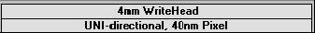
Configuration file in use; double-click to change

change configuration

The main menu offers a number of logical menus:

- File:

- Designs


- Environment Files

- Help on Environment Files

- Exit

Contains the functions necessary to inspect which data files are available on the machine's hard disk.

- Job:

- Make Job

- Run Job

Exposure conditions and data sets of an Exposure Job are modified using the above commands. A prepared job may be started.

- Setup:

- New

- Exposure Map


The following options are only available in systems equipped with cameras

- Simple Cross Alignment

Using FindXY
Using PosXY

- Field Alignment Method

- Test Field Alignment

- Define Template

The Setup commands allow for the setup or modification of a job environment as well as the setup and testing for a number of automatic or semi-automatic sequences for alignment, including the definition of image templates.

Measure:

- Overlay

- Distance

- Positions

- Linewidth

- Pitch,Stitching,Edge

Measure commands allow for control of exposure quality.
Tools:

- Analyse Report for Alignment

- Analyse Report for Measurement Results

- View Job Log

- View Measurement Method

- Service:

- Debug

A window for communication between the Menu and the main system that may be viewed in the Small Talk window

NOTE: Do not use the small talk window during an exposure as it slows down communication and can cause errors!

- View OS9 Config.

- Control Panel F9

- Edit Configuration File
Used to view and set values of the various system parameters.

Video Calibration
- Reset Stage

- Help:

Main Subject Index
- Read Me

- About

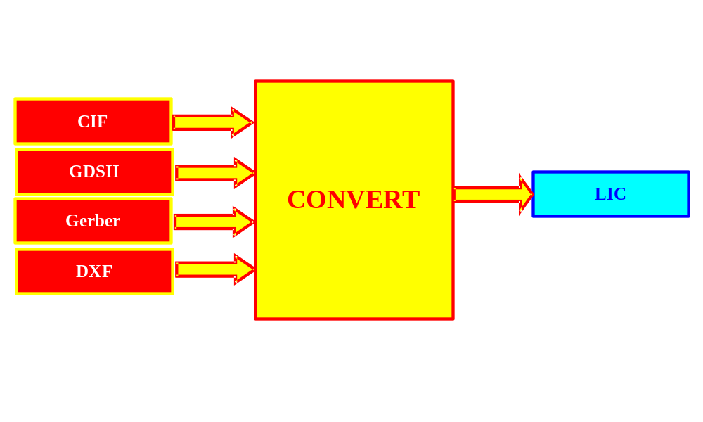
Conversion Software

INTRODUCTION
The purpose of this software package is to convert source files from gerber, dxf, cif, gdsii, hpgl or structure format into LIC format. Unlike the other input data formats the LIC format can be converted in real time into the final pixel data set. The advantage of the LIC format compared to the final pixel data set is that its file size is much smaller due to a highly optimized compression.

Theoretically the source file could also be converted directly into the final pixel data set, yet this data file is much larger than the LIC files, which would increase the demands on the hardware.

CONVERSION STATION
If a combined User / conversion PC is part of the shipment, the conversion software is installed on a seperate LINUX partition on the PC. In this case, the PC needs an Ethernet connection to the machine in addition to the serial connection used by the menu software.

For additional information on data conversion and transfer, see Conversion Software Manual.

Applying Power / Powering Down
CAUTION

- Never use a timer switch with the HeCd laser!

- In case of emergency, press the large red button located on the front of the DWL machine.

NOTE

- The HeCd laser and the interferometer must warm up before initializing the machine and then exposing

- Switch on the HeCd laser and the DWL 66 at least 30 minutes before exposure

APPLYING POWER INSTRUCTION

- Switch on HeCd laser with the key switch.

- Press the green ON-button located on the front panel of the DWL 66.

- If system was switched off with Emergency Stop button, that button must be released first

- Switch on the User PC.

POWERING DOWN INSTRUCTION:

- Shut down the User PC and switch it off.

- Press the red OFF-button located on the front panel of the DWL 66.

- Switch off the HeCd-Laser using the key switch.

CHAPTER 3 - HOW TO DO EXPOSURES

WARNING:

- Be sure to read all safety instructions outlined in the safety precautions section of this guide before operating the DWL 66.

- Always observe all warnings during use of this laser device.

INTRODUCTION

This chapter contains instructions for the following:

- Preparing for Exposure

- Changing Writeheads

- Main Menu

- Login with the Mini Terminal

- Check IF-Status

- Loading

- Focusing

- Processing the Design Data

- Job Control Functions

- Setting the Origin

- Preparing Field Alignment Sequences

- Exposing

- Overlay Exposures

Preparing for Exposure

CAUTION

- If computer monitors are positioned close to the DWL they may, after a while, expose the plates.

- Make sure that monitor brightness is set to a minimum.

- Make sure that monitors are covered when plates are being handled in front of them for a long period.

INTRODUCTION

Before beginning the exposure sequence, make sure that correct plates are prepared.

PLATES:

- For exposures with HeCd-lasers usually chrome-on-glass plates coated with resist are used.

LIGHT:

- Plates must be handled under an appropriate safelight.

- Safelight specifications can be obtained from the plate manufacturer.

- Usually, chrome plates are handled under yellow safelights.

Changing Write Heads

INTRODUCTION

The DWL 66 is designed such that the user can easily change the write heads in order to change the resolution of the exposure. Some write heads may require a special HF-unit, where the corresponding writehead must be changed together with the HF-unit. If the wrong HF-unit is applied, the machine will not be damaged as a result, but satisfactory exposures cannot be achieved.

CAUTION

- Always turn off the DWL 66 before changing the HF-unit!

- Touching the mirrors with bare hands will damage them beyond repair

- Move the writehead completely up before changing as to minimize the risk of damaging the nozzle

CHANGING THE HF-UNIT INSTRUCTION

- Turn off DWL 66.

- Loosen the four screws on the front plate of the HF-unit.

- The HF-unit is located behind the front panel of the cover box, in the lower left corner of the electronics rack.

- Carefully pull out the HF-unit and unplug the two cables connected to the backside.

- Connect the new HF-unit to the two cables and carefully push it into the rack.

- Tighten the screws; making sure that the switch on the front plate is in the ON position.

- Turn on the DWL 66.

CHANGING WRITEHEAD INSTRUCTION
REQUIREMENTS

- #3 Metric Allen wrench

- Unplug the motor cable and piezo cable (as shown in the figure below):

- Use a #3 Metric Allen wrench to loosen the four screws located on the top of the write head.
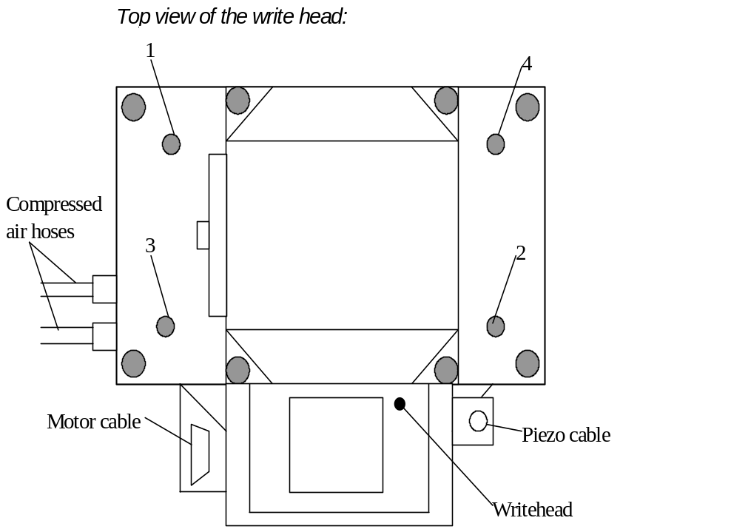

CAUTION

- Hold write head with one hand.

- Push write head up when removing the screws.

- Be careful that write head does not fall and damage the nozzle and / or the chuck.
- Remove write head, pulling it carefully away from the machine.

- Place new write head into its holder with the piezo connector and motor cable facing away from the machine.
  - Push up on the write head at all times during the process

  - Don’t let the nozzle touch the chuck

- Push write head in as far as it will go.

- Tighten screws X-wise, as indicated below, while pushing up on the write head.
- Make sure write head is tightly mounted and in its correct position.

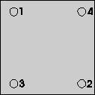

CHANGING SYSTEM CONFIGURATION INSTRUCTION

- Open the DWL 66 menu on the User PC and double-click on the configuration information field on the right side of the menu bar.

- A window with the available DWL 66 configuration files will appear:

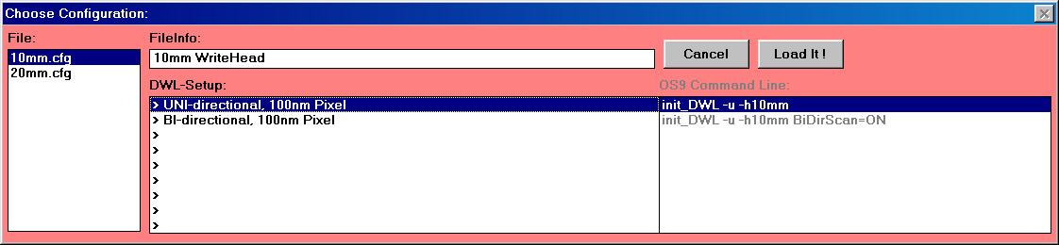

- Change configuration according to the installed write head (e.g., 10mm.cfg for 10mm write head).

- Highlight desired setup (e.g., UNI-directional, 100nm write-grid)

- Press Load it! -button

- The system will now reload the menu with the new configuration file

Main Menu

OPEN MAIN MENU INSTRUCTION

The following steps will open up the main menu on the User PC:


- Switch on the User PC.
- Open up the DWLII user menu, by clicking on the icon.

  - The following window will appear (picture shown represents systems with installed camera unit):

- The DWL II window enables setup and control of all DWL processes.
NOTES

- Following this instruction for every exposure is unnecessary; the user menu can remain open for any length of time.

- When the DWL is not performing tasks for a longer time, it is advisable to close the Main Menu and shut down the computer.

SHUTTING DOWN MENU AND COMPUTER:

- Exit DWLII Menu by highlighting Exit under the File submenu.

- Confirm menu shut down in dialog box

- Shut down Windows by pressing Alt-F4 or choosing shutdown from the start menu.

- Switch off computer and monitor (if not done automatically).

Login with the Mini Terminal

INTRODUCTION

This is a very simple Terminal program. Its main purpose is to let the user log in to the OS9 main DWL 66 processing system. Do not use this program for extensive OS9 sessions.

NOTE: DO NOT TRY to transfer large files using the Mini Terminal. For extensive OS9 sessions, close the menu and use KERMIT or TERATERM (icons on desktop). Use ws_ftp for file transfers.

NOTE: If the main menu has been started, but the user PC is not logged in to the OS9 system yet, the message: "DWL does not respond" will appear.

MINI TERMINAL LOGIN INSTRUCTION

- Open up the Mini Terminal by clicking on the icon:

  - The following window will appear:

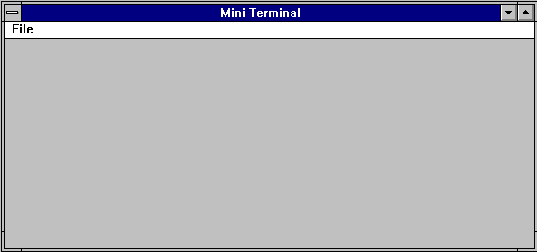

- Login by entering "dwl". The password is set to "dwl" by the factory, but it can be changed (consult HEIDELBERG INSTRUMENTS).

NOTE: Press Enter for the login prompt to appear.
  - Now the port is available to process commands

- Close the terminal by clicking on the icon.

Check Interferometer Status
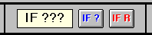

Before the stage can be initialized, check the interferometer status by clicking on "IF ?" in the Main Menu.

  - If the label "IF ???" changes to "IF: OK,”proceed to the next section

  - If "IF: FAIL" appears, then reset the Interferometer by clicking on "IF R"
Reasons why the label might still read "IF: FAIL" after a reset are:

- The machine was just switched on (the interferometers need about 20 minutes to reach a stable state)

- The interferometer laserbeam is blocked

- Check for obstacles in the optical path

NOTE: The IF status label is only updated when the "IF ?" or "IF R" buttons are clicked.

Loading

LOADING INSTRUCTION

- Open the Control Panel by clicking on the toolbar icon, or by clicking on the DWL Control Panel under Service in the Main Menu.

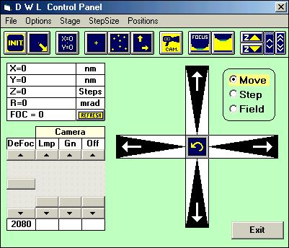

- Click on the INIT button to initialize the stage.

  - The stage will move slowly in negative X-direction and then in negative Y-direction until it reaches the end switches, from where it will move back to the center position

  - Note that the origin is not necessarily in the center of the stage as the operator may choose where to set it (see Setting the Origin)

  - The orientation of the machine's coordinate system is shown in the following picture:

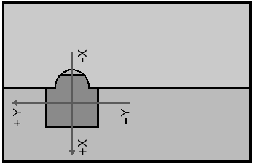

NOTE: Pressing the INIT button again after the first initialization will only cause the stage to move to the center position and the coordinate system to reset.
- Click on the (UN)LOAD icon

  - The write lens will move up as the stage moves to the load position.

NOTE: The LOAD button is also available in the Expose window, which is opened by highlighting Run Job under Job in the Main Menu.

- Before loading the DWL 66 (i.e., loading the plate onto the chuck), plug the stopper pins into the chuckholes for easy plate alignment.

- To expose a plate, switch off the white-light and switch on the safelight in the dark room.

- Take the plate out of the box.

- Leave the white-light switched off until the plate is developed.

- Make sure plate and chuck are clean and smooth.

- Make sure the resist-covered side of the plate is facing up.

- Place the plate onto the chuck.

- Keep the plate a little tilted until the stoppers are reached.

- Let the plate down carefully.
- The plate should be roughly centered on the chuck.

- Switch on the vacuum with the switch in front of the chuck.

- The four white screws in front of the chuck are used to adjust the size of the vacuum area to the plate size.

- All vacuum areas are centered on the middle of the chuck.
→ 4 cm x 4 cm vacuum area

→ 6 cm x 6 cm vacuum area

→ 10 cm x 10 cm vacuum area

→ 12 cm x 12 cm vacuum area

→ 16 cm x 16 cm vacuum area

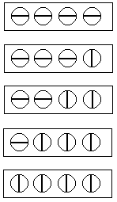

NOTE: In case the plate is even smaller than the smallest vacuum area, use copy foil to cover the open chuckholes.

- Once the plate is in place make sure that the vacuum hold down system is working properly by moving the plate sideways.

- If the plate can be moved, there is an air leak and suction must be improved by pressing the plate down carefully onto the chuck.

CAUTION: Do not touch the resist on areas to be exposed!

- If, after pressing down on the plate it is still not held down tightly, check the surfaces again for dirt or scratches.

- If necessary, try a new plate.

Focusing

FOCUSING INSTRUCTION

- Open the Control Panel by clicking on the toolbar icon, or by clicking on the DWL Control Panel under Service in the Main Menu.

- Click on the INIT button and the program will center the stage.

- If the plate was placed in the center of the stage during loading, it is now centered as well.

- If not, you can roughly center the plate manually with the XY STAGE control buttons.

- Click on the FOCUS button.

CAUTION: Before clicking on the FOCUS button, make sure the substrate is completely under the writehead. If the system focuses on anything else but the substrate, the nozzle is liable to crash!

NOTE: The FOCUS button is also available in the Expose window, which is opened by highlighting Run Job under Job in the Main Menu.

NOTE: The FOC-slider sets a focus offset. Usually it can be left in the default position of 2048. The defocus value for the final exposure must be found in a series of test exposures.

Processing the Design Data

INTRODUCTION

In the User PC Main Menu the groups File, Job and Setup are designed for choosing data files and setting exposure conditions. In the following sections these groups are introduced with step-by-step instructions. For a thorough description of the groups consult the User Guide, PART II.

PROCESSING INSTRUCTION

- Highlight New under Setup in the Main Menu.

  - The following window will appear:

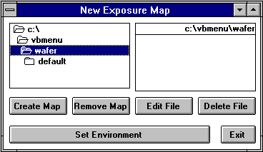

- In the directory select box on the left, highlight \VBMENU\WAFER as shown in the New Exposure Map window.

CREATE MAP

All files for one project, including report files are located in the same directory.

- To create a directory click on the Create Map button and input a name consisting of not more than eight characters.

- The eight-character name entered is to be used as a project name

- A directory is created and the program copies three root files from the \VBMENU\WINDWL\ into the new directory.
NOTE: In systems without a camera unit, the file default.fa is not used and may be ignored.

- Confirm in dialog box to set the environment to the newly created one.
NOTE

The DWL exposure program requires the following job dependent data files:

- Map File (.map)
- Job File (.dwl)

If the system is equipped for alignment, an additional (alignment) file is added to each job environment.

- Field Alignment File (.fa)

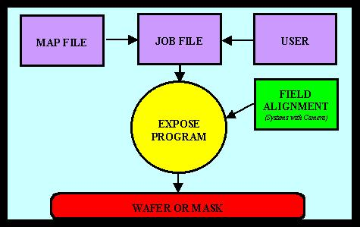
The following diagrams describe the set up of a typical project where an exposure is performed in connection with an alignment:

For every project a set of files (shown in the diagram below) is stored in a corresponding directory:
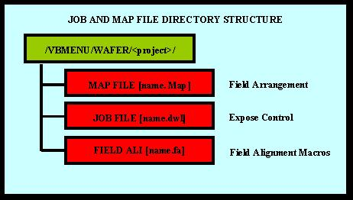
NOTE

- For the DWL to run as expected, it is essential that the correct files are stored in a personal project directory.

- Before starting an exposure, or measurement, check the environment files under the File menu.

- Exit New Exposure Map window and highlight Exposure Map located under Setup in the Main Menu, and the following window will appear (with no or different specifications, depending on any previous Designs) that controls the exposure process:

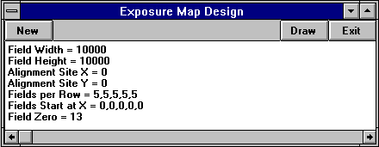

- Upon opening the Exposure Map Design window, data from the current Map is loaded

- Click on the New button and a map file minus any values will appear.

- Enter numbers according to the Design Data file.

- Each line to be entered into the Exposure Map Design is given below with the corresponding sketch of a map:

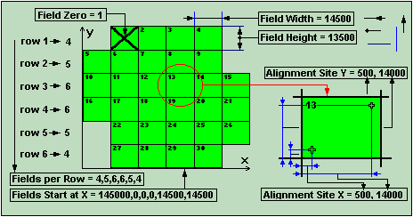

LINE 1: Field Width =:

- Enter desired width in micrometers
- Value must be large enough for the design
- If width is too small, there will be overlapping

LINE 2: Field Height =:

- Enter desired height in micrometers
- Value must be large enough for the design
- If the height is too small, there will be overlapping

LINE 3: Alignment Site X =:

LINE 4: Alignment Site Y =:

- Distance of the alignment sites to the origin of the die

LINE 5: Fields per Row =:

- Enter number of fields for the first row
- For every following row, the corresponding value is entered, separated by a comma
- The number of rows and fields per row set must fit on the substrate

LINE 6: Fields Start at X =:

- Enter value where each row is to begin -in the X direction in micrometers

LINE 7: Field Zero =:

- Enter field value corresponding to the substrate origin

NOTE: The zero point of the design in this first field is the zero point for the exposure! This is the point to be defined as the coordinate origin on the Control Panel (SET 0,0 button).

NOTE

In the case of a single layer with a single field Mask exposure, the Map might look like the following:

Field Width = 100000

Field Height = 100000

Alignment Site X = 50000

Alignment Site Y = 50000

Fields per Row = 1

Fields Start at X = 0

Field Zero = 1

- Click on the Draw button and the Map corresponding to the latest entries will be displayed.

- Press Set Environment.

- Close Exposure Map Design window with the Exit button.

Job Control Functions

INTRODUCTION

The functions located under the Job menu option are used for routine work. The Edit Job spreadsheet found in the Make Job submenu allows the user to adjust final exposure parameters, such as the Lic Data selection, Defocus, and Energy. Once an environment is set up, an exposure is run using the Run Job submenu function. Exposure instructions are located in the section on Exposing. For a thorough description of the Job menu selection, see the corresponding chapter in the User Guide, PART II.

JOB COMMANDS

- Make Job:

Prepares and edits job files.

- Run Job:

Loads and unloads plates, runs and tests exposures, alignment procedures and measurements.

JOB CONTROL INSTRUCTION

- Highlight Make Job located under Job in the Main Menu.

- The following spreadsheet will appear:

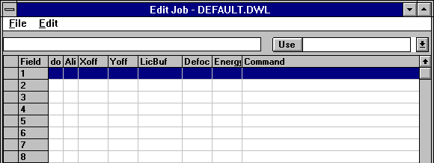

- The following options are located under File in the Edit Job window:

- Highlight New, opens an empty spreadsheet, where the number of rows corresponds to the current Map file.

- Load a Job file from the \VBMENU\WAFER\ directory (if available). If the corresponding Map file is not loaded, then only the number of fields that cover the current Map file will be displayed.

- Load a New Map from the \VBMENU\WAFER\ directory. A New Map appears and a new Job file with the name: "NONAME.DWL" is created, where the name of the new Map is entered into the list of current environment files.

NOTE

The corresponding alignment file will not necessarily be loaded. If an alignment is necessary, check alignment before executing this new Job File.

- The following describes the setup of a new sheet. To edit a file that already exists, use the tools under the Edit heading (for a thorough description of Edit Job window commands see the User Guide, PART II).

FIELD COLUMN

Contains a field number, which refers directly to the field in the wafer Map, shown concurrently with the Edit Job window. The field number usually coincides with the number of the row it is in, but this is not essential. Fields will be exposed according to their position on the sheet and not according to the field number. However, fields cannot be moved using this program (Use i.e., MS Excel for moving fields).

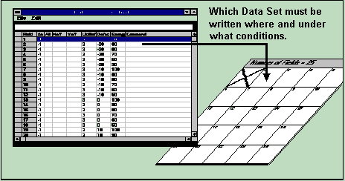

- Click on the first row of the do column.

- The flag entered here, determines whether the Map field corresponding to this row is to be written.
do column

- Enter -1 if the flag is true and the field is to be written.

- Enter 0 or leave the field empty, if you want the field to be skipped.

- Click on the first row of the Ali column. The value entered here, determines the alignment method to be used:

ALI COLUMN

Enter the value:

ALI=: No Alignment

ALI=0: No Alignment

ALI=1: One Site Alignment

ALI=2: Two-Site Alignment

ALI=3: Three-Site Alignment

ALI=4: Four-Site Alignment

Multi-site alignment can be used to increase alignment accuracy.

In systems without camera unit, leave ALI=: field blank

- Click on the first row of the Xoff column.

- The value entered here (in microns), determines the X offset of the starting point of the exposure from the point that is determined from the Map geometry

- The value may be negative and can have a decimal point

- Click on the first row of the Yoff column.

- The value entered here (in microns), determines the Y offset of the starting point of the exposure from the point that is determined from Map geometry

- The value may be negative and can have a decimal point

- Click on the first row of the LicBuf column.

- To do an exposure (see the Exposures box below), enter the name of the directory where LIC data is stored.

- To make a measurement, enter the name of a measurement procedure (see Measurements box below) proceeded by an “M:”

Enter the path and name of the LIC directory where graphics data is stored.

Exposures:

It is possible to expose more than one design, or even the same design several times, by entering more design names separated by a semicolon.

- Measurements:

The name of the measurement file must be entered proceeded by “M:” (e.g., M:test.msr). If several measurements are to be executed in the same field, a semicolon must separate the file names.

- Click on the first row of the Defoc column.

- Enter a value between 0 and 4095 as a focus offset

- A value of 2048 means no defocus

- If the cell in the Defoc column is left empty, the defocus value of the previous exposure is used

- The 4095 steps equal an (uncalibrated) range of approximately ± 10µm, so one unit equals approximately 5 nm

- Before making a final exposure, a series of fields with the same pattern at various defocus levels is exposed to find the best focus offset for the exposure (Necessary for substrates with relatively thick resists)

- When choosing the defoc values for such a series, keep in mind that the focus depth of the 4mm write lens is 1.8µm and the autofocus is stable within a range of 100nm

- Since the 40mm write lens has a focus depth of 250µm, it is not necessary to adjust the autofocus offset

- Click on the first row of the Energy column.

- Enter the number for an intensity correction file: the file 100 sets the energy to 100%; 90 sets the energy to 90%, etc

- Not all values are available. Generally, the values from 10 to 100 in steps of 10 are prepared. To check which files are available; open the mini-terminal and type, “chd sys” followed by, “dir.” The files corresponding to the numbers will appear with a preceeding “FI_”. Before leaving the Mini-Terminal, retype “chd.”
- Similarly to finding the best focus by varying the defocus, the Energy column is used for finding the best energy by varying the energy across an array of fields

- If less than 30% of the maximum energy is necessary, use the grey filters for a basic adjustment

- A 30% transmission filter is a good choice for the 40mm write lens

- Try a 3% transmission when using the 4mm lens (30% filter + 10% filter)

- Click on the first row of the Command column.

- Enter a number of commands to be executed before or after the exposure or measurement. The available commands are listed in the selection box on the right above the Job table

- To select a command, highlight it in the list and click on the Use button (The command will be automatically added to the current command sequence)

- Enter the numeric or string value, if required.

- All commands to be executed before an exposure or measurement must be preceded by the keyword BEFORE:

- Commands to be executed after the exposure / measurement are to be preceded by the keyword AFTER:

- BEFORE: / AFTER: These two words must only appear once, but each can be followed by a number of commands (The commands must be separated by a semicolon)

- For a list of available commands, refer to User Guide, Part II

CAUTION

Use the BEFORE: / AFTER: option with care and test it thoroughly.

NOTE

- For special service jobs, the Command column is used for placing OS9 commands

- Enter a command preceeded by OS9:

- If an OS9 command is not preceded by any of the two keywords BEFORE: or AFTER: the command will always be executed before an exposure / measurement.

- Repeat steps 4: through 11: proceeding to the next spreadsheet row for every cycle.

- Repeat for the number of rows (i.e. fields) necessary.

- To save a current job file under a new name, scroll down and highlight Save As… under File in the Edit Job Main Menu, or save it under the original name (if applicable) by highlighting Save under File in the Edit Job Main Menu.

- Together with the Edit Job spreadsheet, the Map currently loaded for an exposure / measurement is being displayed.

- Another way of checking the Map is by clicking on the icon on the Main Menu toolbar

- The Map window will appear:

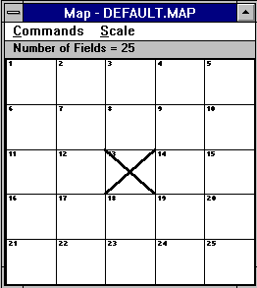
If a design to be exposed is repeated several times, or if different designs must be written onto different fields, then the Map displays how the fields are currently arranged.

During an exposure, the Map will show which field is being exposed.
- Some options for the Map display can be modified under the Commands menu.

Select Fields:

Highlights fields in the Exposure Map that will automatically set marks on corresponding rows in the Make Job window and allows the operator to mark several fields at once (e.g., program a selected row of fields to have the same focus offset aided by the Make Job submenu). The zero field, marked with a cross, is used as a coordinate reference.

Clear Fields:

Removes selected flags and row marks in the Make Job program.

Show Positions:

Displays absolute coordinates in microns in reference to a selected field.

Jump Positions:

If the interferometer coordinate system is set and aligned to a substrate, the Jump Positions command may be used for leaping to a selected field. When the Jump Positions command is highlighted, a warning window will appear.

CAUTION

The Jump Positions command is only to be used after substrate is aligned and its respective coordinates are set to the Map correctly; otherwise, the stage may leave the auto-focus regime, and moving it back may damage the nozzle.

- Select any of the absolute scale displays. All entries show the size of the entire Map area.

- Automatic:

Both the X and Y-axis are independently normalized and will show a distorted view of field distribution.

- Once the setup of an exposure is complete, close both the Map and the Edit Job window, by scrolling down and highlighting Exit located under File in the Edit Job window.

- If no alignment is necessary, proceed to the section: Setting the Origin.

Aligning Manually

MANUAL ALIGN PROCEDURE

If the system supports coordinate rotation (ECU-A2 in system controller), this preprogrammed sequence interactively aligns a substrate along the X-axis, or along the Y-axis. The procedure is as follows:

- Choose whether alignment is to be performed along the X- (click Yes) or along the Y-axis (click No).

- Point camera cursor to the first alignment site on substrate (for example, the lower horizontal edge) using the manual alignment window and click OK.

- Point camera cursor to the second alignment site on substrate (for example, several millimeters away from the first site) along the axis originally chosen for alignment and click OK.
NOTE

In the manual alignment window, invoke the Control Panel to move over larger distances than the camera field.

- The system will calculate the angle of rotation between the two points.

- The rotation will be compensated by a computational rotation of the stage coordinate system.

- After calculation of the rotation, a dialogue box will appear showing the calculated rotational angle and ask if the compensation should be executed.

- After rotation, repeat Steps 2 – 4 until the measured angle is satisfactory.

- Accept the last compensation, then click “Cancel” in the Point to 1st Site window to complete the alignment sequence

NOTE

If tighter precision during a sequence is necessary, simply switch to the micro camera and use larger distances between the alignment sites. It should be possible to align a substrate in accordance to the coordinate system within a few micro radians, depending on the quality of the alignment sites.

- The system will request to “Point to Set-to-ZERO position.”

- Either move the substrate origin below the write head using the control panel and point to the exact zero point location, or choose “Cancel” and use a different procedure to set the origin

Setting the Origin

INTRODUCTION

For a successful exposure it is extremely important to have the origin of the coordinate system set to the correct location as required by the design (i.e., center of the plate, lower left corner of the plate, etc.). The Control Panel is used to define the origin of the coordinate system.

ORIGIN INSTRUCTION

- Determine position on the plate, which design requires as the coordinate origin.

- Open the Control Panel by clicking on the toolbar icon.

- Move the stage with the XY STAGE directional buttons, so that the nozzle gets above the desired coordinate origin.

- When nozzle is in its correct position, click on the Set 0,0 button on the Control Panel.

- Present position is defined as the origin of the coordinate system.

Note: The Expose window discussed in the following section offers additional features for setting the origin.

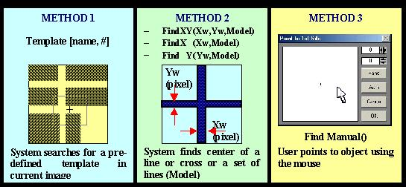
Preparing Field Alignment Sequences

INTRODUCTION

For overlay exposures as well as for measurements it is important to align the machine coordinate system to alignment structures on the substrate. Aside from the manual rotational alignment described before, this also means that the coordinate origin for each field should be adjusted according to the position of an alignment structure, which is part of each of these fields. To do this, a field alignment method for detection of the structure position must be setup, and the coordinates corresponding to the structure position within the design coordinate system must be entered into the Map file.

SETUP OF A FIELD ALIGNMENT PROCEDURE

There are two ways of setting up a field alignment procedure for a DWL 66. If the alignment structure is a cross, the procedure may be prepared automatically by using one of the Simple Cross Alignment commands under Setup in the main menu while the structure is in clear view of the camera. If the structure to be used for alignment is not a cross, the complete procedure must be setup automatically.

SETUP OF A SIMPLE CROSS ALIGNMENT

- Load plate and focus.

- Using the Xy-Stage buttons in the Control Panel, move substrate so that the cross is well within the monitor image field (as close to the center as easily possible).

- Optimize camera settings (lamp, offset, gain) for best contrast.

- Highlight Simple Cross Alignment under Setup in the main menu.

There are two methods offered:

- Using Find XY for a cross with a clear outline

- Using Pos XY for a cross where the outline is blurred, e.g., by an additional resist layer

- Indicate the borders of the cross following the instructions given.

- The system will try to detect the cross and determine the width of the lines

- All values (camera settings, alignment method settings) are entered into field alignment procedure macro, which is automatically setup after the method has been chosen and the cross has been detected

- To check, test and edit the field alignment macro that has been created, highlight Field Alignment Method. Check if the values obtained from the bracket behind the alignment method are non-zero; otherwise, manually enter estimation for the values necessary. All values are in tics.

- Pos XY: Values to be entered are (in the following order)

  - Small side of measurement box: should be larger than the cross linewidth

  - Large side of of measurement box: 4 – 5 times the cross linewidth

  - Distance of measurement boxes from monitor image center: should be around 200 pixels, depending on the size of the cross (more than one linewidth)

- Test method by clicking on Test button.

SETUP OF OTHER ALIGNMENT PROCEDURES:

- Load plate and focus.

- Using the Xy-Stage buttons in the Control Panel, move substrate so that the structure is well within the monitor image field

- Optimize camera settings (lamp, offset, gain) for best contrast.

- Highlight Field Alignment Method under Setup in the main menu.

- The following window will open:

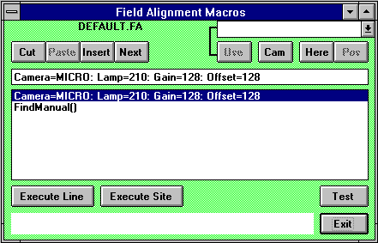

- Empty the list of all entries by pressing Cut repeatedly.

- Transfer the current camera settings to the edit line by pressing Cam; press Enter on the keyboard to transfer this line to the command macro list.

- Press Next to continue with the next command line.

- From the selection box (upper-right corner of the Field Alignment Macros window), choose the command delay() and press Use.

- Enter the number of seconds the system should wait after a movement before the alignment sequence starts

- Press Enter on the keyboard to transfer the command to the list

- Proceed to the next line and choose an alignment function from the list.

- Find XY, Pos XY: Detect a cross (see Simple Cross Alignment)

- Find Manual: Structure must be marked manually by the operator

- Find Template: Structure is detected by comparison with a predefined template

- Find X, Find Y: Detect horizontal / vertical lines; if both are used successively (with a possible movement in between), the position of the point where the lines would cross is the result of the alignment procedure

- Repeat the alignment function if a higher precision is necessary (3-repetitions recommended)

- Test sequence by pressing the Test button.

For more in-depth explanations of the alignment functions or template definition, see User Guide PART II: Reference Manual.

NOTE

A field alignment sequence should be tested thoroughly in different portions of the plate before it is used for overlay exposures or measurements. Besides testing the alignment sequence from the Field Alignment Macros window, it is also possible to start a full alignment test run for all fields where alignment has been set to “1”* in the Job file by pressing the Test Align button in the Exposure window (see previous section). Highlighting Analyse Report for Alignment Results under Tools in the main menu will allow for the viewing of test results.

*(or the number of alignment sites given in the map)

Exposing
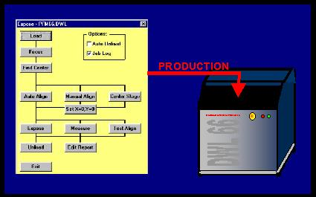

INTRODUCTION

The expose window is kept as simple as possible and can be used to routinely run pre-defined jobs. If you change designs be sure to change the environment first. After this is done, the available functions can be used in the logical sequence as shown in the Expose window.

EXPOSE INSTRUCTION

- Open the Expose window by highlighting Run Job under Job in the Main Menu.

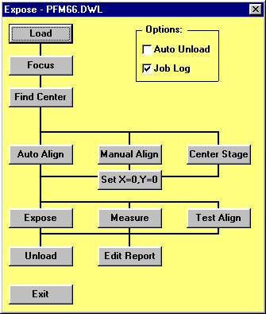
- The following window will appear:
Not available in systems without camera

- Click on the Load button to move up the writehead, perform a stage initialization -if necessary, and move the stage to the load position.

- Manually load the substrate and focus.

- Loading was described in a previous section, and if the substrate was previously loaded, the Load step can be skipped

- Make sure substrate is completely under the nozzle before clicking on the Focus button

- If the origin was not previously set using the Control Panel, the Expose window offers several additional possibilities for choosing and setting the origin.

- If the origin should be set in the center of the substrate then the Find Center button should be pressed to detect the substrate edges using the autofocus and deducing the substrate center position from them
CAUTION: Be sure to focus near the plate center before starting the Find Center procedure

- If the center position should be set in the stage center, press Center Stage and then Set X=0,Y=0

- If the origin should be set following a substrate alignment procedure, press Manual Align

- The manual alignment procedure previously described will be started

  - To start an exposure, press Expose
- The Map window is continuously updated during an exposure

- While a field is exposed the User PC waits and displays how many stripes remain to be written for each field

- In case of an emergency, pressing the BREAK button in the During Exposure window will interrupt the current exposure

- After Break is pressed, the current stripe will finish and all processes necessary for completing an exposure will be stopped.

NOTE: Do not press the Expose button until everything is setup correctly, i.e., the Make Job file is correct, the write head is in correct position, etc.

NOTE: Make sure system is focused!

- Once exposure is finished, click Unload button

- Write head will move up while the stage moves to the unload position

- The Edit Report button allows for the (test) exposure report to be viewed and saved under a different name.

Auto Unload:

If checked, the Unload function will be executed automatically after the exposure is finished.

Job Log:

If checked, the name of the exposure / measurement job file is entered into a list, followed by the first Lic- or M:file name encountered. Next, both start time and date and stop time and date are listed, and this information is entered into the file, "JOBLOG.TXT" -which can be found under C:\VBMENU\WINDWL.

OPTIONS:

Overlay Exposures
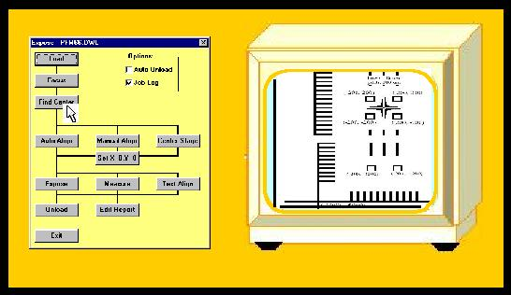
INTRODUCTION

Several preparations are necessary to do overlay exposures:

Before starting an exposure of the second (third...) layer, the machine coordinate system must be aligned to the previous layer(s) on the substrate, and the position of the write beam must be measured with respect to the center of the monitor image.

TESTING AND ADJUSTING OVERLAY ACCURACY

The testing and adjustment of overlay accuracy must be executed whenever a write head has been changed or removed for any reason since the last overlay exposure. Such a procedure serves to measure the write spot position with respect to the center of the monitor image, which is the reference point for alignment.

- Load a fresh substrate and set the zero point in the center (use Find Center function).

- Load the environment for overlay test exposures which was setup for the current write head: C:\VBMENU\wafer\align_<focal length of write head>

- In systems with only one write head, the environment is sometimes called “align”

- Expose the first layer of the test design.
- In the Job file, enter “0” in the Ali cell, and “OL <focal length of write head> mmCM” in the Lic Buffer cell

- Choose standard energy and defocus

- Run the exposure

- After developing, load substrate and move one of the corner crosses of the design close to the center of the monitor image. Edit the current field alignment method by highlighting Field Alignment Method under Setup in the main menu and test the method by pressing Test.
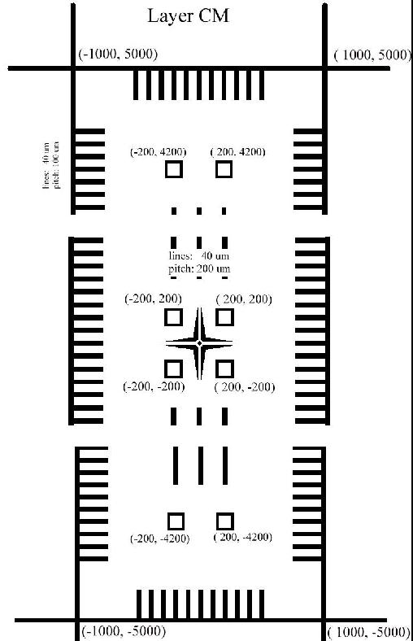
- If problems occur, try to adjust the method until it works reliably
- Execute a manual alignment procedure along the y-axis (choose No) using the two crosses at either end of the overlay design.

- Press the Auto button to use the Field Alignment Method for structure position detection when the crosses are well within the monitor image field

- Do not Set 0,0 position

- Open Expose window and press the Find Center button to determine the coordinate origin (should be roughly in the center of the sloping cross structure).

- Expose the second layer:

- Change Ali to 4 so alignment is executed using all 4 corner crosses

- Change design name to “OL <focal length of write head> mmCU”

- Expose

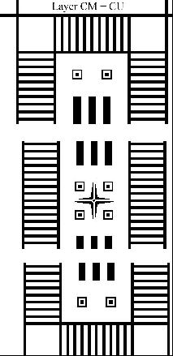
- After developing, determine the registration between the layers either by using an overlay measurement on the box-in-box structures, or by checking the overlap of the line structures.

- Enter the numbers gained from the measurement into the menu configuration file by adding it to the values given for XBEAM and YBEAM

- Perform another test exposure repeating steps 1 through 8.

- Repeat until registration is satisfactory

Note: The overlay test design is prepared with a different magnification for each write head. The numbers given in the picture of Layer CM – CU are valid for magnification 1, which is used for 20mm write head. For the other write heads, the numbers are scaling with the focal length.

OVERLAY EXPOSURE INSTRUCTION

- If since the last overlay exposure the write head has been moved for any reason, perform the overlay accuracy test first.

- Expose and develop first layer.

- Setup a field alignment method for a typical structure, which should be used for alignment of the coordinate origin for each field.

- Perform a manual alignment for rotational correction.

- If identical structures are used for the rotational alignment as for the field alignment, the field alignment method may be used for position detection by pressing the Auto button while the structure is well within the monitor image field.
- Set the origin in the position demanded by the design.

- In the Map file, enter the positions of the field alignment sites relative to the respective field origin (Parameters Alignment Site X= and Alignment Site Y=; up to four sites with identical structures may be defined, coordinates are then set apart by commas).

- Open Exposure window and perform a Test Align procedure to verify that all sites are found for all fields.

- Start second layer exposure.

_______________________________________________________

CHAPTER 4 - HOW TO DO METROLOGY

INTRODUCTION

A number of measurement procedures to quantify exposures are listed under Measure in the main menu. Some of these commands are specifically developed to aid with the measurement of parameters important for system specific adjustments and calibrations. Most metrology commands require top illumination, which will lower quality measurement of emulsion plates if using the high magnification objectives with 4mm and 10mm focal lengths.

- Overlay:

Measures the relative positioning accuracy of two overlaid exposures on a single plate by utilizing a number of models, such as box-in-box structures, etc.

- Distance:

Offers both an automatic and a manual metrology method for measuring the distances between two features on a substrate.

- Positions:

Measures die-to-die alignment of a feature in order to ensure that the machine coordinate system is linear and orthogonal.

- Linewidth:

Measures and analyzes the line width of a feature based on its video profile.

- Pitch, Stitching, Edge

Measures the distance between two identical features by associating video profiles of the images and then searching for the maximum in the correlation function. These measurements are then repeated in different locations and the results are analyzed according to the method chosen.

Overlay Measurements
INTRODUCTION

The purpose of overlay measurements is to determine the registration between two exposed layers that are printed on top of each other. In order to achieve the best results, the micro-camera is used for most overlay measurements. The HEIDELBERG INSTRUMENTS PERFORM Test Pattern can be used to check the overlay quality of the system. For each write head there are several special performance files available.

Two different measuring methods may be chosen:

LARGE BOX IN BOX METHOD
REQUIRED PATTERN

Part of the HIMT test pattern may be used:
A frame is written to a first layer
(e.g., "PFMXX_AX").

A second frame with equal line thickness but of a different size is written onto the second layer ("PFMXX_BX") over the first layer.

Ideally, the centers of the two squares coincide.

How well the two layers actually do coincide, is determined by the Overlay Measurements program.

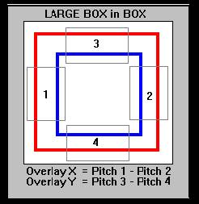

MEASUREMENT PROCEDURE

Four fields must be defined as shown in the Large Box in Box figure above. Within each of the four fields the pitch between the two lines is measured.

- For the overlay measurement in the X direction the pitch measurements of the fields 1 and 2 are compared

- For the Y direction the pitch measurement of the fields 3 and 4 are compared
The overlay error in x and y is then calculated from the difference between the X and Y pitches, respectively.

- The Large Box in Box structure is usually larger than the micro-camera field. The system therefore must measure the fields sequentially and centers each one on the screen before doing a pitch measurement

SMALL BOX IN BOX METHOD
REQUIRED PATTERN

The Small Box in Box structure consists of two patterns, as shown in the figure on the right.

A frame is written to the first layer, and a square is written to the second layer over the first layer.

Ideally, the centers of the two structures coincide.

How well the two layers actually do coincide, is to be determined by the Overlay Measurements program.

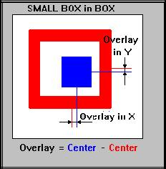

MEASUREMENT PROCEDURE

The overlay is determined by measuring the distance between the symmetry axes, as shown in the Small Box in Box figure above.

OVERLAY MEASUREMENTS INSTRUCTION

- Load DWL with the substrate to be measured as described in the Loading and Focusing sections.

  - Move stage to chosen overlay structure.

- Highlight Overlay located under Measure in the Main Menu.

- The following window will appear:

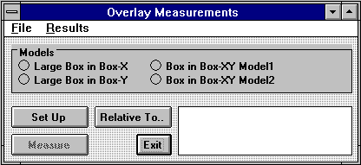
- To proceed with a measurement file previously created in the \MEASURE directory, open up the Overlay Measurements File menu, highlight Load and load desired file.

- The Model option is read from the file and switches on automatically

- A Window will request to: “Point to the Reference Site,” relative to which all positions will be measured

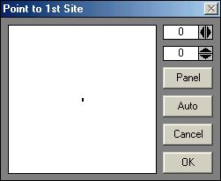

- Once file is loaded, proceed directly to Step 11

- To set up a new measurement file, choose one of the four models:

- Large Box in Box-X:

Performs measurement previously described above in the X direction.

Large Box in Box-Y:

Performs measurement previously described above in the Y direction.

- Box in Box-XY Model1:

(Actually: Small Box in Box Model) Performs measurement previously described above, measuring x and y overlay quality at the same time.

Box in Box-XY Model2:

(Actually: Small Box in Box Model) Performs measurement previously described above, and is especially designed for low contrast designs and structures covered by a resist layer.

- Click on the Set Up button, to setup measurement program.

- Depending on which model was selected, the Define Box window appears, requesting that measurement frames be placed over the structure.

- After the measurement procedure is set up, click on Cancel to close the Define Measurement #... window.

- To save the measurement program, select a reference point.

- If a reference point is not selected, the program will simply save the current stage position as the reference point

- To define a reference point click on the Relative To.. button

- For a local series of measurements, the location of the first structure is usually chosen as the reference point
- When preparing a method for a fully automatic measurement procedure, the field alignment site can be used

- Save measurement program by highlighting Save Measurement located under the File menu in the Overlay Measurements window.

- In case a reference site has never been marked, a window will appear notifying the fact and asking if the method should be saved anyway

- Start measurement by clicking on the Measure button and continue the measurement until enough data is collected.

  - A result window shows the updated values

  - After the measurement, the average value is displayed

- To view measurement results click on the Results menu in the Overlay Measurements window and highlight View and Save.

  - An editor displays the results, which may be saved by highlighting Save As.. under File in the Overlay Measurements window

- Scroll down and highlight To Excel located under the Result menu in the Overlay Measurements window to view results on a Microsoft Excel spreadsheet.

- Highlighting To Excel will copy the results into the Clipboard

- Start Microsoft Excel and load data into a spreadsheet by pressing CTRL-V or by using the Paste function

- All data processing options that Microsoft Excel offers are available

- When spreadsheet results are complete return to the Overlay Measurements window

- Click Exit to return to the main menu window.

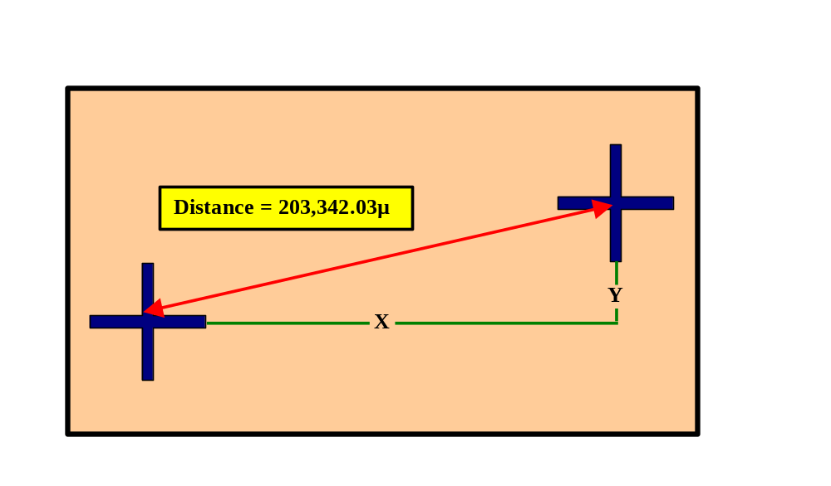
Distance Measurements

INTRODUCTION

The Distance Measurements program is designed for the measurement of distances between structures on a substrate. A distance can be small as to fall within the camera image, or large as to encompass the entire stage travel range. Repeating measurements several times can enhance the precision, and will result in additional statistical information. The best values are obtained when automatic template recognition is used for the real measurement.

MEASUREMENTS USING MANUAL ALIGNMENT INSTRUCTION

- Load the DWL with the substrate to be measured as described in the Loading and Focusing sections.

- Use the XY STAGE directional buttons on the Control Panel for moving the stage to the structures to be measured.

- Open the Distance Measurements window by highlighting Distance located under Measure in the Main Menu.

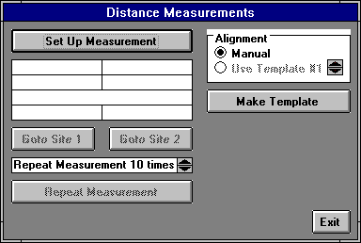

- Check Manual inside the Alignment box.

- For instructions on how to proceed using a template, read the next section

- Click on the Set Up Measurement button and the Point to 1st Site window will appear.

- Using the cursor, select first and second measuring sites.

- If the two sites do not fall within the camera field, use the Control Panel to move the stage

- The Control Panel may be used to switch between cameras, adjust the contrast, etc

- To view the two chosen reference sites, click on the Goto Site 1 and the Goto Site 2 buttons.

- Set the Repeat Measurement # times box to at least 5 for a good measurement.

- Start the measurement by clicking on the Repeat Measurement button.
  - When measurement is complete, the distance between the two points will be shown in microns

    - When distance measurements are complete, click Exit and return to the main menu window.

MEASUREMENTS USING A TEMPLATE INSTRUCTION

- Load the DWL with the substrate to be measured as described in the Loading and Focusing sections.

- Use the XY STAGE directional buttons on the Control Panel for moving the stage to the structures to be measured.

- Open the Distance Measurements window by highlighting Distance located under Measure in the Main Menu.

- Choose one of the templates offered in the Alignment field

- If there are no templates, click on the Make Template button

- For an explanation on how to define a template, refer to User Guide II

- Once a template is defined, set the Repeat Measurement # times box to at least 5.

- The higher the value, the more precise the measurement, and the lower the value, the less time measurement takes

- Start measurement by clicking on the Repeat Measurement button in the Distance Measurements window.

  - When measurement is complete, the distance between the two points will be shown in microns

- When distance measurements are complete, click Exit and return to the main menu window.

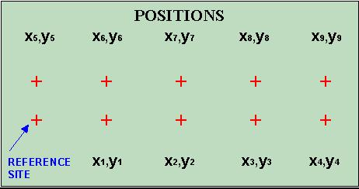
Position Measurements

INTRODUCTION

Position measurements provide information, not only about distances, but angular distortions or non-linearity over a substrate as well. Position measurements are therefore an important tool for initial system calibration and exposure quality control.

POSITION MEASUREMENTS INSTRUCTION

- Load the DWL with the substrate to be measured as described in the Loading and Focusing sections.

- Using the XY STAGE directional buttons on the Control Panel, move the stage to the structure to be measured.

- Open the Position Measurements window by scrolling down and highlighting Positions located under Measure in the Main Menu.

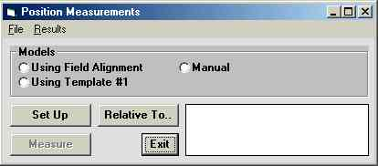
    - To proceed with a measurement file previously created in the \MEASURE directory, open up the Position Measurements File menu, highlight Load and load desired file.

- The Model option is read from the file and switches on automatically

- A Window will request to: “Point to the Reference Site,” relative to which all positions will be measured

- Once file is loaded, proceed directly to Step 10

  - To set up a new measurement file, choose one of the Methods described above for a measurement in the X or in the Y direction

    - Click on the Set Up button, to setup measurement program.

    - Depending on which model was selected, the Define Box window appears, requesting that measurement frames be placed over the structure.

- After the program is set up, click on Cancel to close the Define Box window.

- Start measurement by clicking on the Measure button and continue the measurement until enough data is collected.

  - A result window shows the updated values

  - After the measurement, the average value is displayed

- To save the measurement program, select a reference point.

- If a reference point is not selected, the program will simply save the current position as the reference point
- To define a reference point click on the Relative To.. button

- For a local series of measurements, the location of the first structure is usually chosen as the reference point

- When preparing a method including a fully automatic program, the field alignment site can be used

- Save measurement program by highlighting Save Measurement located under the File menu in the Position Measurements window.

- In case a reference site has never been marked, a window will appear notifying the fact and asking if the method should be saved anyway

- To view measurement results click on the Results menu in the Position Measurements window and highlight View and Save.

  - An editor displays and will save the results

- Scroll down and highlight To Excel located under the Result menu in the Position Measurements window to view results on a Microsoft Excel spreadsheet.

- Highlighting To Excel will copy the results into the Clipboard

- Start Microsoft Excel and load data into a spreadsheet by pressing CTRL-V or by using the Paste function

- All data processing options that Microsoft Excel offers are available

- When spreadsheet results are complete return to the Position Measurements window

  - Click Exit to return to the main menu window.

Linewidth Measurements

INTRODUCTION

The line width measurement program allows line widths in the X and Y direction as well as circle diameters to be measured. In order to achieve the most precise results, modify Lamp, Gain and Offset parameters of the camera in the Control Panel to optimize the contrast of the image.

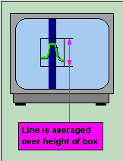
As shown in the figure on the right, a box is to be defined across the line. The pixels belonging to the line structure are summed up vertically, which results in a curve with a variation in X. A fit is performed on the curve and the fitted curve is normalized.

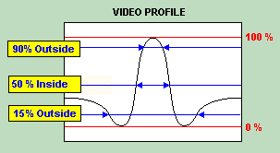
In the Figure shown on the left, the line width is determined by finding the expansion in X of a fit to the measured intensity values at a given threshold value.

The Figure shows that there are different methods for finding the expansion in X (Inside, Outside, etc.), and various procedures and thresholds can be defined.

MODEL

- LineWidth-X:

Measures the width of vertical lines.

- LineWidth-Y:

Measures the width of horizontal lines.

- Thick LineWidth-X:

Selects the measurement method for thick vertical lines (larger than ½ monitor image).

- Thick LineWidth-Y:

Selects the measurement method for thick horizontal lines (larger than ½ monitor image).

PROPERTIES

- Threshold=#:

Defined in percent, with the amplitude of the normalized video profile equal to 100%. For most purposes the threshold value should range between 25% and 50%.

- Repeats=#:

In order to improve the results, the pixel count for the whole box can be done several times and the result will be averaged.

- Inside:

The line width is defined as the horizontal expansion of the profile at the threshold value. The profile is traced until the threshold height is reached, starting at the center.

- Outside:

The line width is defined as the horizontal expansion of the profile at the threshold value. The profile is traced until the threshold height is reached, starting at the endpoints.
- Minimum:

The line width is defined as the distance between the two minima. The location of the extrema is found by locally fitting a parabola.

NOTE

- There are several ways to define the line width, meaning that obtained values are only useful for comparing line widths.

- The values are not correct on an absolute scale.

- If the absolute values are necessary, an offset must be defined using a calibration standard.

LINEWIDTH MEASUREMENTS INSTRUCTION

      - Load the DWL with the substrate to be measured as described in the Loading and Focusing sections.

      - Using the XY STAGE directional buttons on the Control Panel, move the stage to the line or circle structure to be measured.

      - Open the Line Width Measurements window by scrolling down and highlighting Linewidth located under Measure in the Main Menu.

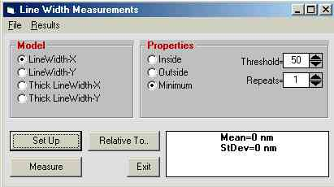

- To proceed with a measurement file previously created in the \MEASURE directory, open up the Line Width Measurements File menu, highlight Load and load desired file.

- The Model option is read from the file and switches on automatically
- A Window will request to: “Point to the Reference Site,” relative to which all positions will be measured:

- Once file is loaded, proceed directly to Step 12

- To set up a new measurement file, choose one of the Methods described above.

- Choose the Properties as described above.

- Click on the Set Up button, to setup measurement program.

- Depending on which model was selected, the Define Box window appears, requesting that measurement frames be placed over the structure.

- After the program is set up, click on Cancel to close the Define Box window.

- To save the measurement program, select a reference point.

- If a reference point is not selected, the program will simply save the current position as the reference point

- To define a reference point click on the Relative To.. button

- For a local series of measurements, the location of the first structure is usually chosen as the reference point

- When preparing a method for a fully automatic measurement procedure, the field alignment site can be used

- Save measurement program by highlighting Save Measurement located under the File menu in the Line Width Measurements window.
- In case a reference site has never been marked, a window will appear notifying the fact and asking if the method should be saved anyway

- Start measurement by clicking on the Measure button and continue the measurement until enough data is collected.

  - A result window shows the updated values

  - After the measurement, the average value is displayed

- To view measurement results click on the Results menu in the Line Width Measurements window and highlight View and Save.

  - An editor displays the results, which may be saved

- Scroll down and highlight To Excel located under the Result menu in the Line Width Measurements window to view results on a Microsoft Excel spreadsheet.

- Highlighting To Excel will copy the results into the Clipboard

- Start Microsoft Excel and load data into a spreadsheet by pressing CTRL-V or by using the Paste function

- All data processing options that Microsoft Excel offers are available

- When spreadsheet results are complete return to the Line Width Measurements window

- Click Exit to return to the main menu window.

Pitch and Stitching

INTRODUCTION

In many cases it is important to measure the distance between two structures, located relatively near to each other. If such structures are identical in appearance, the distance being measured- or pitch is uniquely defined by a numerical comparison of the two video profiles of each structure. A cross correlation will yield the pitch with an extremely high repeatability.

MODELS

STITCHING MEASUREMENTS

Determines the vertical distance of two horizontal lines or the horizontal distance of two vertical lines and is designed to run DWL stitching performance measurements in both X and in Y, using the system test pattern.

Stitching-X:

Measures the distance between two vertical lines, on both left and right sides of a stripe border, and will repeat the measurement in other locations on the substrate, if required. The RMS deviation of the results from the resulting average will determine stitching quality in X.

- Stitching-Y:

Measures the vertical distance between the sections of two horizontal lines, on both left and right sides of a stripe border, and will repeat the measurement in other locations on the substrate, if required. The RMS deviation of the results from the resulting average will determine stitching quality in Y. This value depends on the stage velocity and therefore must be minimized by optical adjustment for each configuration individually.

PITCH MEASUREMENTS

The pitch measuring method is applied for finding the horizontal distance of two vertical lines or for finding the vertical distances of horizontal lines. This method may be extended to measure whole sets of equidistant lines.

Pitch-X:

Compares the distance between two vertical lines or a row of equidistant lines over a programmed area.

Pitch-Y:

Compares the distance between two horizontal lines or a row of equidistant lines over a programmed area.

EDGE MEASUREMENTS

The measurement of edge roughness in an exposure; the position of a horizontal or vertical edge is measured at a number of positions along the edge. The RMS deviation of a fit through these position measurement results will determine edge roughness.

Edge-X:

Determines the roughness of a vertical edge due to position fluctuations. No other structures may be close to the edge.

Edge-Y:

Determines the roughness of a horizontal edge due to position fluctuations. No other structures may be close to the edge.

OTHER APPLICATIONS

Scan Linearity:

If Scan Linearity is measured, a series of pitch measurements are applied to successive positions in the linearity measurement area of the DWL PERFORMANCE PATTERN. The RMS deviation of the average becomes the scan linearity quality.

PITCH MEASUREMENTS INSTRUCTION

- Load the DWL with the substrate to be measured as described in the Loading and Focusing sections.

- Using the XY STAGE directional buttons on the Control Panel, move the stage to the first line to be measured.

- Open the Pitch Measurements window by scrolling down and highlighting Pitch, Stitching, Edge, Positions located under Measure in the Main Menu.

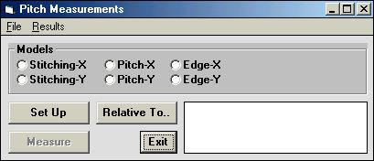

    - To proceed with a measurement file previously created in the \MEASURE directory, open up the Pitch Measurements File menu, highlight Load and load desired file.

- The Model option is read from the file and switches on automatically

- A Window will request to: “Point to the Reference Site,” relative to which all positions will be measured:

- Once file is loaded, proceed directly to Step 11

- To set up a new measurement file, choose one of the Methods described above for a measurement in the X or in the Y direction

- Click on the Set Up button, to setup measurement program.

- Depending on which model was selected, the Define Box window appears, requesting that measurement frames be placed over the structure(s)

- After the program is set up, click on Cancel to close the Define Box window.

- To save the measurement program, select a reference point.

- If a reference point is not selected, the program will simply save the current position as the reference point

- To define a reference point click on the Relative To.. button

- For a local series of measurements, the location of the first structure is usually chosen as the reference point

- When preparing a method including a fully automatic program, the field alignment site can be used

- Save measurement program by highlighting Save Measurement located under the File menu in the Pitch Measurements window.

- In case a reference site has never been marked, a window will appear notifying the fact and asking if the method should be saved anyway

- Start measurement by clicking on the Measure button and continue the measurement until enough data is collected.

- For Pitch Measurements, the first distance measured will be used as default, and only the first box will have to be placed for every succeeding measurement

  - A result window shows the updated values

  - After the measurement, the average value is displayed

- To view measurement results click on the Results menu in the Pitch Measurements window and highlight View and Save.
  - An editor displays the results, which may be saved

- Scroll down and highlight To Excel located under the Result menu in the Pitch Measurements window to view results on a Microsoft Excel spreadsheet.
- Highlighting To Excel will copy the results into the Clipboard

- Start Microsoft Excel and load data into a spreadsheet by pressing CTRL-V or by using the Paste function

- All data processing options that Microsoft Excel offers are available

- When spreadsheet results are complete return to the Pitch Measurements window

- Click Exit to return to the main menu window.

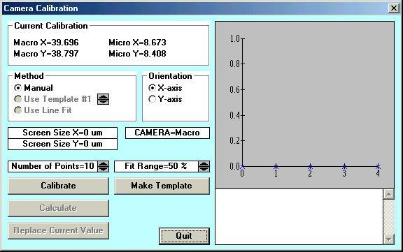
Camera Calibration
CAMERA CALIBRATION INSTRUCTION

- Load substrate as described in Loading and Focusing.

- Select camera to be calibrated and switch on the camera monitor

- Use the DWL Control Panel to select camera

- Move a clearly defined structure on the substrate (i.e., a cross) to the approximate center of the screen.

- Train system a template for finding the defined structure at various stage positions.

NOTE: Camera calibration may also be done manually, but the result may be less precise.

- Use Gain and Offset slides to optimize contrast of the image.

- Exit Control Panel.

- Highlight Video Calibration under Service in the Main Menu and the Camera Calibration window will appear.

- Click on Make Template and the Define Template window will appear.

- Define a template from the image on the monitor by placing a box of an appropriate size above a structure or part of a structure, which can be easily recognizable even if it is in a different part of the monitor image. First, place the box and then choose the size.

- Store the template in the temporary memory on the frame grabber-card by clicking on Save Template in IPC.

- Test template. If the result is poor, try to improve the contrast, or find a structure better suited, and repeat instruction beginning at Step 4c).

- Select number of data points and the range of the camera field over which the calibration should take place.

- Calibration range is limited to 90%, so the structure may drift out of view

- Click on Calibrate button.

- The stage will now be moved around the camera field and the position of the plate is measured using the defined template

- If manual mode is chosen, the operator must manually point to the structure’s edge, or center at each measurement position

- Click on Calculate and the system will calculate the best fit.

- Replace old calibration value with the new one by clicking on Replace Current Value.

- Repeat full instruction for both axes and both cameras.

CHAPTER 5 - ERRORS AND TROUBLESHOOTING

INTRODUCTION

This section suggests corrective action for common difficulties.

THE DWL WILL NOT IMAGE

- Verify that the AC power cord is plugged into the wall outlet and that the outlet is receiving power.

- Verify that the coverlid / flowbox window is completely closed.

- Try rebooting the OS9 system.

LINES NOT TO SIZE

Line thickness problems may have the following causes:

- Poor developing technique

- Wrong developing speed

- Wrong emulsion or media thickness

- Focus height incorrect

- Incorrect exposure

- Out of date emulsion

- File creation error

FILM FOGGING

Film fogging may have the following causes:

- Too much ambient light

- Safe light with wrong filter (Use a red filter or one recommended by the film manufacturer)

- Safe light on for too long

- Out of date emulsion or media

- Safe light power too high

- Wrong developer

THE DWL STOPS ANYTIME DURING THE EXPOSURE

- The accessed file is too big or the lic buffer is too small - Try split lic

- The DWL reached an endswitch, because the imaging area was set incorrectly

- The accessed file has the wrong format

- The data file is too complex, which causes the MBCIII to be selected without being READY.

- Try a slower writing speed or a smaller stripe width

- The interferometer head is broken

PLATE COMES OUT ALL BLACK

- The Test Beam Mode might still be on.

PLATE COMES OUT COMPLETELY CLEAR

- Wrong laser

- Something is blocking the beam path

ONLY HALF THE SCAN IS EXPOSED

- Stripe distance was not entered correctly in the conversion (wrong writehead chosen)
- Wrong writehead installed

- Wrong configuration was chosen

CHAPTER 6 - OPERATOR MAINTENANCE

INTRODUCTION

The DWL 66 requires some minimal operator maintenance; however, only trained service engineers should perform regular maintenance on the system. See Chapter 1 - Safety Precautions.

SYSTEM CHECKS

Before operation the following routine maintenance should be performed:

- Make sure all access covers are firmly in place.

- Clean the chuck surface with a dry towel

- Verify that the room temperature and humidity are within the following limits:

TEMPERATURE: 65° - 75°F (18° - 24°C)
NOTE

In addition to being within the recommended range, the temperature must be stable (within 2°C) in order to assure high quality film and plate registration.

RELATIVE HUMIDITY: 40% to 60% (non-condensing)

CLEAN ROOM: Class 1000

ENVIRONMENTAL ADJUSTMENT

- Allow room humidity to come within the specified range before using the MaskWrite.

- If temperature is out of range, determine how long this condition has prevailed.

- Adjust room temperature to within the specified temperature range and allow the DWL to stabilize.
- For stabilization of the system allow an amount of time equal to the time the temperature was out of range.

NOTE

- During imaging, the most accurate results are obtained when the environment remains at a constant temperature and humidity.

- If the system is equipped with a laminar flowbox, to achieve the optimum accuracy during imaging, place substrate on chuck 2-3 hours before exposure, close DWL window, and do not open window until exposure is finished.

